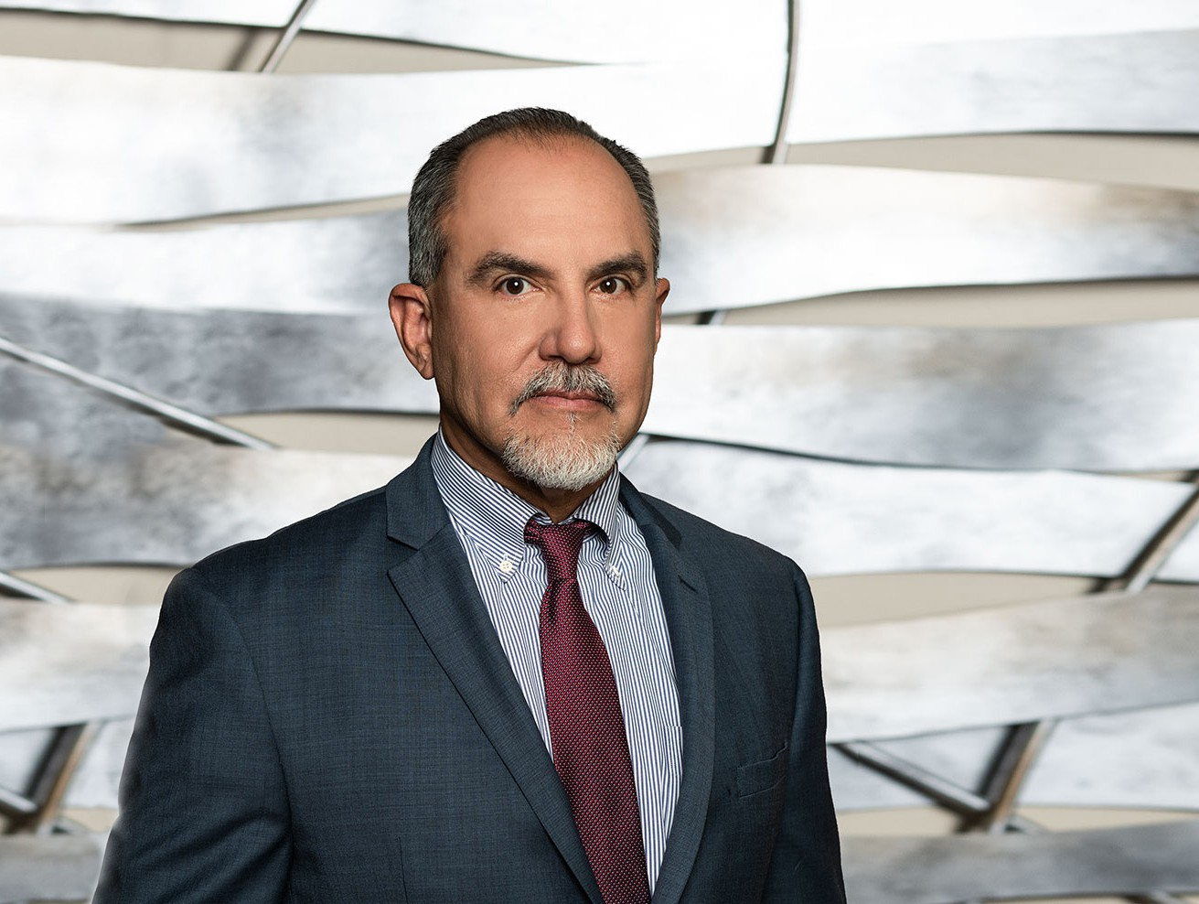

DON J. POOL

Director

[Financial Restructuring](https://www.fennemorelaw.com/services/financial-restructuring-bankruptcy-creditors-rights/)

[Fresno](https://www.fennemorelaw.com/contact-us/fresno/)

P: 559.432.4500 F: 559.432.4590

[dpool@fennemorelaw.com](mailto:dpool@fennemorelaw.com)

**DON J. POOL**

Don Pool’s practice focuses primarily on the enforcement of creditor’s rights and commercial litigation in state, federal and bankruptcy courts throughout California. He has represented national, regional and local banks, credit unions, and private lenders in loan enforcement actions, bankruptcy cases, and wrongful foreclosure and lender liability actions. Don also represents commercial landlords and trust deed beneficiaries in post- foreclosure unlawful detainer proceedings, loan workouts, debt restructuring, commercial litigation, and real property litigation.

Born and raised in the Central Valley of California, Don worked through high school on his family’s farm near Modesto, California. That experience has given him a special insight into representation of his farmer, rancher

and agriculture clients. With a finance and business administration degree in college, he was always interested in the intersection of law and business. He has represented commercial creditors for nearly 30 years in state, federal and bankruptcy courts throughout California. He works closely with institutional and private lenders to find cost-effective solutions to problem loans and commercial debts.

To get away from it all, Don enjoys horseback riding, boxing, reading, and riding dirt bikes in Baja.

# EDUCATION

J.D., University of Southern California, Gould School of Law B.S., California Polytechnic State University, San Luis Obispo

# AREAS OF PRACTICE

OTHER EXPERIENCE

Bankruptcy

Financial Restructuring Business Litigation

# PROFESSIONAL AND COMMUNITY ACTIVITIES

Member, California Receiver’s Forum Member, California Mortgage Association

Member, Fresno County Bar Association

Past Board Member and President, Central California Bankruptcy Association, 2016-2018

# ADMISSIONS

California

U.S. District Court, Central District of California

U.S. District Court, Eastern District of California

U.S. District Court, Northern District of California

U.S. District Court, Southern District of California

U.S. Court of Appeals, Ninth Circuit

U.S. Court of Appeals, Tenth Circuit