# DONOVAN C. COLLIER

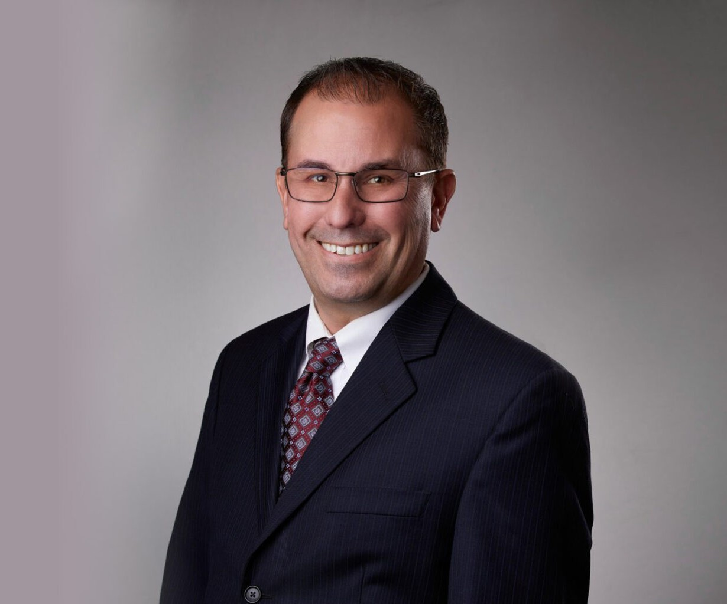

DONOVAN C. COLLIER

Director

[Land Use](https://www.fennemorelaw.com/services/land-use/)

[San Bernardino](https://www.fennemorelaw.com/contact-us/san-bernardino/)

P: 909.723.1814

F: 909.890.9877

[dcollier@fennemorelaw.com](mailto:dcollier@fennemorelaw.com)

“

Society cannot exist without law. Law is the bond of society: that which

makes it, that which preserves it and keeps it together. It is, in fact, the essence of civil society.

- Joseph P. Bradley

”

Donovan Collier is a director in our San Bernardino office where he has extensive experience counseling clients to ensure compliance with complex federal and state environmental laws and regulations. This includes the California Environmental Quality Act (CEQA), National Environmental Policy Act (NEPA), Federal and California Endangered Species Acts, Clean Water Act, and Porter-Cologne Water Quality Act. Donovan has acted as lead entitlement counsel for numerous complex and controversial land use projects, successfully appearing before local agencies throughout Southern California.

He takes great pride in assisting clients with assessing, developing, and implementing strategies for land use and regulatory compliance, including counsel on legislative and administrative land use approvals, such as development of impacted properties, development agreements, tentative maps and subdivision map issues,

zoning, general plan amendments, specific plans, traffic and transportation issues, and conditional use permits and variances.

During his distinguished career, Donovan has represented national and multi-national clients in obtaining local land use entitlements for the development of large commercial developments. His experience enables him to provide effective guidance and management of the entitlement process to ensure the entitlements obtained are legally defensible. He has successfully guided clients through the permitting of development projects involving water rights, wetlands, waste materials, species protection, the Surface Mining and Reclamation Act, and other environmental matters, including CEQA/NEPA document review and project entitlement.

Donovan represents clients in federal land issues, including mine permitting and reclamation, federal land exchanges, environmental compliance issues, and other natural resource and environmental matters. His

practice also involves outdoor advertising law matters including local and state permitting under the California Outdoor Advertising Act and associated Caltrans regulations.

# EDUCATION

J.D., University of San Diego School of Law, *magna cum laude*

B.S., California State University, San Bernardino

# AREAS OF PRACTICE

**OTHER EXPERIENCE**

Land Use Land Use Real Estate

Natural Resources Mining Law

# REPRESENTATIVE MATTER

Mining Counsel for Mitsubishi Cement South Quarry Expansion Project

# ARTICLES AND PRESENTATIONS

Reporter, Rocky Mountain Mineral Law Foundation Newsletter

# PROFESSIONAL AND COMMUNITY ACTIVITIES

Member, Association of Environmental Professionals Member, CalCIMA Legal Action Committee

Member, The State Bar of California, Environmental Law Section Member, Rocky Mountain Mineral Law Foundation

Member, SOAR Charter Academy Board of Directors

# ADMISSIONS

California