# JAMES B. DE LOS REYES

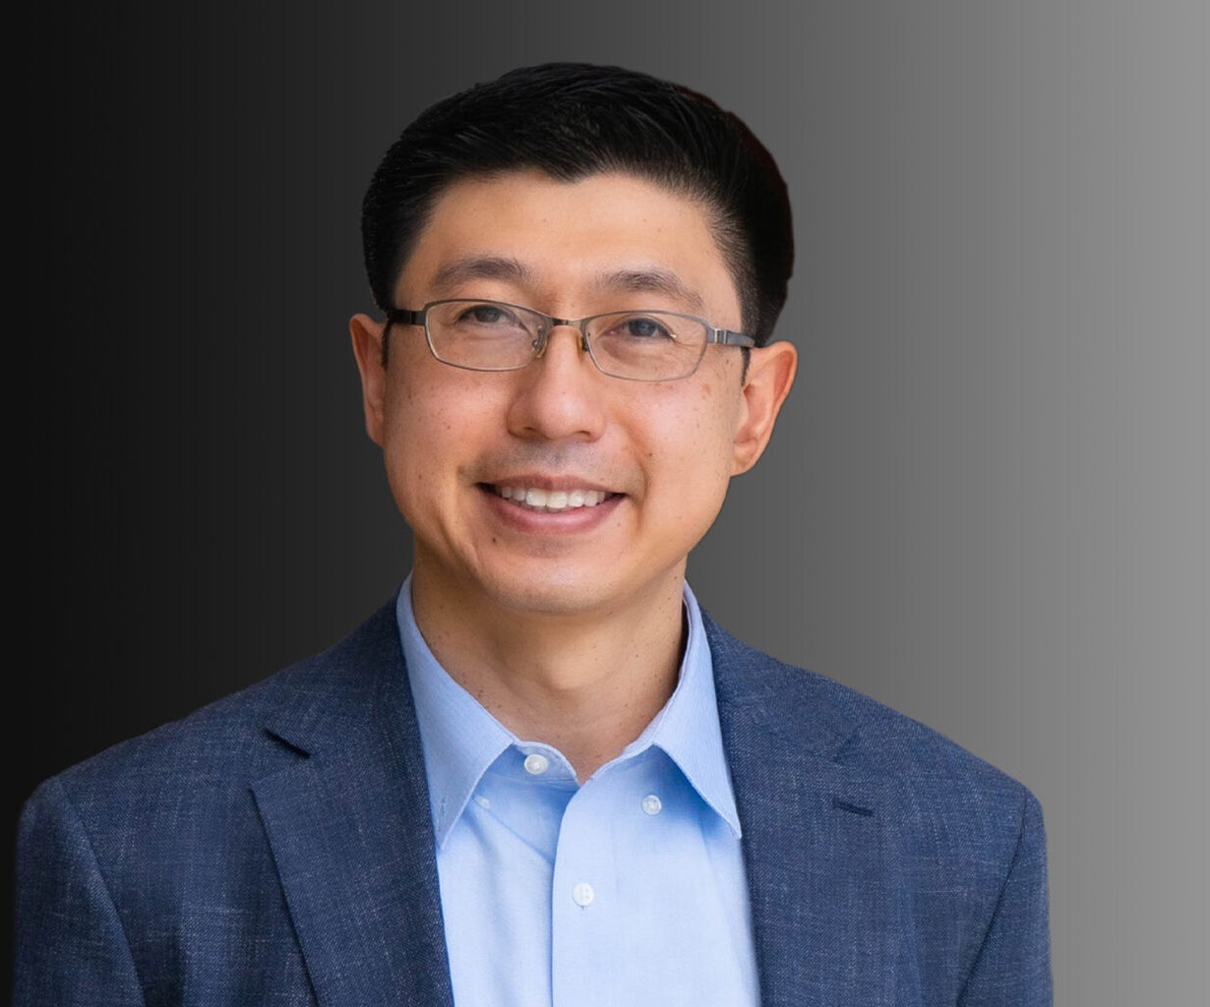

JAMES B. DE LOS REYES

Associate

[Business Litigation](https://www.fennemorelaw.com/services/business-litigation/)

[Oakland](https://www.fennemorelaw.com/contact-us/oakland/)

P: 510.834.6600

F: 510.834.1928

[jdelosreyes@fennemorelaw.com](mailto:jdelosreyes@fennemorelaw.com)

James has represented a variety of clients in matters relating to construction, real estate and general litigation. His experience includes all phases of civil litigation, including handling of pre-litigation claims, discovery, law and motion, depositions, dispositive motions, expert meeting and mediation proceedings, trial preparation and post-trial motions.

Before joining Fennemore Wendel, James worked for Haight Brown and Bonesteel’s San Francisco office and Boornazian, Jensen & Garthe in Oakland where he focused on construction defect and general civil litigation in a variety of practice areas.

James serves on the board of directors for Operation Dignity, a non-profit organization that provides housing and support services to veterans in the Bay Area. He regularly serves as an alumni coach and judge for UC Hastings Moot Court intercollegiate competition teams.

# EDUCATION

J.D., University of California, Hastings College of the Law B.A., Stanford University

# AREAS OF PRACTICE

Business Litigation Construction Law

# ARTICLES AND PRESENTATIONS

Featuring, “Attorney James de los Reyes on becoming a lawyer, diversity in the profession and community service,” San Francisco Business Times, May 23, 2023

Featuring, “Meet Our Donors!” Operation Dignity, May 2, 2023

# AWARDS AND HONORS

*Best Lawyers in America*®, Ones to Watch – Litigation – Construction, 2021-2025

*Best Lawyers in America*®, Ones to Watch – Construction Law, Personal Injury Litigation – Defendants, 2025

# PROFESSIONAL AND COMMUNITY ACTIVITIES

Member, Alameda County Bar Association

Member, Judiciary Committee, Filipino Bar Association of Northern California

# ADMISSIONS

California

U.S. District Court, Northern District of California