# JESSICA HERRERA

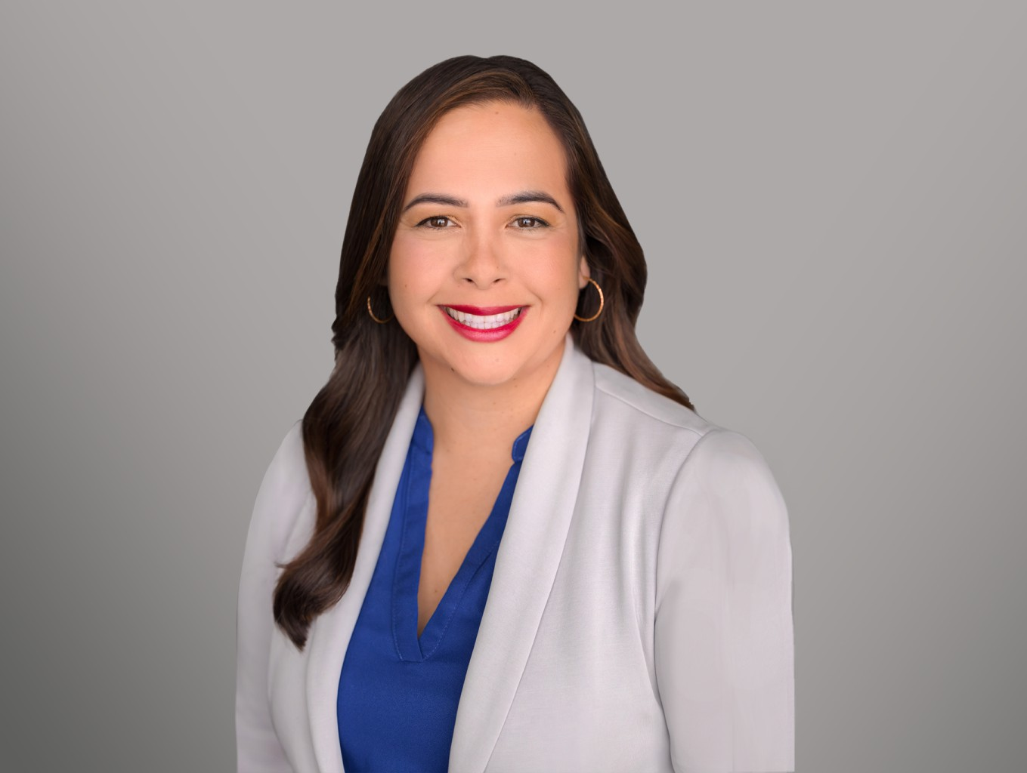

JESSICA HERRERA

Associate

[Business & Finance](https://www.fennemorelaw.com/services/business-and-finance/)

[Sacramento](https://www.fennemorelaw.com/contact-us/sacramento/)

P: 916.920.5286

F: 916.920.5286

[jherrera@fennemorelaw.com](mailto:jherrera@fennemorelaw.com)

Jessica Herrera, an associate attorney, practices taxation, business, and estate law. Her background as a paralegal, where she gained experience in tax law, helped transition into her role as an attorney. Jessica is particularly renowned for her strategic tax planning, advising clients on federal and state tax audits, international tax reporting, and compliance matters. Her skillset ensures that clients benefit from optimized financial efficiency and compliance with complex tax regulations.

Additionally, Jessica has a track record in representing clients in tax controversies. Her successes include disputing IRS tax adjustments, obtaining tax refunds, and providing comprehensive legal opinions on a variety of tax matters, such as California residency, exit strategies, and foreign reporting compliance. Her ability to resolve tax disputes has made her a tremendous support to her colleagues and an asset to her clients.

In her spare time Jessica enjoys spending time with her family and attending Bay Area sporting events. She is also an avid cook and traveler.

# EDUCATION

J.D., Golden Gate University

LL.M., Taxation, Golden Gate University B.S., California State University

# AREAS OF PRACTICE

Business & Finance Tax Law

# AWARDS AND HONORS

Rising Star, Northern California Super Lawyers, 2023

# PROFESSIONAL AND COMMUNITY ACTIVITIES

Member, State Bar of California Member, American Bar Association

Member, Sacramento County Bar Association

Member, California Women Lawyers California Notary

# ADMISSIONS

California

California Notary Public California Supreme Court

U.S. District Court, Northern District of California

U.S. Federal Court of Claim

U.S. Tax Court