# JOHN J. MCGREGOR

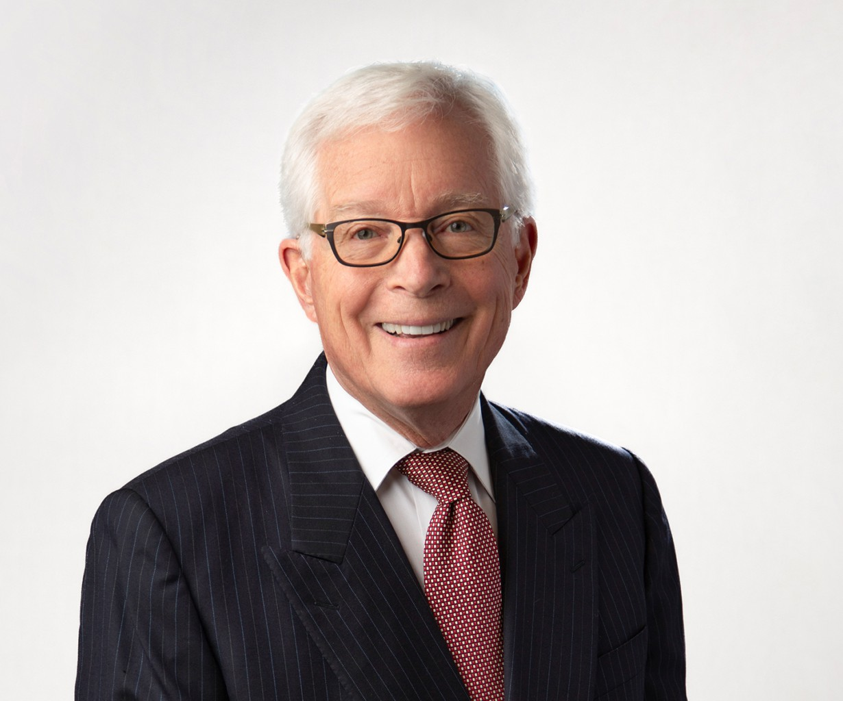

JOHN J. MCGREGOR

Of Counsel

[Tax Law](https://www.fennemorelaw.com/services/tax/)

[Fresno](https://www.fennemorelaw.com/contact-us/fresno/)

P: 559.753.2802

F: 559.432.4590

[jmcgregor@fennemorelaw.com](mailto:jmcgregor@fennemorelaw.com)

John J. McGregor is an Of Counsel attorney who works out of our Fresno office. A seasoned professional with over 40 years of experience in taxation and business transactions, John is certified as a specialist in Taxation Law by the State Bar of California Board of Legal Specialization. He has successfully represented taxpayers in

income, estate, property, sales and use tax controversies in federal courts and before the Internal Revenue Service, the California Franchise Tax Board, and the California Board of Equalization.

Additionally, his tenure as a member and chair of the Fresno County Assessment Appeals Board is a testament to his knowledge in California property tax disputes.

# EDUCATION

Master of Laws, Taxation, New York University

J.D., University of California College of the Law, San Francisco B.A., University of San Francisco

# AREAS OF PRACTICE

Tax Law

Business Litigation Agribusiness

# AWARDS AND HONORS

Only elected member of the American Law Institute practicing in the Central Valley AV® Preeminent™ Peer Review Rated by Martindale Hubbell

Northern California Super Lawyer in the field of Taxation, 2005, 2008-2024 Marquis’ Who’s Who in America

Marquis’ Who’s Who in American Law Marquis’ Who’s Who in the West

Fresno County Bar Association 1983 volunteer attorney of the year

2018 Alumnus of the Year of the Fresno Chapter of the University of California Hastings College of Law Alumni Association

# ARTICLES AND PRESENTATIONS

“New Wine in AMT Old Bottle,” with Charles Davenport, 74 Tax Notes 939, 1997

“Taxation of Real Property Transfers,” (1981) and supplements; California Continuing Education of the Bar “Collection of Delinquent Federal Taxes,” with Charles Davenport, 28 U.S.C. Tax Institute 589, 1976 Presenter, University of Southern California Tax Institute

Presenter, California CPA Society Farmers’ Tax and Accounting Conferences Presenter, Annual Meetings of the California Tax Bars

Presenter, IRS Tax Institutes

Presenter, The California State Bar Fall Section Education Institute

Adjunct Professor of Law, San Joaquin College of Law, teaching federal tax procedure Guest lecturer, California State University, Fresno, teaching mergers and acquisitions

# PROFESSIONAL AND COMMUNITY AFFILIATIONS

Member, American Law Institute, 1991-present Trustee, Community Health Systems, 2011 – 2022

Trustee, California Health Sciences University 2012 – 2023 Community Advisor, San Joaquin Valley Town Hall

Member, State Bar of California Taxation Section Executive Committee (1983-86)

Chair, State Bar of California Taxation Section Standards of Tax Practice Committee (1997-1998) Editor, The California Tax Lawyer, 1985-1986

Director, Fresno County Bar Association, 1983-1986

President, Fresno County Young Lawyers Association, 1982 Member, State Bar of California

Member, Fresno County Bar Association

# ADMISSIONS

California