Jordan Smith is a paralegal who works out of our Oakland and Walnut Creek offices, where he assists attorneys in the management of all aspects of litigation – from inception through trial. Jordan enjoys conducting thorough investigations and document review to obtain key facts which support or dispute claims

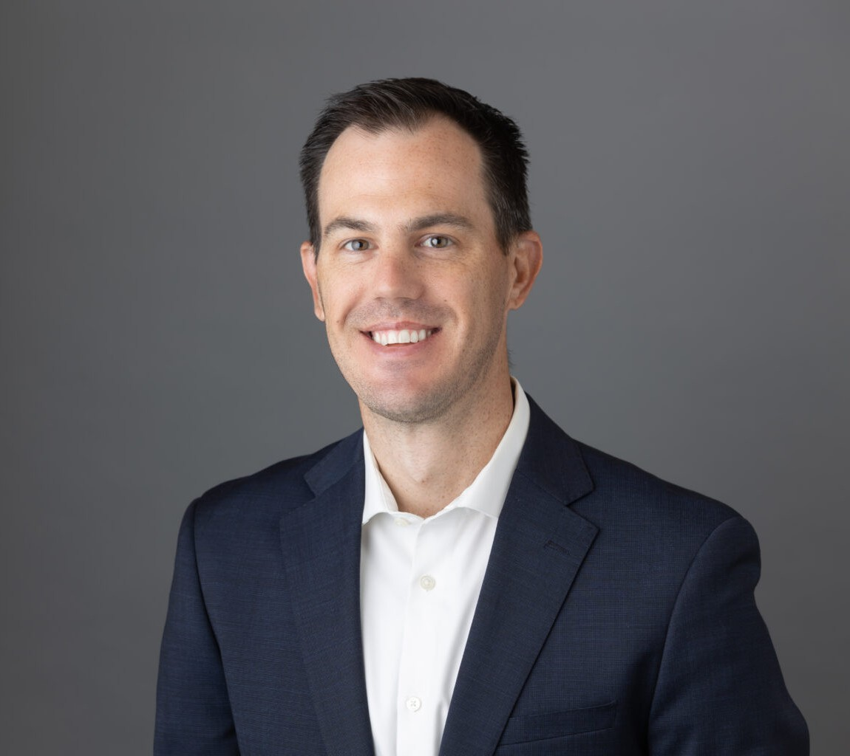

JORDAN SMITH

Paralegal

[Business Litigation](https://www.fennemorelaw.com/services/business-litigation/)

[Walnut Creek](https://www.fennemorelaw.com/contact-us/walnut-creek/)

P: 510.622.7505 F: 510.834.1928

[Oakland](https://www.fennemorelaw.com/contact-us/oakland/)

P: 510.622.7505 F: 510.834.1928

[jlsmith@fennemorelaw.com](mailto:jlsmith@fennemorelaw.com)

“

Don’t give up. Don’t ever give up.

Jim Valvano

**JORDAN SMITH**

”

Jordan’s brothers delivered newspapers when he was younger, and filed suit on behalf of more than 1,000 newspaper carriers against the local newspaper for antitrust violations and price-fixing, which resulted in reforming the industry. That was his first introduction to how the law worked. Jordan later became a summer file clerk while in school and quickly pivoted his studies to become a paralegal.

Outside of the office, Jordan is a Football Referee, currently working in the NCAA, IFL, and other various semi- pro leagues. He also enjoys golfing and snowboarding.

# EDUCATION

U.C. Berkeley Extension – Paralegal Studies, Awarded with Distinction

# AREAS OF PRACTICE

Business Litigation Estate Litigation

Employment & Labor Real Estate

# PROFESSIONAL AND COMMUNITY ACTIVITIES

President, Contra Costa Football Officials Association

San Francisco-Bay Area Regional Leader, Northern California College Football Officials Organization

# ADMISSIONS

*\*Not licensed to the practice of law*