**JOSEPH H. ZIMMERL**

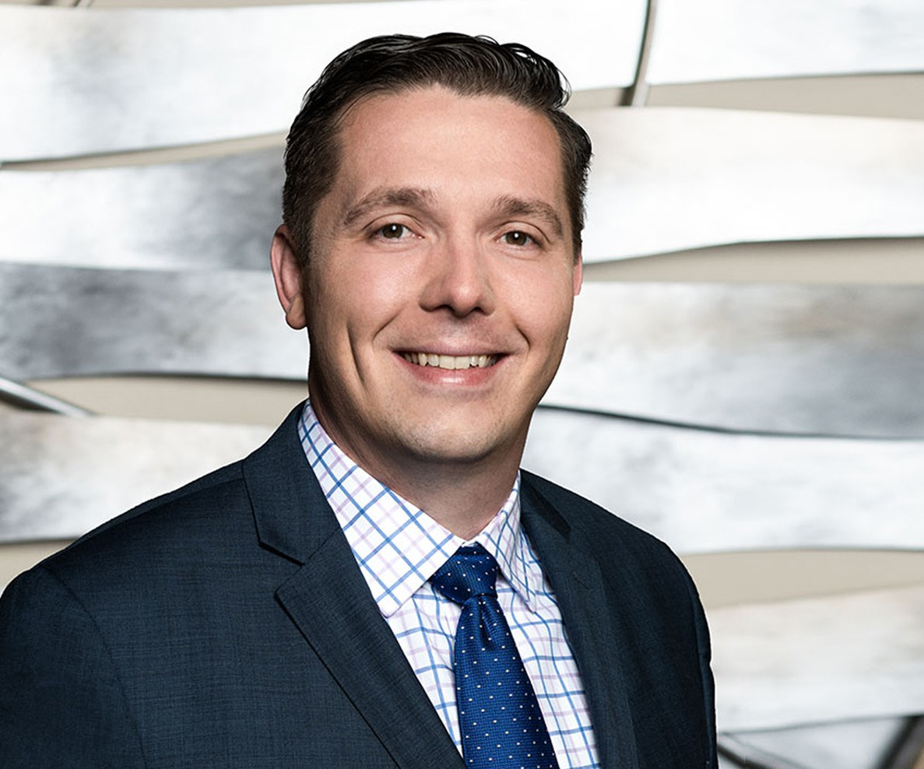

JOSEPH H. ZIMMERL

Director

[Business & Finance](https://www.fennemorelaw.com/services/business-and-finance/)

[Fresno](https://www.fennemorelaw.com/contact-us/fresno/)

P: 559.432.4500

F: 559.432.4590

[jzimmerl@fennemorelaw.com](mailto:jzimmerl@fennemorelaw.com)

Joe Zimmerl is an attorney working out of our Fresno office where his practice focuses on agribusiness, business transactions, financing, estate planning, and trust administration.

Taking great pride in his accessibility and availability to his clients, most, if not all of his clients have his cell- phone number. In today’s business world, clients expect near instant responses to their requests, and he wants

to make sure he is available to serve their needs. Joe takes great pleasure in helping his clients accomplish their goals.

Outside of work, you’ll probably find Joe spending time with his family – or heading toward the beach.

# EDUCATION

J.D., Georgetown University Law Center B.A., Loyola Marymount University

Staff Member, *Georgetown Environmental Law Journal*

# AREAS OF PRACTICE

Business & Finance Estate Planning Trusts & Estates

# ARTICLES AND PRESENTATIONS

[Featuring, “A Conversation On Life In The Legal Profession With Attorney Joseph Zimmerl,” Fennemore Blog,](https://www.fennemorelaw.com/the-practice-of-law-is-ultimately-about-relationships/) [July 13, 2023](https://www.fennemorelaw.com/the-practice-of-law-is-ultimately-about-relationships/)

# PROFESSIONAL AND COMMUNITY ACTIVITIES

Member, State Bar of California, Business Law Section and Estate Planning Section Member, Fresno County Bar Association, Estate Planning and Business Section Member, Los Angeles Bar Association, Business Section and Estate Planning Section

President, Fresno Sunset Rotary, 2019-2020

# AWARDS AND HONORS

*Best Lawyers in America*®, Ones to Watch – Corporate Law, Trusts and Estates, 2024-2025 Rising Star, *Northern California Super Lawyers*®, 2024

*Northern California Super Lawyers*®, 2023

# ADMISSIONS

California

U.S. District Court Eastern District of California

U.S. District Court Northern District of California

# LANGUAGES

Slovenian, Conversant