Marcus DiBuduo is an attorney in our Fresno office where his practice supports entrepreneurs of all ages, whether startups, investment-ready businesses, or firmly established multi- national enterprises. He is regularly called on by his clients to provide strategic counsel on all aspects of intellectual property law, including the acquisition, enforcement, and licensing of patents, trademarks, copyrights, and trade secrets. Marcus also advises clients on matters unique to e-commerce, such as compliance with various consumer and data privacy laws, cybersquatting, domain name disputes, and online copyright infringement matters.

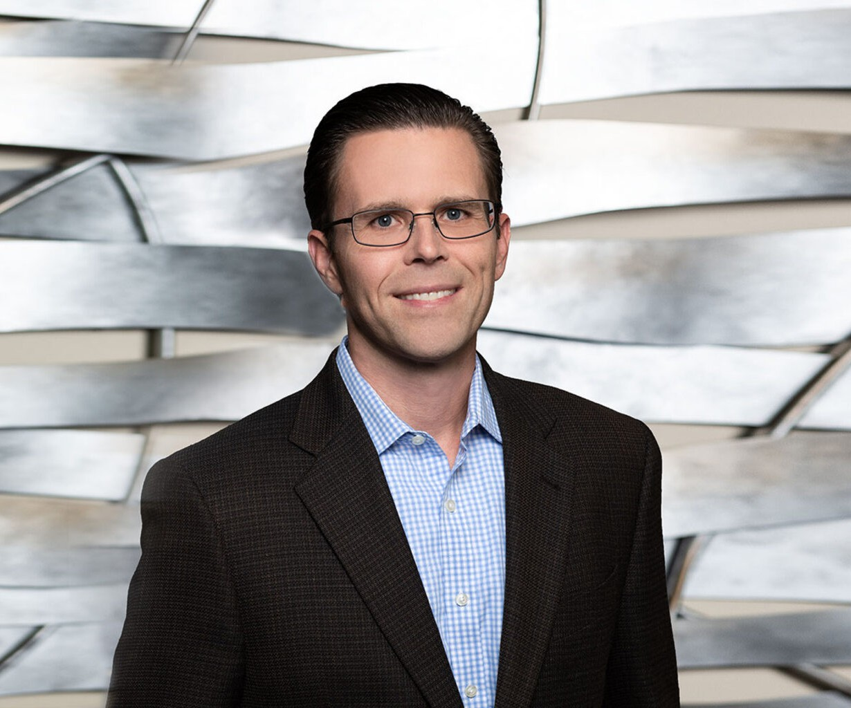

MARCUS N. DIBUDUO

Director

[Intellectual Property](https://www.fennemorelaw.com/services/intellectual-property-and-ip-litigation/)

[Fresno](https://www.fennemorelaw.com/contact-us/fresno/)

P: 559.432.4500

F: 559.432.4590

[mdibuduo@fennemorelaw.com](mailto:mdibuduo@fennemorelaw.com)

“

Problems are the price of progress.

-Charles Kettering

**MARCUS N. DIBUDUO**

”

Marcus never set out to be an attorney; a series of fortuitous events brought him to the practice of law. He began his professional career developing cellular communications and geo-location firmware, and then he continued to develop surveillance equipment power and motion control circuitry. As an engineer, Marcus was fortunate enough to conceive of ideas that exposed him, as an “inventor”, to the U.S. patent system (he has even seen his name in the USPTO’s National Inventors Hall of Fame and Museum). His background gives him the advantageous ability to truly understand his clients’ technology and business to better assist them in navigating complex legal matters. Marcus excels at, and he deeply enjoys, helping his clients to develop and implement effective strategies to protect their ideas, brands, and creative works. Marcus has a Martindale-Hubbell Distinguished™ peer reviewed rating in Intellectual Property, Patents and Litigation from and has been selected by *Super Lawyers®* to its Northern California List for Intellectual Property.

So as to not stray too far from his family’s deep agricultural roots in California’s Central Valley, Marcus, his wife, and three children live on rural property with pecan trees and various livestock. “Time off” generally involves boots and shovels, and some form of agricultural engineering, although he still manages to occasionally tinker with homemade microprocessor-based Internet-of-Things devices.

# EDUCATION

J.D., San Joaquin College of Law

B.S., Electrical Engineering, California State University, Fresno

# AREAS OF PRACTICE

**OTHER EXPERIENCE**

Business and Tort Litigation

Business Transactions and Entity Formation Internet and E-Commerce

Intellectual Property Agribusiness

Blockchain & Cryptocurrency Business & Finance

Business Litigation

Emerging Businesses & Technologies Privacy & Data Security

# AWARDS AND HONORS

*Northern California Super Lawyers®*, 2019-2024

*Northern California Super Lawyers® Rising Stars*, 2012-2018 Martindale-Hubbell Distinguished™ Rating

# PROFESSIONAL AND COMMUNITY ACTIVITIES

Member, American Intellectual Property Law Association Member, International Trademark Association

Member, Federal Circuit Bar Association

Member, San Joaquin Valley Association of Business Trial Lawyers

Member, Federal Bar Association, Intellectual Property and Communications Law Section Member, American Bar Association, Intellectual Property Law Section

Member, State Bar of California, Intellectual Property Law Section Member, Fresno County Bar Association

# ADMISSIONS

California

U.S. District Court, Central District of California

U.S. District Court, Eastern District of California

U.S. District Court, Northern District of California

U.S. District Court, Southern District of California

U.S. Court of Appeals, Ninth Circuit

U.S. Court of Appeals, Federal Circuit

U.S. Patent and Trademark Office