# MARK J. GLEASON

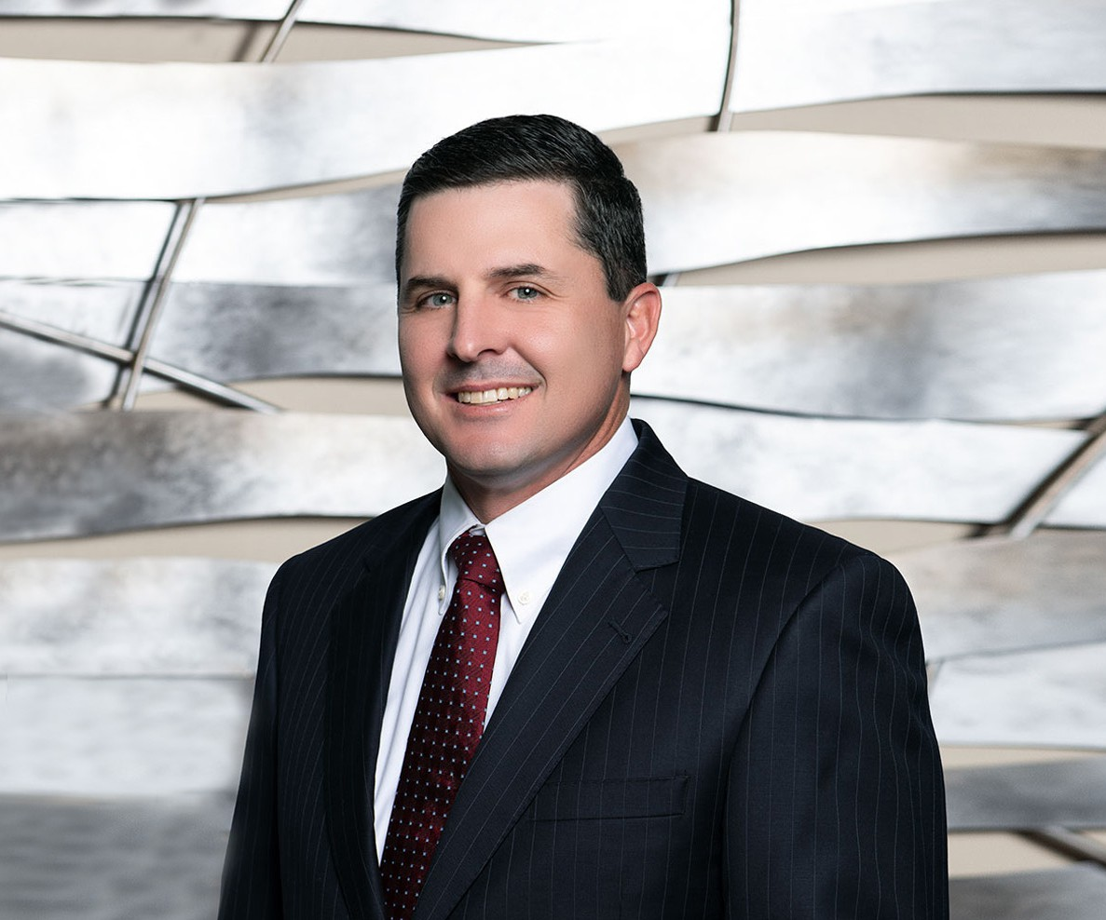

MARK J. GLEASON

Of Counsel

[Trusts & Estates](https://www.fennemorelaw.com/services/trusts-estates/)

[Fennemore Forward](https://www.fennemorelaw.com/contact-us/fennemore-forward/)

P: 916.791.4500

F: 916.791.4550

[mgleason@fennemorelaw.com](mailto:mgleason@fennemorelaw.com)

Mark Gleason is an attorney in our trusts and estates, real estate, and business and finance practice groups. In his practice, Mark works closely with clients regarding estate planning, business succession planning, and the administration of trusts and estates. He also works with individuals and businesses regarding entity formation,

contract negotiations, real estate transactions, and mergers and acquisitions.

Born and raised on a ranch, and competing in rodeo through college, Mark’s passion for agriculture steered his undergraduate degree and his initial career in food processing. However, his analytical nature ultimately led him to a career in law. While he maintained a strong interest in agricultural issues, his practice branched out to include assisting clients in a variety of situations. Whether advising individuals regarding their estate plans or large companies in acquisitions, Mark finds the most enjoyable task is boiling down complex issues in a way his clients can understand, allowing them to feel confident in their decisions.

Mark began his career with a large international law firm in Orange County, where his practice involved real estate matters and civil litigation. Prior to joining our firm, Mark also served as a Deputy City Attorney to the City of Fresno, where he focused on municipal finance, contract negotiations, and real estate matters.

In his spare time, Mark is either helping operate his family’s cattle ranch, or he’s doing whatever activity his four children are involved in at the moment, including horseback riding, skiing, basketball and lacrosse.

# EDUCATION

J.D., George Washington University Law School, with highest honors,

B.S., Agribusiness, California Polytechnic State University, San Luis Obispo, *cum laude*

Order of the Coif

# AREAS OF PRACTICE

Trusts & Estates Agribusiness Business & Finance Tax Law

Real Estate

Estate Planning

# ADMISSIONS

California