# PATRICIA E. CURTIN

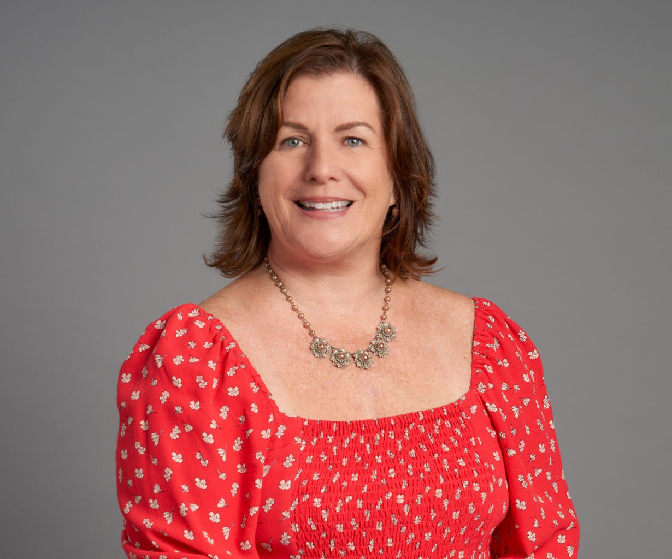

PATRICIA E. CURTIN

Director

[Land Use](https://www.fennemorelaw.com/services/land-use/)

[Walnut Creek](https://www.fennemorelaw.com/contact-us/walnut-creek/)

P: 510.834.6600

F: 510.834.1928

[pcurtin@fennemorelaw.com](mailto:pcurtin@fennemorelaw.com)

Patricia has more than three decades of experience in local government and land use law. She focuses on processing and obtaining land use entitlements for the private sector and advises the public agencies on land use and local government law. Patricia has presented and written extensively on land use topics, including co- authoring State and Local Government Land Use Liability (Thomson Reuters) and served as a Planning Commissioner in her home town for over 10 years.

Patricia assists clients in processing and obtaining approvals for complex master planned and mixed-use projects, market rate and affordable housing projects, logistic centers, hotels and resorts, educational and medical facilities; drafting and negotiating development, disposition, annexation, reimbursement, school

mitigation and affordable housing agreements; application of density bonus laws, streamlining processes for development applications, and affordable housing opportunities She stays current on all the new housing/streamlining laws from the Legislature and explains their impact on local governments. Patricia periodically presents on new housing laws and the California Environment Quality Act to her clients. She also assists clients in complying with CEQA and in creating assessment and other financing districts.

Patricia also advises affordable housing providers throughout the state, and serves as a Board member of HomeAid, Northern California whose mission is to assist people experiencing or at risk for homelessness.

Patricia’s practice includes obtaining permits for mental health facilities for a major provider throughout the state. She also secures approvals for other supportive services (i.e., care homes for persons with eating disorders and safe homes for victims of human trafficking) and for affordable housing non-profit groups. She

also co-authors a national land use book; one of the chapters focuses on the unique issues relating to uses for persons with disabilities (includes mental health) under the ADA and Rehabilitation Act.

Patricia serves as legal counsel to over 12 Geologic Hazard Abatement Districts (GHADs). She counsels GHADs and represents property owners, cities, and counties in forming, annexing into and operating GHADs. As Secretary on the board for the non-profit California Association of GHADs, she works to improve the effectiveness of GHADs at preventing, mitigating, and controlling geological hazards. Patricia has written several articles and papers related to GHAD formation and implementation.

# EDUCATION

J.D., University of the Pacific, McGeorge School of Law

B.A., California State University, Chico

# AREAS OF PRACTICE

Land Use Real Estate

Government Relations & Regulatory

# AWARDS AND HONORS

*San Francisco Magazine*, Top Women Attorneys in Northern California, 2021

*Daily Journa*l, Top Women Lawyers, 2020

*Best Lawyers in America*®, Land Use & Zoning Law, Real Estate Law, 2001 – 2016, 2018 – 2020, 2023-2025; Lawyer of the Year, Land Use & Zoning Law, 2015, 2017

GlobeSt. Real Estate Forum, Women of Influence, 2019

*Northern California Super Lawyers*®, 2005 – 2023

*San Francisco Business Times*, Forever Influential Women in Bay Area Business, 2016

*San Francisco Business Times*, Northern California Real Estate Woman of Influence, 2015

*San Francisco Business Times*, Most Influential Women in Bay Area Business, 2015

East Bay Commercial Real Estate Women (CREW), Sustained Leader ECHO Award, 2013 *Northern California Super Lawyers*®, Top Women Attorneys in Northern California, 2012 *Daily Journal*, Top 25 California Land Use Lawyers, 2011

*California Real Estate Journal*, Top Women in Real Estate, 2009

# ARTICLES AND PRESENTATIONS

Author, “Planning, Zoning and Development Law Update Summary of Case Law in 2023,” UCLA Extension Public Policy Program, February 2, 2024

Paper and presentation for Contra Costa County City Attorneys Association, titled *Significant Housing Legislation Signed by Governor Newson,* October 2023

The Use of Geologic Hazard Abatement District to Mitigate Landslides, *San Francisco Daily Journal*, May 30, 2023

Co-Author, “State and Local Government Land Use Liability,” Publisher West Group – Updated Annually

Author, State Density Bonus Law Update and Significant 2022 Housing Legislation, Cal Cities City Attorney Spring Conference , May 17, 2023

Presenter, State Density Bonus Law Update and Significant 2022 Housing Legislation, Cal Cities City Attorney Spring Conference, May 17, 2023

Presenter, Til the Landslide Brought Me Down: Prevention and Dealing with Geologic Hazards, Alameda County Bar Association, May 10, 2023

Presenter, Processing Housing Development Applications under SB 330, Cal Cities Planning Commissioners Academy, March 30, 2023

Author and Presenter, Planning and Zoning Law Update, 37th Annual Land Use Law & Planning Conference, UCLA Extension Public Policy Program, January 27, 2023

Presenter, “2022 Significant Land Use Summaries,” UCLA Extension Land Use & Planning Conference, 2023

Presenter, “Streamlined Housing Law and New Housing Legislation,” Planning Commissioners Academy, League of California Cities, 2022

Presenter, “Streamlined Housing Approval with SB 35, SB 330 and New Housing Legislation,” Wendel Rosen LLP, 2021

Presenter, “How to Prepare Findings and Conditions of Approval,” 2021 Planning Commissioners Academy, League of California Cities, March 2021

Presenter, “How to Prepare Findings and Conditions of Approval,” Planning Commissioners Academy, League of California Cities, 2015, 2016, 2017, 2019, 2020, 2021, 2022

Presenter, “Streamlined Processing of Ministerial Projects Under SB 35,” City Attorneys Conference, League of California Cities, 2019

Presenter, “A Brave New World? Over-the-Counter Approvals for Large Projects Under SB 35,” Sonoma State University, 35th Annual Planning Commissioners Conference, December 2018

Presenter, “Role of a Planning Commissioner,” Planning Commissioners Academy, League of California Cities, 2018

Presenter, “Planning Commission 102 – Nuts and Bolts of Planning,” Planning Commissioners Academy, League of California Cities, 2018

Presenter, “Financing the Future – Geologic Hazard Abatements District/An Adaptive Management Strategy to Mitigate Flood Risk,” SF Bay Conservation and Development Commission, 2017

Presenter, “Policy Role in Land Use Planning,” New Mayors and Council Member, League of California Cities, 2014 and 2015

Presenter, “Planning in an Adversarial Environmental,” Planning Commissioners Academy, League of California Cities, 2014

# PROFESSIONAL AND COMMUNITY ACTIVITIES

Board Member, HomeAid Northern California

Member, East Bay Commercial Real Estate Women (CREW) Former Planning Commissioner, City of Lafayette

Founding Member and Secretary, California Association of Geologic Hazard Abatement (GHAD) Member, League of California Cities

Member, American Planning Association Former Board Member, John Muir Health

Founding and Former Board Member, Special Education Enrichment Development Foundation Board Member, Dreamcatchers Empowerment Network

# ADMISSIONS

California

U.S. District Court, Northern District of California

U.S. Court of Appeals, Ninth Circuit

U.S. Supreme Court