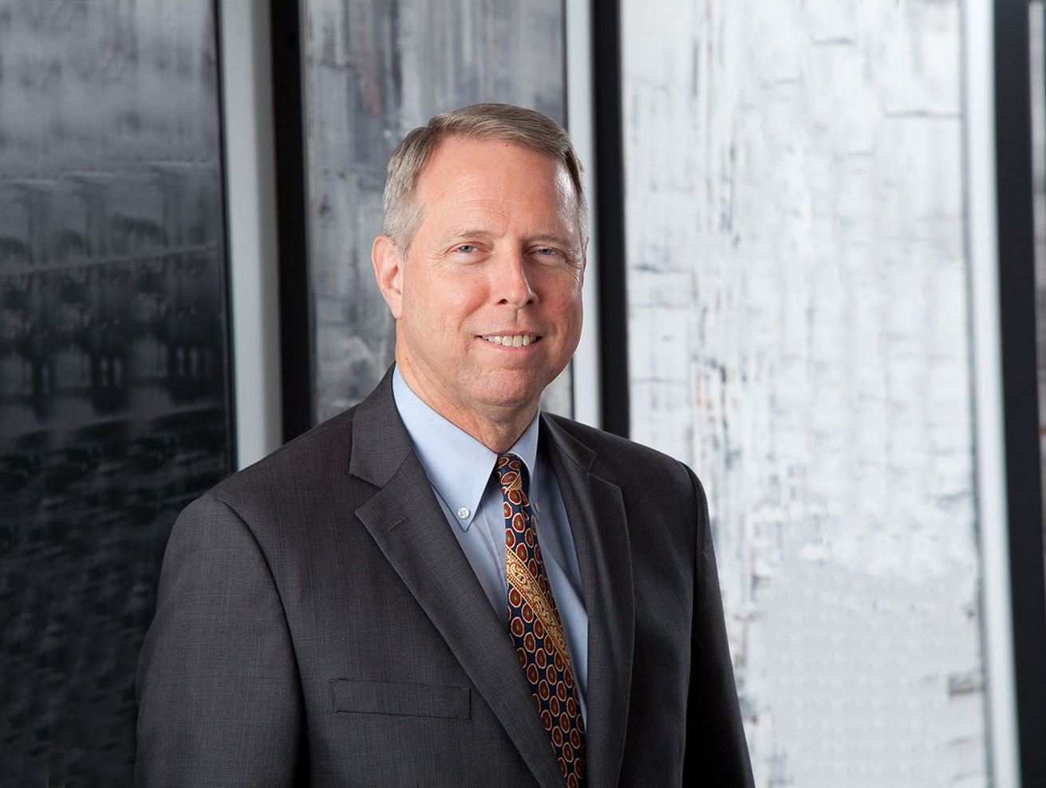

PATRICK IRVINE

Director

[Business & Finance](https://www.fennemorelaw.com/services/business-and-finance/)

[Phoenix](https://www.fennemorelaw.com/contact-us/phoenix/)

P: 602.916.5406 F: 602.916.5606

[pirvine@fennemorelaw.com](mailto:pirvine@fennemorelaw.com)

**PATRICK IRVINE**

Pat is a former Judge of the Arizona Court of Appeals who practices in federal, state and local taxation, nonprofit and tax-exempt organizations, government regulation, Indian law, alternative dispute resolution and appeals. He advises and represents clients on all aspects of state and local tax, nonprofit formation and

operation, qualification for tax exemptions, charitable contributions, tax audits and appeals, and government regulation. His broad experience as a judge and attorney in interpreting and applying statutes and contracts, combined with specialized knowledge and experience in taxation and government regulation, make him uniquely qualified to understand what governing documents and agreements mean and how they should be drafted. His experience as a judge and advocate, along with his work as a mediator and arbitrator, help him to work with clients to efficiently resolve internal and external disputes.

In the nonprofit area, Pat advises charter schools on the open meeting and public records laws, as well as state aid and charter school governance issues. Representing a charter school and its management company, he successfully defended a multi-million dollar lawsuit initiated by the Arizona Department of Education for

overpayment. He has also advised clients on the law governing gambling by Indian tribes and nonprofits, and was recently successful in a court action addressing whether certain electronic machines qualified as “raffles” under Arizona law.

Pat is recognized as one of the State’s leading state and local tax practitioners. He has a master’s degree in tax law and previously served as the Chief Counsel of the Arizona Attorney General’s Tax Section. He has represented clients in tax controversies before administrative agencies and at all levels of the state and federal courts, including a successful argument before the U.S. Supreme Court involving tax and Indian law. He has also been a Tax Manager at a leading accounting firm, where he assisted clients with compliance, tax planning and tax controversies.

He advises public and private clients on fiduciary duties and conflicts of interest, and his experience in ethics and professional responsibility includes service on the Arizona Supreme Court’s Committee on Character and Fitness and the Judicial Ethics Advisory Committee.

For over thirty years Pat has been a frequent speaker, teacher and trainer on legal issues, including nonprofit formation and operation, taxation, open meeting law, mediation, arbitration and Indian law. His teaching for institutions of higher education has included dozens of sections of business law and public administration, as well as employment law, accounting, taxation and Indian law.

Away from work, Pat volunteers with Kiwanis International, and spends time with his family.

# EDUCATION

LL.M., Taxation, University of San Diego School of Law

J.D., Arizona State University, Sandra Day O’Connor College of Law B.S., Arizona State University

Phoenix College Alumni Hall of Fame

# AREAS OF PRACTICE

**OTHER EXPERIENCE**

Appeals

Estate Planning Indian Law Litigation

Mediation and Arbitration

Nonprofit and Tax-Exempt Organizations Business & Finance

Tax Law

# AWARDS AND HONORS

*Best Lawyers in America®,* Appellate Practice, Native American Law, Tax Law, 2015-2025

*Best Lawyers in America®,* Administrative Law, Regulatory Law, 2022-2025

*Southwest Super Lawyers®,* Alternative Dispute Resolution, 2018-2024

*Southwest Super Lawyers®,* Tax, 2015-2017

Recipient, Henry Tom Outstanding Tax Attorney Award, 2016

Recipient, Jim Jones Distinguished Service Award, Conference of Western Attorneys General Recipient, Distinguished Public Lawyer Award, State Bar of Arizona

Recipient, U.S. Supreme Court Best Brief Award, National Association of Attorneys General Recipient, Counselor of the Year Award, Arizona Attorney General’s Office

# ARTICLES AND PRESENTATIONS

Featured, “Patrick Irvine: Appointed as Vice-Chair of the Committee on Character and Fitness in the Supreme Court of the State of Arizona,” Arizona Courts, February 2023

[Co-author, “The CARES Act: New Tax Provisions for Charitable Deductions,” Fennemore Client Alert, March](https://www.fennemorelaw.com/insights/newsletters/2020/the-cares-act-new-tax-provisions-for-charitable-deductions) [31, 2020](https://www.fennemorelaw.com/insights/newsletters/2020/the-cares-act-new-tax-provisions-for-charitable-deductions)

[Co-author, “Model City Tax Code Gets Proposed Edits,” Fennemore Client Alert, March 5, 2019](https://www.fennemorelaw.com/insights/newsletters/2019/model-city-tax-code-gets-proposed-edits) [Interview, “Tribal Tax Jurisdiction and Remote Sales,” The Talking Stick, August 2018](https://soundcloud.com/talkingstick/ilp-talking-stick-tribal-tax-jurisdiction-remote-sales)

Interview, “Sales Tax for Online Retailers,” *Tucson Morning News,* June 29, 2018

Speaker, “ADR Talks,” State Bar of Arizona 2018 Annual Convention, June 28, 2018

Speaker, “501(c)(3) Tax-Exempt Organizations: Do’s and Don’ts,” Kiwanis International Southwest District Mid- Year Conference, March 2018

Speaker, “Sales Tax Issues for Indian Country,” Arizona State University E-Commerce Conference, February 2018

Speaker, “Establishing a 501(c)(3) Organization,” National Business Institute, October 2, 2017 Speaker, “Arbitration Talks,” 2017 State Bar of Arizona Annual Convention, June 15, 2017 [Author, “10 Tips for Effective Appellate Advocacy,”](http://www.azattorneymag-digital.com/azattorneymag/20160708/?pg=15&pg15) [*Arizona Attorney,*](http://www.azattorneymag-digital.com/azattorneymag/20160708/?pg=15&pg15)[July/August 2016](http://www.azattorneymag-digital.com/azattorneymag/20160708/?pg=15&pg15) Speaker, “Arbitration Myths and Realities,” State Bar of Arizona Convention, June 2016

Speaker, “Open Meeting Law” and “School Finance Issues,” Arizona Charter School Association, May 2016 Moderator, “Discovery Objections Under the New Federal Rules,” U.S. District Court Conference, March, 2016

# PROFESSIONAL AND COMMUNITY ACTIVITIES

Board of Directors, Ronald McDonald House Charities of Central and Northern Arizona Member, State Bar of Arizona

Member, State Bar of California

Arbitrator, American Arbitration Association Arbitrator, Financial Industry Regulatory Authority

Member, Committee on Character and Fitness, appointed by the Arizona Supreme Court

Kiwanis

Advisor, Southwest District Kiwanis Foundation

Past Lieutenant Governor, Kiwanis Southwest District Past President, Capitol Gateway Kiwanis Club

Past President, Camelback Kiwanis Club

Member, Board of Directors, Arizona Tax Research Association

Adjunct Faculty, Arizona State University College of Law, Indian Legal Program, 2006-present Past Lawyer Representative, Ninth Circuit, U.S. District Court of Arizona

Past Member, State Bar of Arizona Civil Practice and Procedure Committee

Past Member, Executive Council, State Bar of Arizona Alternative Dispute Resolution Section Past Member and Chair, City of Phoenix Judicial Selection Advisory Board

Past Member and Chair, State, Tribal & Federal Court Forum Past Member, Judicial Ethics Advisory Committee

Former Advisory Committee Member, Phoenix College Tribal Court Advocacy Program Adjunct Faculty, Phoenix College, 1992-2001; 2015

Past President, Phoenix Museum of History

# ADMISSIONS

Arizona

California

U.S. District Court, District of Arizona

U.S. Court of Appeals, Ninth Circuit

U.S. Supreme Court

U.S. Tax Court