# PHILIP M. SAVAGE IV

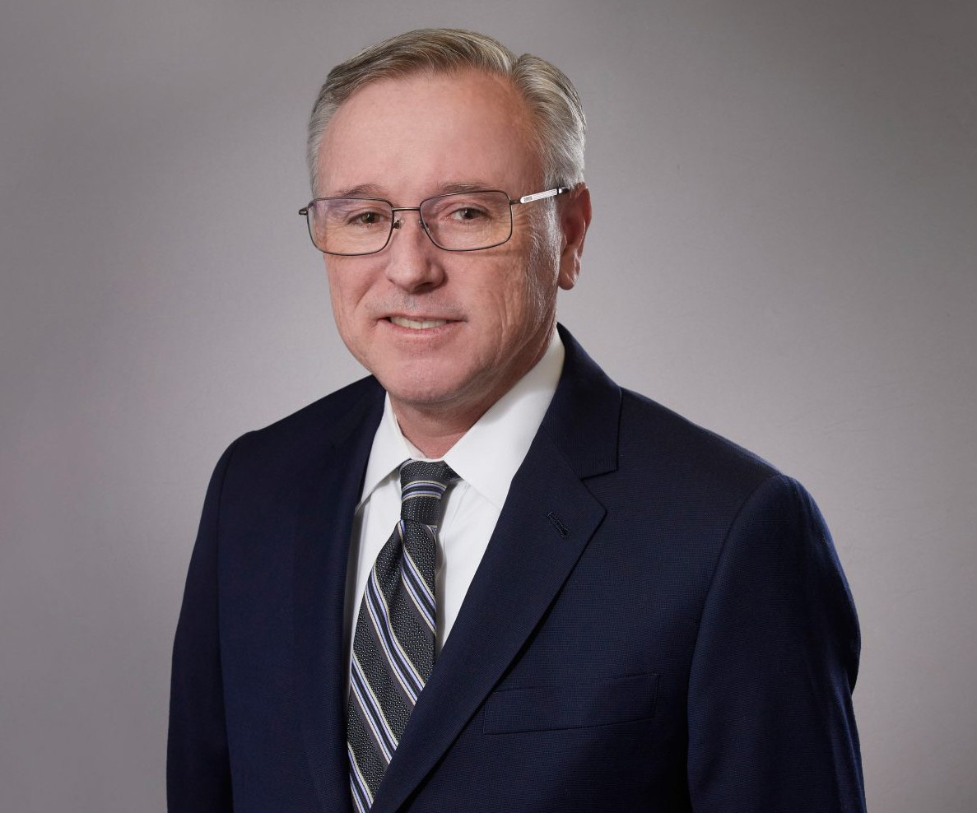

PHILIP M. SAVAGE IV

Director

[Trusts & Estates](https://www.fennemorelaw.com/services/trusts-estates/)

[San Bernardino](https://www.fennemorelaw.com/contact-us/san-bernardino/)

P: 909.890.4499

F: 909.890.9877

[psavage@fennemorelaw.com](mailto:psavage@fennemorelaw.com)

“

“At his best, man is the noblest of all animals; separated from law and justice

he is the worst.”

- Aristotle

”

Phil Savage is a director in our San Bernardino office where his practice focuses on business succession, estate planning and trust administration. He works with his clients to create business succession and estate transfer plans that preserve wealth and enhance family relationships. His clients include corporations, charities, high net worth families and individuals, and fiduciaries.

Phil enjoys providing personalized estate planning, estate administration, and business succession counsel. He provides clients with a practical approach to achieve their planning objectives, including the planning and preparation of revocable and irrevocable trusts, and the administration of trusts and estates involving estate and gift tax issues. He also advises and counsels individuals and charitable organizations on planning and implementing charitable gifts.

A certified specialist in estate planning, trust, and probate law by the State Bar of California Board of Legal Specialization, Phil is a past chair of the Estate Planning, Trust, and Probate Law Advisory Commission of the State Bar of California Board of Legal Specialization. He has presented estate planning seminars to many organizations.

# EDUCATION

J.D., Loyola Law School, Los Angeles B.A., Stanford University

# AREAS OF PRACTICE

Trusts & Estates

Business & Finance Tax Law

Estate Planning

# ARTICLES AND PRESENTATIONS

Estate Planning – The Basics and Pitfalls to Avoid, Crafton Hills College, January 2019 First Steps in Trust Administration, 2018 Bench-Bar Symposium, June 2018

Estate Planning for Digital Assets, Orange County Estate Planning Council, September 2017 Estate Planning and Charitable Planning, San Bernardino Valley College, January 2016 Estate Planning for Digital Assets, Riverside Estate Planning Council, March 2015

Estate Planning Basics, California State University San Bernardino, June 2014 Estate Planning Basics, University of California Riverside, April 2014

# PROFESSIONAL AND COMMUNITY ACTIVITIES

Member, American Bar Association, Real Property, Probate & Trust Section Member, The State Bar of California, Estate Planning, Probate & Trust Section Member, University of California, Riverside, Planned Giving Advisory Board Member, California State University San Bernardino Philanthropic Foundation Board Member, Loma Linda University Children’s Hospital Foundation

Board Member, The Community Foundation, Serving Riverside & San Bernardino Counties Member, Estate Planning Councils of San Bernardino and Riverside

Member, Riverside Sunrise Rotary

Member, San Bernardino Community Scholarship Association, Board Member

# ADMISSIONS

California