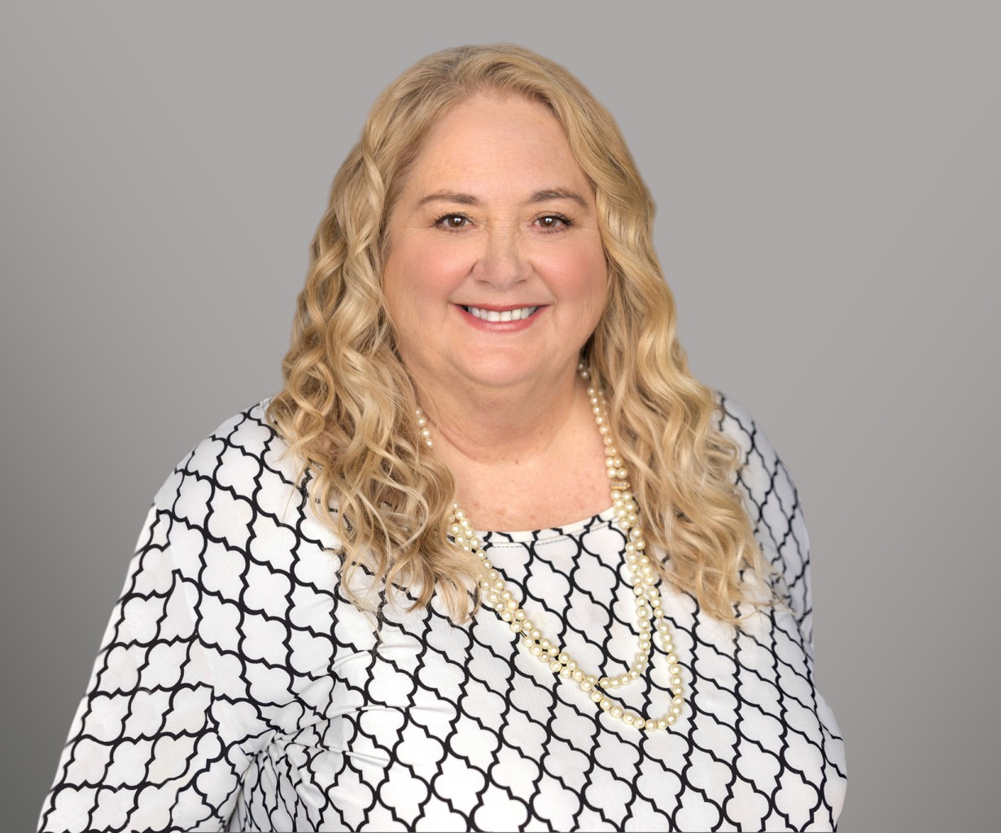

ROBIN L.

KLOMPARENS

Director

[Trusts & Estates](https://www.fennemorelaw.com/services/trusts-estates/)

[Sacramento](https://www.fennemorelaw.com/contact-us/sacramento/)

P: 916.920.5286 F: 916.920.5286

[rklomparens@fennemorelaw.com](mailto:rklomparens@fennemorelaw.com)

# ROBIN L. KLOMPARENS

Robin Klomparens is a tax attorney with a finance degree from the Warrington College of Business at University of Florida and a Juris Doctorate and LL.M. in Taxation from the University of Miami. Admitted to the Florida Bar in 1986 and the California Bar in 1987, she also practices before the U.S. Tax Court and the U.S. Supreme Court.

Her achievements include receiving the Joanne Garvey Lifetime Achievement Award in 2019.

Renowned for her expertise in tax law, Robin excels in navigating complex tax code changes, providing her clients with up-to-date and effective legal counsel. She has contributed significantly to legal education as an adjunct professor at USF’s LLM program, Golden Gate University’s MS program, and currently at McGeorge School of Law. A prior member and current advisor to CLA’s Tax Section Executive Committee and Estate and Gift Committee, and a member of ACTEC, she also contributes to various charitable boards. Her extensive lecturing and publications further establish her knowledge in tax law.

# EDUCATION

L.L. M., Taxation, University of Miami

J.D., University of Miami, School of Law B.S., B.A., University of Florida

# AREAS OF PRACTICE

Trusts & Estates Business & Finance Estate Litigation

Tax Law

Estate Planning

# AWARDS AND HONORS

Joanne Garvey Distinguished Lifetime Achievement Award, State Bar of California

V. Judson Klein Award for Outstanding Achievement in Taxation, State Bar of California

AV Preeminent 5.0 Peer Review Rated by Martindale-Hubbell

# ARTICLES AND PRESENTATION

Presenter, “From Death to Distribution,” 2024 Estate and Gift Tax Conference, California Lawyers Association, March 21, 2024

Co-Author, “Corporate Transparency Act,” Firm Newsletter, January 19, 2024

Author, “California Senate Bill 131 Closes Loophole for Incomplete Gift Non-Grantor Trusts (“INGs”),” Firm Newsletter, July 18, 2023

Co-Author, “Proposition 19 Brings Substantial Changes to California’s Property Tax Assessment Rules,” Firm Newsletter, December 16, 2020

Author, “California v. Texas – Now is the Time to Consider Filing a Protective Claim for Refund,” Firm Newsletter, July 13, 2020

# PROFESSIONAL AND COMMUNITY ACTIVITIES

Fellow, American College of Trusts and Estates Counsel Fellow, Tax Policy and Business Law Committees, 2018-present

Member, State Bar of Florida Member, State Bar of California

Vice Chair, Executive Committee of Taxation Section, State Bar of California (2004-2007) Advisor, Executive Committee of the Taxation Section, State Bar of California (2014 to present) Chair, Estate & Gift Tax Sub-Committee, State Bar of California (multiple years since 2000) Member, American Bar Association

Member, Sacramento County Bar Association Adjunct Professor, McGeorge School of Law

# ADMISSIONS

California Florida

U.S. Supreme Court

U.S. Tax Court