# WILLIAM C. "DAVE" DAVIS JR.

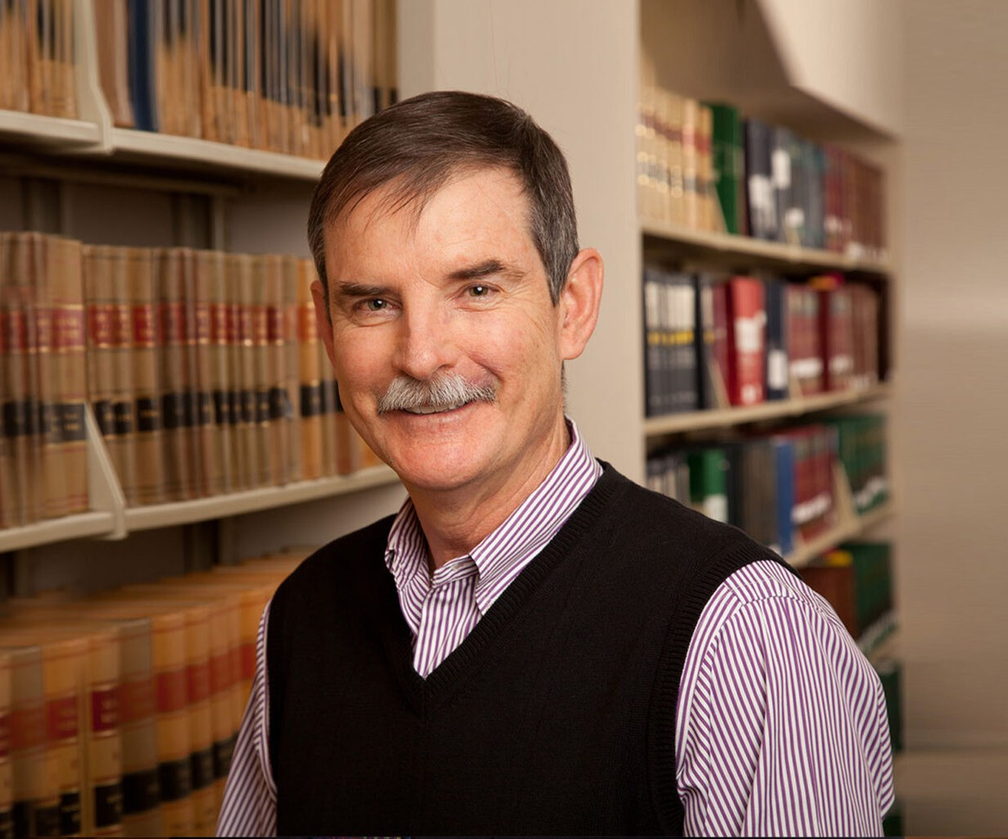

WILLIAM C. “DAVE” DAVIS JR.

Of Counsel

[Real Estate](https://www.fennemorelaw.com/services/real-estate/)

[Reno](https://www.fennemorelaw.com/contact-us/reno/)

P: 775.788.2270

F: 775.788.1177

[wdavis@fennemorelaw.com](mailto:wdavis@fennemorelaw.com)

Dave concentrates his practice in the area of commercial real estate, representing clients in all aspects, and renewable energy development and permitting. Representative clients include the [Juliet Companies, LLC](https://www.julietcompanies.com/), [Terra-Gen Power, LLC](https://www.terra-gen.com/) and [Invenergy](https://invenergyllc.com/). Dave served for many years as general outside real estate counsel for a publicly traded real estate investment trust in five Western states.

He enjoys finding practical and effective solutions to clients’ problems. When not working, Dave enjoys fishing and hiking in the Sierra.

# EDUCATION

J.D., University of Georgia School of Law, *cum laude*

M.Ed. University of Georgia

A.B. Georgia State University

# AREAS OF PRACTICE

OTHER EXPERIENCE

Aviation, Aerospace and Autonomous Systems Litigation

Real Estate Development and Financing Real Estate Litigation

Renewable Energy and Clean Tech Real Estate

Construction Law Natural Resources

# AWARDS AND HONORS

*Best Lawyers in America®,* Lawyer of the Year, Real Estate Law, 2025

*Best Lawyers in America®,* Lawyer of the Year, Construction Law, 2018 and 2024 *Best Lawyers in America®,* Construction Law, Real Estate Law, 2008-2025 *Chambers USA,* Leading Lawyers for Business, 2013-2014

*Mountain States Super Lawyers®,* Real Estate, 2007-2014

*Nevada’s Best Lawyers®,* 2013

AV® Preeminent™ Peer Review Rated (the highest rating available), by Martindale-Hubbell

# PROFESSIONAL AND COMMUNITY ACTIVITIES

CASA (Court Appointed Special Advocate) for displaced children, 2012-present Member, American Bar Association

Member, State Bar of Nevada Member, Clark County Bar Association

Member, Washoe County Bar Association

# ADMISSIONS

Nevada