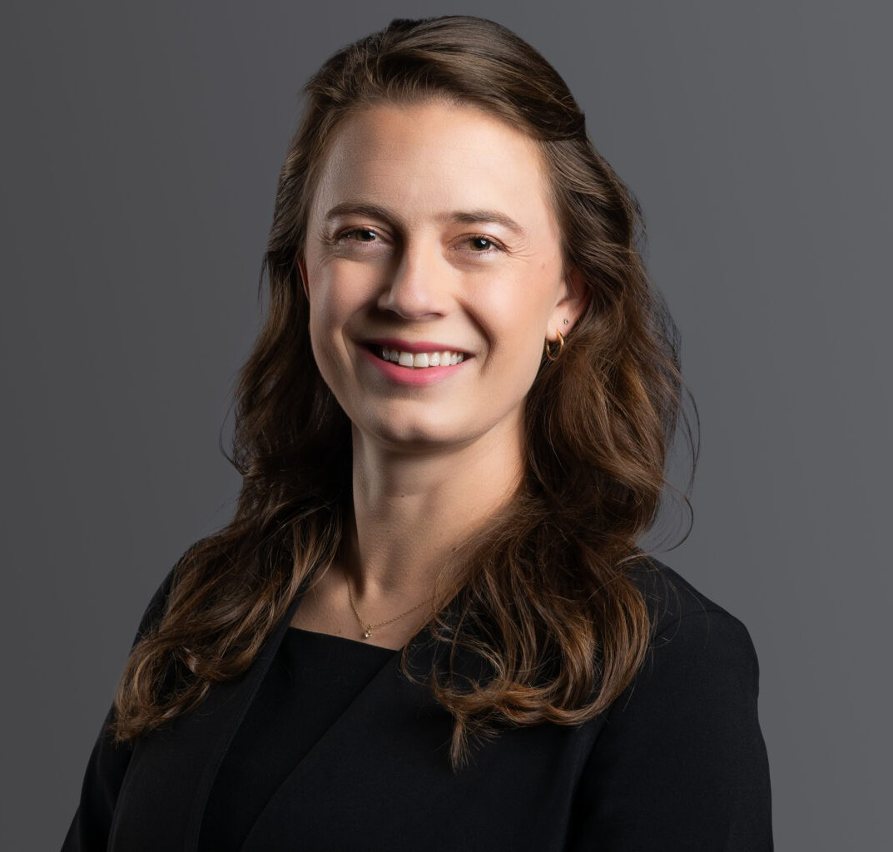

ALLISON M. HESTER

Associate

[Business Litigation](https://www.fennemorelaw.com/services/business-litigation/)

[Denver](https://www.fennemorelaw.com/contact-us/denver-2/)

P: 303.813.3829

F: 303.291.3201

[ahester@fennemorelaw.com](mailto:ahester@fennemorelaw.com)

# ALLISON M. HESTER

Allison is a member of the firm’s Business Litigation and Intellectual Property groups, focusing her practice on appellate advocacy, intellectual property law, and civil litigation.

Allison has drafted appeals and briefs for clients in multiple appellate courts in the state and federal system, including the Colorado Court of Appeals, the Colorado Supreme Court, the United States Court of Appeals for the Tenth Circuit, as well as submitting an amicus brief to the United State Supreme Court. In her appellate practice, Allison draws on her work experiences within appellate courts. She spent two years clerking for Chief Judge Steven Bernard of the

Colorado Court of Appeals, working directly with Judge Bernard on the drafting of appellate

opinions. In addition, Allison interned at the Colorado Supreme Court for then-Justice Allison Eid (now Judge Eid of the United States Court of Appeals for the Tenth Circuit).

Allison’s intellectual property practice focuses on trademark administration and litigation, protecting and prosecuting the intellectual property rights of clients before the United States Patent and Trademark Office and well as in civil litigation in the court system.

Allison also represents clients in civil litigation, focusing on complex motions within civil cases in trial courts and arbitrations. Allison supplements her experience representing clients with knowledge of the workings of trial courts in Colorado through her prior externship with Judge David Goldberg of the District Court for the City and County of Denver.

Allison is a native of Boulder, Colorado. In her spare time, Allison enjoys reading novels, hiking 14ers, and alpine skiing.

# EDUCATION

J.D., University of Colorado, Order of the Coif

B.A., Colgate University, High Honors-History, *magna cum laude*

# AREAS OF PRACTICE

Business Litigation Intellectual Property

# AWARDS AND HONORS

Best Lawyers® Ones to Watch®, Appellate Practice, 2023 – 2025

Best Lawyers® Ones to Watch®, Commercial Litigation, 2022 – 2025 Colorado Super Lawyers Rising Star, General Litigation, 2024

# ARTICLES AND PRESENTATIONS

Author, “You Ken Be Anything, Except Barbie,” Managing IP*,* October 2023 Author, “Queer Inclusivity in the Legal Field,” *Firm Blog,* June 2022

Co-Author, “Silver Linings Provide Optimistic Future for Litigation Post-Pandemic,”

*ColoradoBiz,*September 2021

Co-Author, “Moye White Attorneys Assist in Supreme Court Case,” *Firm Blog*, July 2020

Author, Maxwell, Lewis v. Clarke, and the Trail Around Tribal Sovereign Immunity 88 COLO. L. REV. Vol. 3, 2017

# ADMISSIONS

Colorado

U.S. District Court – District of Colorado 10th Circuit Court of Appeals