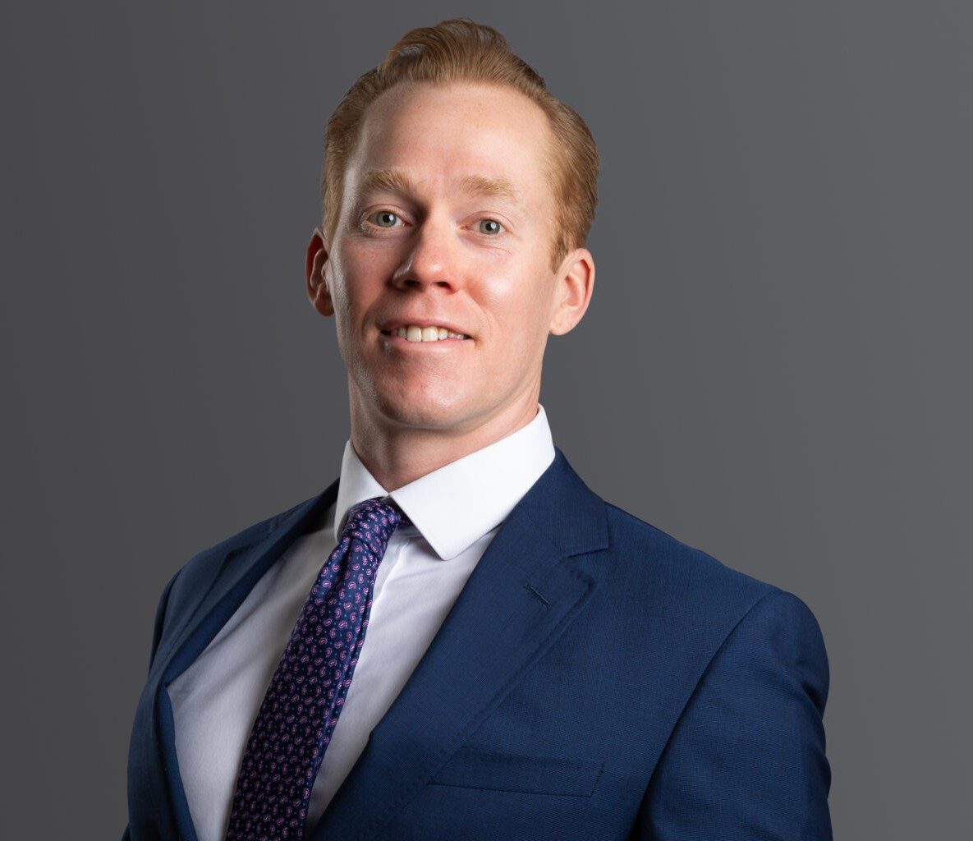

ANDREW T. FLYNN

Director

[Business Litigation](https://www.fennemorelaw.com/services/business-litigation/)

[Denver](https://www.fennemorelaw.com/contact-us/denver-2/)

P: 303.813.3817

F: 303.291.3201

[aflynn@fennemorelaw.com](mailto:aflynn@fennemorelaw.com)

# ANDREW T. FLYNN

Andrew is a director in the Business Litigation group and represents clients in a variety of commercial disputes. Andrew’s practice includes corporate and limited liability company

disputes, real estate disputes, title disputes, insurance coverage and recovery, and construction law. He has extensive deposition, mediation, and trial experience and has tried dozens of jury

trials, court trials, and arbitrations throughout Colorado. Although based in Colorado, Andrew has represented clients throughout the United States, including New York, Texas, California, and Pennsylvania, among others.

Andrew represents clients in state and federal courts, arbitrations, and bankruptcy adversary proceedings. An experienced trial attorney, Andrew represented a national property developer

in a dispute with another property developer in a multi-million dollar real estate deal. After a five- day court trial, Andrew’s client won specific performance of a contract for the sale of a valuable piece of real estate. He also represented an international automotive and trucking company in multiple lawsuits arising from a complex embezzlement scheme. The scheme resulted in two federal lawsuits, a state court lawsuit, and a bankruptcy adversary proceeding, in which Andrew recovered millions of dollars from various defendants for his client.

Andrew’s previous experience includes defending insurance companies and their policyholders from an array of claims. He now draws upon his extensive knowledge of the insurance industry to help corporate policyholders understand insurance coverage and maximize their recoveries. Additionally, Andrew also has experience bringing bad faith breach of insurance claims against insurance carriers.

Although his primary focus is litigation, Andrew also has experience in corporate transactions, including closing a stock redemption for a minority shareholder of a national food distribution company.

# EDUCATION

J.D., University of Denver

B.A., University of Nebraska

# AREAS OF PRACTICE

Business Litigation

# REPRESENTATIVE CASES

Tried and won an adversary proceeding in United States bankruptcy court for a four million dollar non-dischargeable judgement and award of attorney fees.

Tried and won a five-day court trial for specific performance of a multi-million dollar real estate contract.

First or second chair for thirteen jury trials and numerous court trials.

Second chair for a four day preliminary injunction hearing that tripled the settlement amount for the client in a limited liability company dispute.

Successfully moved to dismiss a lawsuit and won ensuing appeal for personal injury claim involving a nuanced statute of limitations argument.

Managed multiple related litigations for a large national automotive and truck dealership in Colorado State Court, Federal District Court, and Federal Bankruptcy Court.

Won voluntary dismissal of spurious lawsuits against business owners based on the Americans with Disabilities Act

# AWARDS AND HONORS

Benchmark Litigation, Future Star, 2020 2024

*Best Lawyers*®: Insurance Law, 2023-2025

*Best Lawyers® Ones to Watch*, Commercial Litigation and Insurance Law, 2022 and 2025

*Colorado Super Lawyer Rising Star*, General Litigation, 2018-2021

# PROFESSIONAL AND COMMUNITY AFFILIATIONS

Member, Colorado Bar Association Member, Denver Bar Association

Member, Colorado Defense Lawyers Association

# ADMISSIONS

Colorado

U.S. District Court – District of Colorado

U.S. Bankruptcy Court