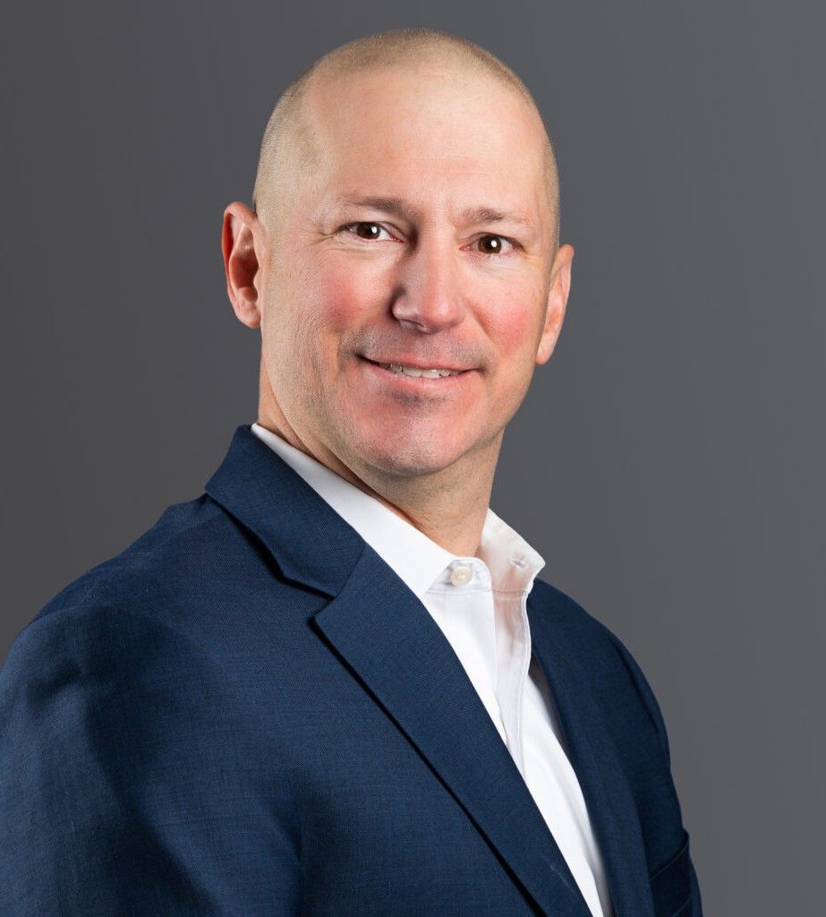

ARTHUR K. GRIFFIN

Director

[Real Estate](https://www.fennemorelaw.com/services/real-estate/)

[Denver](https://www.fennemorelaw.com/contact-us/denver-2/)

P: 303.813.3824

F: 303.291.3201

[Basalt](https://www.fennemorelaw.com/contact-us/basalt/)

P: 970.431.9060

F: 303.291.3201

[agriffin@fennemorelaw.com](mailto:agriffin@fennemorelaw.com)

# ARTHUR K. GRIFFIN

Art represents commercial real estate clients with acquisitions and dispositions, development,

lending, and land use matters, with extensive experience in each of the retail, industrial, office, and hospitality industries. Supplemented by his Master of Laws (LL.M.) in Taxation, Art’s real estate practice is enhanced by his corporate and tax background and he is adept at helping clients navigate complex regulatory matters.

In addition to his real estate practice, Art advises alcohol manufacturers, distributors, and retailers, including major casinos and nightclub operators, regarding federal and state

regulatory alcohol laws and liquor licensing matters. Art has experience resolving licensing and regulatory compliance matters with the Alcohol and Tobacco Tax and Trade Bureau, the

Colorado Department of Revenue – Liquor and Tobacco Enforcement Division, and various Colorado municipalities.

Early in his career, Art served as general counsel to a Denver-based multi-faceted real estate company where he oversaw high volumes of brokerage transactions, leasing matters, and finance arrangements. Prior to that, he worked in the Denver office of a national firm, where he focused on complex real estate transactions, leasing, and lending matters.

Outside of the office, Art enjoys spending time with his family skiing, fishing, and cooking. Art also enjoys recreational and competitive sailing and has sailed throughout the Gulf Coast,

Caribbean, Pacific Coast, and Mountain regions.

# EDUCATION

LL.M, University of Denver J.D., University of Denver B.A., Tulane University

# AREAS OF PRACTICE

Real Estate Advanced Energy Tax Law

# REPRESENTATIVE CASES

Extensive experience assisting clients with leasing matters at major retail shopping centers throughout Colorado and at regional and local shopping centers nationwide, as well as industrial and office leasing in Colorado and other markets.

Represented company in Downtown Denver ground leasing and in-fill projects.

Assisted client and its principals in the acquisition and financing of a major east coast casino in Atlantic City, New Jersey, and assumed lead role in leasing and licensing its six floors of

retail, restaurant, and entertainment venues.

Assisted a major distillery start-up venture advising on all legal concerns, including federal and state licensing and resolution of real property matters, and provided regulatory guidance on manufacturing and processing requirements, record keeping, taxation, “Tied House” and other trade practice/consumer protection provisions.

Assisted client with refinancing of mixed-use and office properties in downtown Denver, Colorado, which involved a $48,000,000 loan made by a life insurance company lender.

Assisted client with acquisition and $60,000,000 financing of multifamily property in Denver, Colorado.

Assisted client with the acquisition of major hotel property in Kauai, Hawaii.

Assisted a major health club client in its acquisition of a swim and tennis club in Manhattan Beach, California.

Assisted client with acquisition and $29,000,000 financing of multifamily property in Austin, Texas.

Assisted client with acquisition and financing of office property near 15th and Market Streets in Denver, Colorado.

Assisted client with acquisition and $81,000,000 financing of multifamily property in Denver, Colorado.

Assisted client with acquisition and $47,000,000 financing of multifamily property in Long Beach, California.

Assisted a major golf course operator and investment company in its acquisition of various established golf courses.

Assisted pro bono client in the corporate consolidation of three non-profit organizations focusing on at-risk and drug-endangered children.

# AWARDS AND HONORS

Best Lawyers® Ones to Watch: Real Estate Law, 2023 – 2024

Colorado Super Lawyer Rising Star: Real Estate, 2018, 2023 – 2024

# ARTICLES AND PRESENTATIONS

Presenter, “Tax Cuts and Jobs Act: Critical Provisions Non-Tax Attorneys Need to Know,” Colorado Bar Association, December 5, 2018

Presenter, “Taxation of Alcohol,” Colorado Bar Association

# PROFESSIONAL AND COMMUNITY AFFILIATIONS

Colorado Bar Association, Former Council Member, Section of Taxation, 2015-2018 Colorado Lawyers Committee

Denver Children’s Foundation, Legacy

Tulane Alumni Association of Colorado, Former President, 2011 – 2017 Urban Land Institute

# ADMISSIONS

Colorado Wyoming