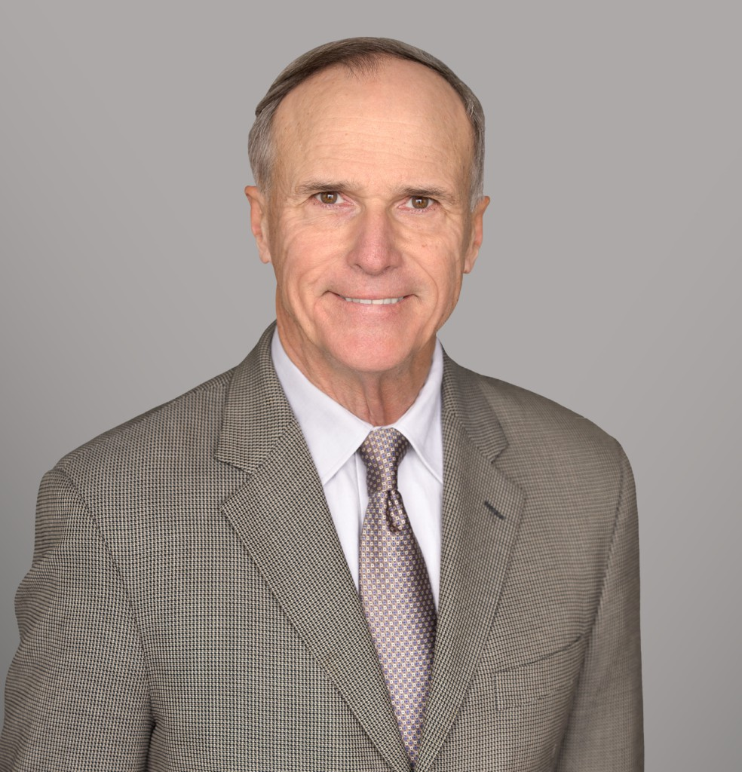

BELAN K. WAGNER

Director

[Business & Finance](https://www.fennemorelaw.com/services/business-and-finance/)

[Sacramento](https://www.fennemorelaw.com/contact-us/sacramento/)

P: 916.920.5286 F: 916.920.5286

[bwagner@fennemorelaw.com](mailto:bwagner@fennemorelaw.com)

# BELAN K. WAGNER

Belan Kirk Wagner is a taxation and transactional attorney, bringing counsel that navigates the intricacies of both realms with proficiency. With over 40 years of experience in business, taxation, real estate, estate planning, and controversy work, Belan has crafted a unique practice that offers a client-centric approach. This approach ensures each legal solution is as distinctive and personalized as the clients themselves, ranging from business owners and executives to individuals navigating today’s multifaceted legal system.

Belan’s practice goes beyond compliance; he creates a legal framework to safeguard his clients’ assets. He provides direct representation to clients while also serving as a resource to clients’ primary attorneys, accountants, financial advisers, and other representatives. His

knowledge is an advantage, offering proactive tax planning and transactional advice that is integrated to protect and maximize financial interests. Belan is a strategic attorney dedicated to your success.

# EDUCATION

LL. M., Taxation, University of Miami

J.D., University of the Pacific, McGeorge School of Law B.A., University of Santa Barbara, *magna cum laude*

# AREAS OF PRACTICE

OTHER EXPERIENCE

Estate and Generational Planning with Emphasis on Business Owners Mergers, Acquisitions and Business Sales

Partnership, LLC, Corporation and Business Entities Medical, Legal and Accounting Professional Entities Agricultural and Ranch Law

Business Controversies

General Counsel to Private Businesses Business & Finance

Mergers & Acquisitions Real Estate

Tax Law

Trusts & Estates Estate Planning

# PROFESSIONAL AND COMMUNITY ACTIVITIES

Adjunct Professor, University of the Pacific, McGeorge School of Law Adjunct Professor, Golden Gate University

Phi Beta Kappa

Member, Traynor Honor Society

Member, Sacramento County Bar Association Member, American Bar Association

Member, State Bar of California

Former Vice Chairman, Executive Committee on Taxation for the State Bar of California Member, Society of California Accountants

Member, Sacramento County Farm Bureau

Former Member and Editor, McGeorge Pacific Law Journal

# ADMISSIONS

California Certified Specialist, Taxation Law Supreme Court State of California

U.S. Tax Court

U.S. District Court, Eastern District of California

U.S. District Court, Northern District of California

U.S. Court of Appeals, 7th Circuit

U.S. Court of Appeals, 9th Circuit