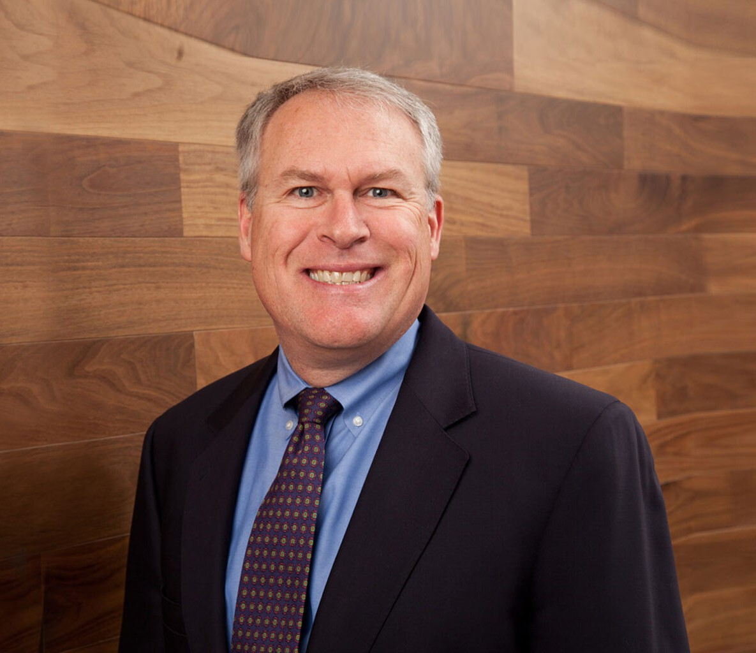

BRUCE E. DAHL

Director

[Intellectual Property](https://www.fennemorelaw.com/services/intellectual-property-and-ip-litigation/)

[Denver](https://www.fennemorelaw.com/contact-us/denver-2/)

P: 303.291.3205 F: 303.291.3201

[bdahl@fennemorelaw.com](mailto:bdahl@fennemorelaw.com)

“

Luck resides at the intersection of opportunity and preparation.

-Seneca

**BRUCE E. DAHL**

”

Bruce Dahl provides a full range of strategic intellectual property legal counseling to our clients. As an IP lawyer, his vast range of experience extends to U.S. and foreign patent prosecution,

patent infringement studies, design-around efforts and agreements relating to intellectual property. Over his career, Bruce has prosecuted patent applications in a wide range of technical fields, including materials science, optics, energy production, computers and

software, general mechanics and thermodynamics. He also represents clients in a wide array of industries, such as manufacturing, mining and film coating.

Blessed with endless curiosity for how things work, Bruce is perfectly suited for his role as a hybrid technologist-engineer lawyer. While he still loves writing and filing exquisite patent applications and distilling complex information as an advocacy tool for the advancement of sciences, Bruce truly relishes counseling clients on how to use IP to achieve their business goals. As an experienced patent lawyer, he truly believes a patent is a type of innovative tool, one that inventors can use both offensively and defensively to achieve their objectives and leverage their businesses.

Like all great engineers, away from the office, you will probably find Bruce in his garage

tinkering, woodworking, metalworking or firing up his fully restored 1965 Mustang that purrs with a sound and vibration that speaks to his heightened sense of sensory perception. A father to two boys and a girl, who are all musically inclined, Bruce recently helped one of his teenage sons create a new PA speaker cart (think angle iron and a welding torch), so new speakers could easily be carted on and off the football field for the marching band’s final performance of the

season. As an intellectual property attorney, he is just as resourceful and inventive as that example suggests.

# EDUCATION

J.D., University of Denver, Sturm College of Law

B.S., Aerospace Engineering, University of Colorado Associate Editor, *Transportation Law Journal,* 1987-1988

# AREAS OF PRACTICE

**OTHER EXPERIENCE**

Aviation, Aerospace and Autonomous Systems Intellectual Property

Business & Finance

Emerging Businesses & Technologies Mining Law

# AWARDS AND HONORS

*Best Lawyers in America®,* Copyright Law, Patent Law, Trade Secrets Law, Trademark Law, 2018-2025

Listed, IP Stars, *Managing Intellectual Property Magazine,* 2018-2020

*Benchmark Litigation,* Local Litigation Star, 2015

Listed, “Top 10 Business Newsmakers,” *Denver Business Journal,* 2014

*Benchmark Plaintiffs,* Local Litigation Star, 2012-2013

# ARTICLES AND PRESENTATIONS

Author, “Technology and intellectual property are the lifeblood of your company,” Denver Business Journal, June 2, 2022

[Interview, “Determine what is important to you and fully commit to making it a priority,”](https://www.fennemorelaw.com/determine-what-is-important-to-you-and-fully-commit-to-making-it-a-priority-2/) [Fennemore Blog, October 14, 2021](https://www.fennemorelaw.com/determine-what-is-important-to-you-and-fully-commit-to-making-it-a-priority-2/)

Quoted, “What’s next for Lululemon’s tech ambitions?” Retail Dive, June 14, 2021 Quoted, “What is a Patent Troll?” Yahoo! News, February 23, 2021

[Quoted, “Let’s Celebrate Random Acts of Kindness Day,” Fennemore Blog, February 18, 2021](https://www.fennemorelaw.com/insights/blogs/2021/let-s-celebrate-random-acts-of-kindness-day) Quoted, “Business Methods Still a Sore Spot,” *Law Week Colorado,* May 16, 2016

Speaker, “Patenting Your Research – The Hows and Whys,” University of Arizona, Tech Launch Arizona’s Lunch and Learn, April 2016

# PROFESSIONAL AND COMMUNITY ACTIVITIES

Board Member, CO-LABS, 2017-Current

Board Member, Colorado IP American Inn of Court, 2015-2017 Member, Denver Bar Association

Member, Colorado Bar Association

Member, American Intellectual Property Law Association

# ADMISSIONS

Colorado

U.S. District Court, District of Colorado

U.S. Court of Appeals, Tenth Circuit

U.S. Court of Appeals, Federal Circuit

Registered Patent Attorney U.S. Patent and Trademark Office