CLAUDINE LALONDE

Paralegal

[Business Litigation](https://www.fennemorelaw.com/services/business-litigation/)

# CLAUDIN“E LALONDE

[Fresno](https://www.fennemorelaw.com/contact-us/fresno/)

P: 559.432.4500 F: 559.432.4590

[clalonde@fennemorelaw.com](mailto:clalonde@fennemorelaw.com)

Be curious. Be present. Embrace uncertainty. - Anonymous ”

Claudine Lalonde is a paralegal for our firm, providing professional work product with attention to detail in a timely manner. She attended the City College of San Francisco, California, and received her Paralegal Certificate from Cañada College, in Redwood City, California. Claudine is a member of the Fresno County Legal Professionals Association, the Fresno County Women

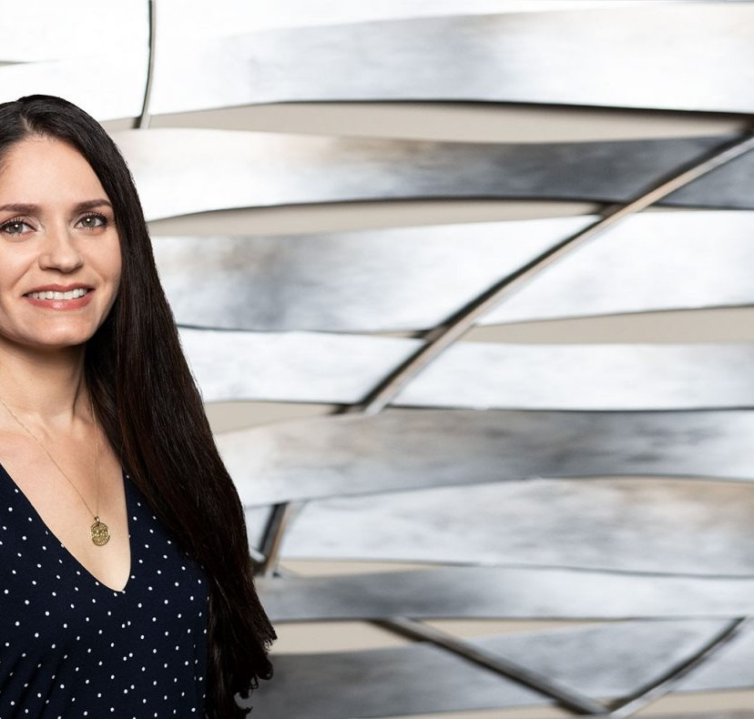

Lawyers, and a former member of the Central California Bankruptcy Association.

With a passion for helping people, Claudine began her legal career up in the Bay Area while working as a receptionist and filing clerk. She was amused by the legal papers she read, which inevitably ignited her curiosity in personal injury and family law matters, thus leading her on a path of redirecting her focus from architecture/interior design coursework to paralegal studies. She takes great pride in knowing that at the end of the day she can provide top-notch work and assurance in helping our clients with their legal needs.

Claudine recharges with anything involving being in nature. Exercise always helps boost her

mood, along with listening to high vibration music and podcasts on self-improvement, enjoying cultural foods and art, and spending time with like-minded people.

# EDUCATION

B.A., City College of San Francisco Paralegal Certification, Cañada College

# AREAS OF PRACTICE

Business Litigation Financial Restructuring

# PROFESSIONAL AND COMMUNITY ACTIVITIES

Member, Central California Bankruptcy Association

Fresno County Legal Professions Association, 2014-present Fresno County Women Lawyers, 2019-present

Central California Bankruptcy Association, 2018

# ADMISSIONS

*\*Not licensed to the practice of law*