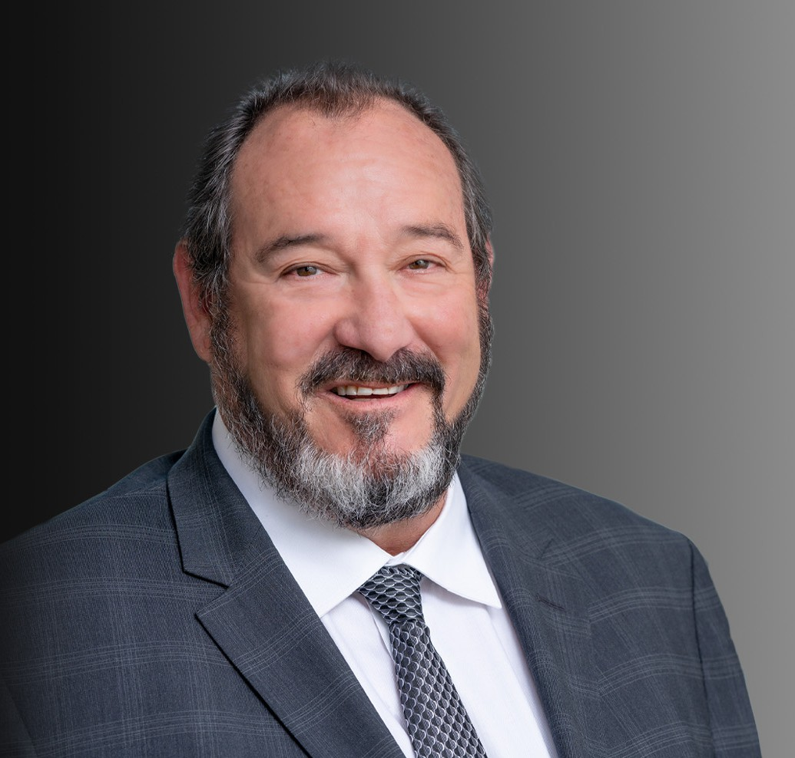

DANIEL RAPAPORT

Director

[Business Litigation](https://www.fennemorelaw.com/services/business-litigation/)

[Oakland](https://www.fennemorelaw.com/contact-us/oakland/)

P: 510.834.6600

F: 510.834.1928

[drapaport@fennemorelaw.com](mailto:drapaport@fennemorelaw.com)

“

Litigation is the pursuit of practical ends, not a game of chess.

- Felix Frankfurter

**DANIEL RAPAPORT**

”

As one of Fennemore’s senior litigators, Dan handles a wide array of complex business litigation, including unfair competition, trust and estate disputes, director and officer liability, and real estate disputes. He represents small and large companies, high net worth individuals, manufacturing concerns, distributors, real estate companies and public entities.

He is equally comfortable in the courtroom representing his clients’ interests or in the boardroom providing advice designed to avoid litigation. His ability to find creative resolutions of complex disputes often presents the best solution for clients.

## Litigation

Dan litigates in varied substantive areas. In the last ten years he has successfully represented bankruptcy trustees in actions against debtors, officers, directors and other professionals for misconduct. He has also represented manufacturing companies against entities who have damaged them through unfair competition, contract disputes, and trade secret theft. He is often called upon to represent shareholders, officers and directors of closely held agricultural, real estate, manufacturing and technology companies that have internal conflicts.

## Conflict Resolution

A stalwart problem solver, Dan focuses on efficient solutions and delivering results that impress his clients. He represents trustees, fiduciaries and beneficiaries of substantial estates and trusts in all types of fiduciary disputes. He represents public and private entities in contract disputes over real estate, construction, and general commercial operations. He also represents companies

that sell products to consumers, regarding Proposition 65 compliance matters.

# EDUCATION

J.D., University of California Davis School of Law B.A., University of California, Berkeley

# AREAS OF PRACTICE

**OTHER EXPERIENCE**

Proposition 65 Business Litigation

# REPRESENTATIVE MATTERS

Represent numerous companies that sell products to consumers regarding Proposition 65 compliance and defense of claims.

Represent numerous companies that manufacture regulated products for sale to consumers regarding advertising and regulatory compliance with California and federal law.

Represent public entities and private entities in contract disputes over real estate, land use, construction, general commercial operations and contracts of insurance.

Represent Trustees and personal representatives of beneficiaries of substantial estates in all types of fiduciary issue disputes.

Focus on problem solving rather than problem creation.

Often called upon to represent shareholders, officers and directors of closely held agricultural, real estate, manufacturing and technology companies that have internal conflicts.

Bankruptcy Trustees in actions against debtors, officers, directors and other professionals for misconduct.

Manufacturing Companies against entities who have damaged them through unfair competition, patent infringement, and trade secret theft.

# AWARDS AND HONORS

*Northern California Super Lawyers*®, 2004, 2009, 2012, 2013, and 2016 – 2018 AV® Preeminent™ Peer Review Rated by Martindale Hubbell

# ARTICLES AND PRESENTATIONS

Author, “The NFL Is Not A Sport, It’s A Business,” Daily Journal, December 2013

Author, “The Quest For Contractual Certainty,” Wendel Rosen Client Update, January 2013 Author, “Interfering With Inheritance,” WealthManagement.com, August 2012

# PROFESSIONAL AND COMMUNITY ACTIVITIES

Judge Pro Tempore, San Francisco Superior Court

Member, Settlement Conference Commissioner, Volunteer Settlement Project, San Francisco Superior Court

Arbitrator, Marin County Superior Court Delegate, State Bar of California

Member, Committee on Administration of Justice, State Bar of California Member, Bar Association of San Francisco

Member, Alameda County Bar Association

# ADMISSIONS

California

All State and Federal Courts in the State of California