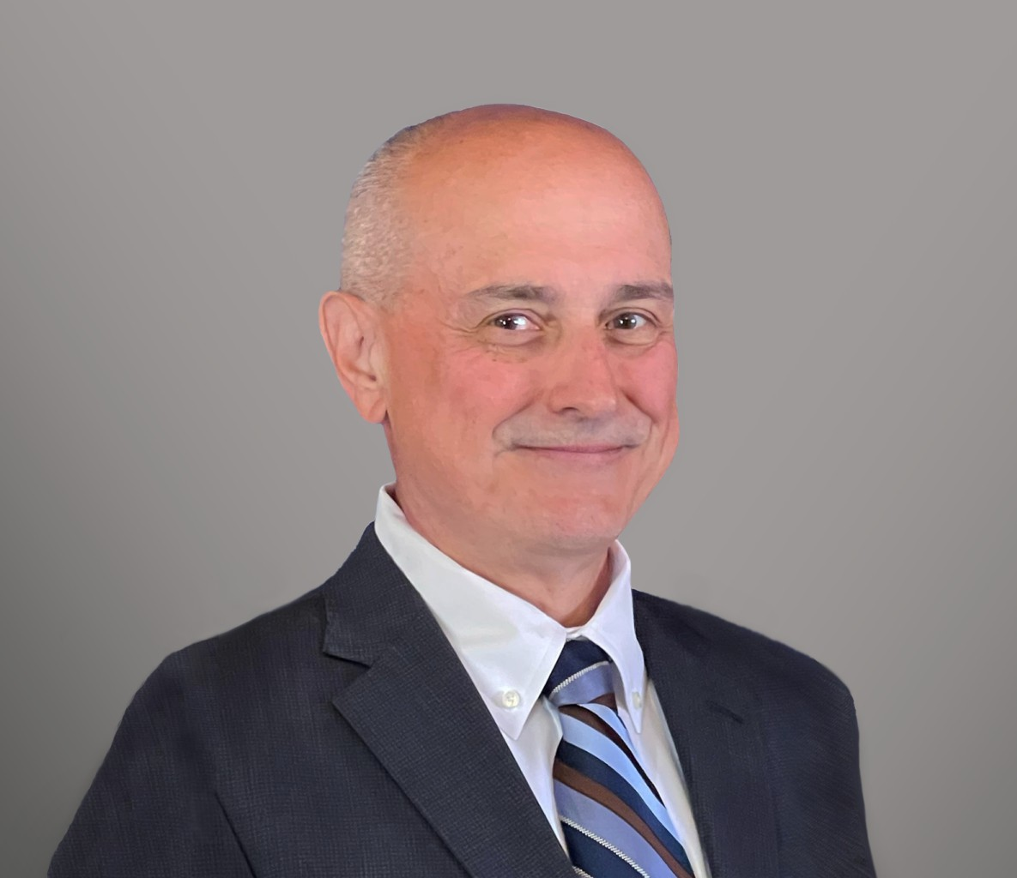

DEREK J. PFAFF

Director

[Real Estate](https://www.fennemorelaw.com/services/real-estate/)

[Fennemore Forward](https://www.fennemorelaw.com/contact-us/fennemore-forward/)

P: 602.916.5398 F: 602.916.5598

[dpfaff@fennemorelaw.com](mailto:dpfaff@fennemorelaw.com)

**DEREK J. PFAFF**

Derek is a real estate attorney focusing on matters including acquisitions and dispositions of improved and unimproved commercial properties as well as farm and ranch properties, shopping center development, commercial leasing, and real estate finance. He handles conventional real estate lending, loan work-outs and mezzanine loan transactions. Derek’s experience includes projects involving public transit facilities, utilities and condemnation.

Derek also works on the real estate aspects of renewable energy projects, specifically solar and wind, including site acquisition and leasing. He is adept at drafting and negotiating purchase agreements, leases, easements, surface waivers and drill site agreements that limit or prevent disturbance by oil, gas and mineral-related activities. Derek works closely with clients to identify and resolve title, survey and other land-related issues, and is able to anticipate the expectations of tax equity and other investors concerning these matters.

Derek spends his free time with his family, hiking, biking and fishing.

# EDUCATION

J.D., University of Arizona, James E. Rogers College of Law, *summa cum laude*

B.A., University of Arizona, *magna cum laude*

# AREAS OF PRACTICE

OTHER EXPERIENCE

Renewable Energy and Clean Tech Real Estate

Advanced Energy

# REPRESENTATIVE CASES

Representation of a private renewable energy company in the acquisition, development and disposition of solar projects in Arizona, California, Idaho and Indiana totaling nearly 300 MW of capacity.

Representation of a publically traded energy company in the acquisition and development of a 14 MW solar project in Texas.

Representation of a private renewable energy company in the acquisition and development of wind farms in Texas.

Development of a natural gas to methanol facility in Louisiana.

Site acquisition and evaluation of mineral rights and entitlements for an 11,000-acre master- planned residential development for a national developer.

Representation of clients in identifying and resolving potential conflicts between surface and mineral estates, and preparation and negotiation of surface use agreements.

Representation of the purchaser of a majority interest in the entities that owned The

Woodlands, a 28,000-acre master-planned community located north of Houston, Texas.

Representation of an international retailer in acquiring and developing store sites throughout Texas, plus representation concerning disputes involving construction, real estate

development, and landlord/tenant issues.

Representation of real estate investment management firm in the acquisition of a 560,000 square foot mixed-use project in Dallas, Texas.

Counsel to a national bank on a series of revolving credit and term loans totaling $53 million to a privately owned motor fuel distributor.

Represented a municipal power agency in connection with the acquisition of easements required for the construction of electric power lines, and various water authorities and municipal utility districts in connection with the acquisition of easements for water lines and drainage facilities.

Represented various large pipeline companies in connection with right-of-way acquisitions.

Representation of owners of a Nevada company in the sale of $170 million in equipment and other hard assets.

# AWARDS AND HONORS

*Best Lawyers in America®,* Real Estate Law, 2023-2025

*Best Lawyers in America®,* Energy Law and Project Finance Law, 2025

# ARTICLES AND PRESENTATIONS

Panelist, “Responding to COVID-19: The Impact of Remote Work on Attorneys,” *Law Technology Today*, March 30, 2020

Author, “A Potential Solution to Short-Term Rentals,” *Daily Journal,* February 26, 2018

[Author, “A Potential Solution to Short-Term Rentals,”](https://realestatedaily-news.com/potential-solution-short-term-rentals/) [*Real Estate Daily News and RED Comps*,](https://realestatedaily-news.com/potential-solution-short-term-rentals/) [February 15, 2018](https://realestatedaily-news.com/potential-solution-short-term-rentals/)

# PROFESSIONAL AND COMMUNITY ACTIVITIES

Member, State Bar of Arizona Member, State Bar of Texas Member, State Bar of Nevada

Councilman, Sedona City Council, 2024-present

Appointed Member, Sedona Historic Preservation Commission, 2016-2022

# ADMISSIONS

Arizona Nevada Texas