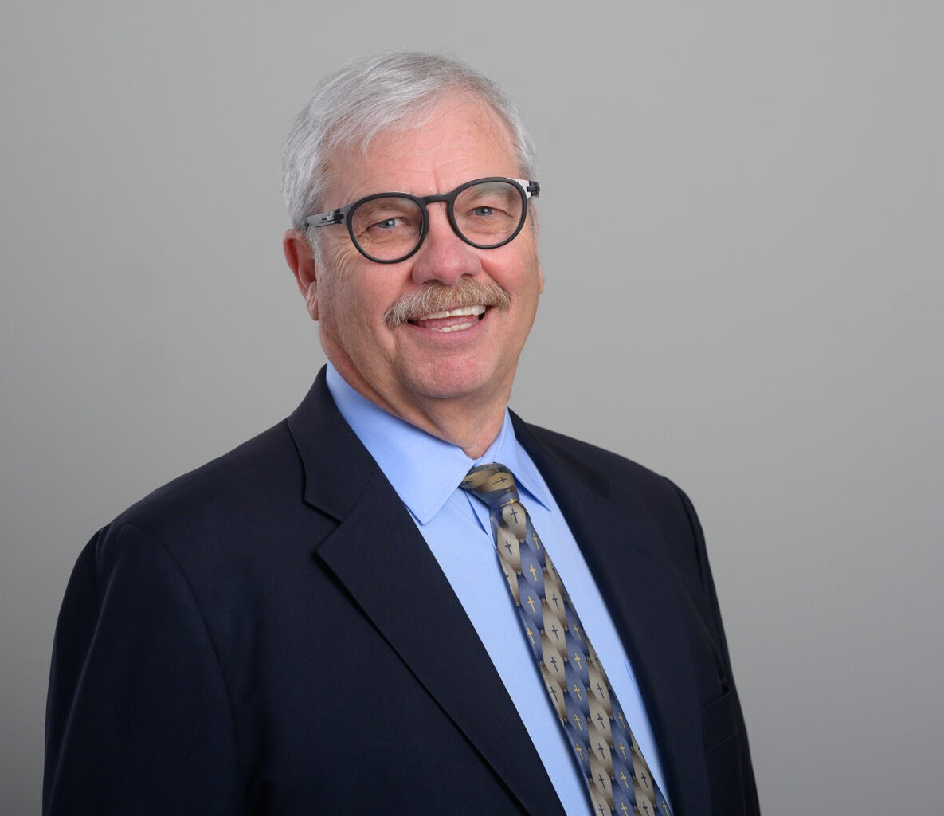

DONALD G. REZ

Director

[Business Litigation](https://www.fennemorelaw.com/services/business-litigation/)

[San Diego](https://www.fennemorelaw.com/contact-us/san-diego/)

P: 619.595.3239

F: 619.231.4372

[drez@fennemorelaw.com](mailto:drez@fennemorelaw.com)

“

Do justice, love goodness, and walk humbly with God.

Micah 6:8

**DONALD G. REZ**

”

Donald G. Rez focuses on business and commercial litigation, antitrust, and trade regulation, demonstrating a commitment to strategic dispute resolution and effective client

communication. His practice covers various commercial lawsuits, including antitrust, breach of contract, franchisor/franchisee issues, lender liability, professional malpractice, and intellectual property including cases with the bankruptcy court. He adeptly handles complex multi-district litigation and a broad spectrum of antitrust claims.

Representing diverse clients, from sports teams like the Former San Diego Clippers to major corporations such as Exxon to local companies such as Blue Tech, Inc. and court-ordered receiver and trustees. Donald’s representation was notably commended by a U.S. District Court Judge in the approval of a significant antitrust class action settlement, (“The quality of representation in this matter was exceptional”) showcasing his skill in delivering results and maintaining strong and professional client relationships.

# EDUCATION

J.D., Harvard Law School, *cum laude*

B.A., University of Texas, Highest Honors

# AREAS OF PRACTICE

Business Litigation Professional Liability

# AWARDS AND HONORS

Mr. Rez has an AV® Preeminent™ Peer Review Rating by Martindale-Hubbell which he has held for more than 30 years. He was selected by his peers for inclusion in the 24th, 25th, 26th, 27th,

28th, 29th and 30th edition of Best Lawyers in America® in the field of Commercial Litigation. He has also been recognized as a San Diego “Top Lawyer,” “Super Lawyer,” and was recognized in the top 1% of The American Registry, “Best of the Best.” In addition, he was recognized by the Martindale-Hubbell Peer Review for achieving highest level of professional excellence.

# ARTICLES AND PRESENTATION

[California Pretrial Practice & Forms](https://jamespublishing.com/), Kane & Rez, James Publishing Company, 2003 updated 2004-2017

Presenter, “[California’s Prohibition Against Non-Compete Agreements (B&P Code § 16600),](https://protect-us.mimecast.com/s/fOjxCR68kKuRjKBJc9_0oN?domain=sullivanhill.com) [the Protection of Trade Secrets and the Practical Relationship Between the Two,](https://protect-us.mimecast.com/s/fOjxCR68kKuRjKBJc9_0oN?domain=sullivanhill.com)” Sullivan Hill Rez and Engel CLE Seminar (September 2022); Meritas Capability Webinar Series, San Diego, April 2015, and California Western School of Law, Business Law Society, March 2015

Presenter, “eDiscovery Essentials,” Network Deposition Services Inc., San Diego, May 2014.

Co-Presenter (with Judge Meyers), “Recent Developments in California Civil Procedure,” San Diego County Bar Association (Civil Litigation Section), April 2014

Presenter, Webinar, “What Works Well in Mediation?” San Diego County Bar Association (Civil Litigation Section), November 2013

Presenter, “Recent Developments in California Civil Procedure,” San Diego County Bar Association Civil Litigation Section, March 2013

Presenter, “Everything You Need to Know: Motion for Summary Judgment,” San Diego County Bar Association (Civil Litigation Section), April 2012

Presenter, “The Art of the Deposition: Deposition Procedure,” Veritext San Diego, February 2012.

Presenter, “E-Discovery in the Mobile Age,” Veritext San Diego, August 2011

Presenter in Southern California seminar series entitled “Foreclosure Prevention & Debt Relief for Lawyers”

Lecturer, “E-Discovery Under the New Federal Rules of Civil Procedure,” Meritas Litigation Section Meeting, 2006

Faculty, Developing Deposition Skills, National Institute of Trial Advocacy NITA, 1999 Adjunct Professor of Law, Pretrial Procedures, California Western School of Law, 1984 Guest Lecturer, Antitrust Law Seminar, University of San Diego, 1999

Lecturer Business Litigation in the 1990’s – Tactics and Techniques, San Diego County Bar Association – Section on General Civil Litigation, 1989

Lecturer, Use of Videotaped Depositions, California Continuing Education of the Bar, 1982 Antitrust Law Journal National Institute Ed., Co-editor, American Bar Association 1981-1984

Antitrust Trade Regulation: Developments Relating to Franchising Sullivan & Rez, ABA Forum Committee on Franchising 1983

Let’s Get Rid of Big Cases Sullivan & Rez, 7 Litigation Nos. 4, p.8, Summer 1981

Antitrust Discovery Handbook and Supplement (Fraudulent Concealment and Sanctions) Contributor, ABA Antitrust Section (1980)

Causation and Automatic Damages in Secondary-Line Cases Under Section 2a of the Robinson-Patman Act: Is Fowler v. Gorlich Dead?, 55 Notre Dame Lawyer 660 1980

Lecturer, Practicum, Federal Practice Institute, California Continuing Education of the Bar, 1979

# PROFESSIONAL AND COMMUNITY ACTIVITIES

Member, San Diego County Bar Association, Civil Litigation Section Editor, Harvard Environmental Law Review

U.S. District Court for the Southern District of California Lawyer Representatives to the Ninth Circuit Judicial Conference

Executive Committee, Harvard Law School Association of San Diego. Board of Visitors, University of San Diego School of Law

Board of Trustees, John Paul the Great Catholic University. Past president, Thomas More Society of San Diego

Knight of the Equestrian Order of the Holy Sepulchre of Jerusalem

Co-chair, 2015 Annual Meeting for the Western Lieutenancy in San Diego Coordinator, Mercy for the EOHSJ in San Diego

Member, Parish and Finance Councils at Our Lady of Refuge Roman Catholic Church Diocesian Pastoral Council for the Diocese of San Diego, 2002-2004

Board of directors of Catholic Exchange

Past president, San Diego Chapter of Legatus, 2012-2014

Co-chair, Friends of the Poor-Nigeria Fundraiser for Bishops Anthony Adaju and Martin Uzoukwu in August 2015

Communion service, Wesley Palms Retirement Home

# ADMISSIONS

California