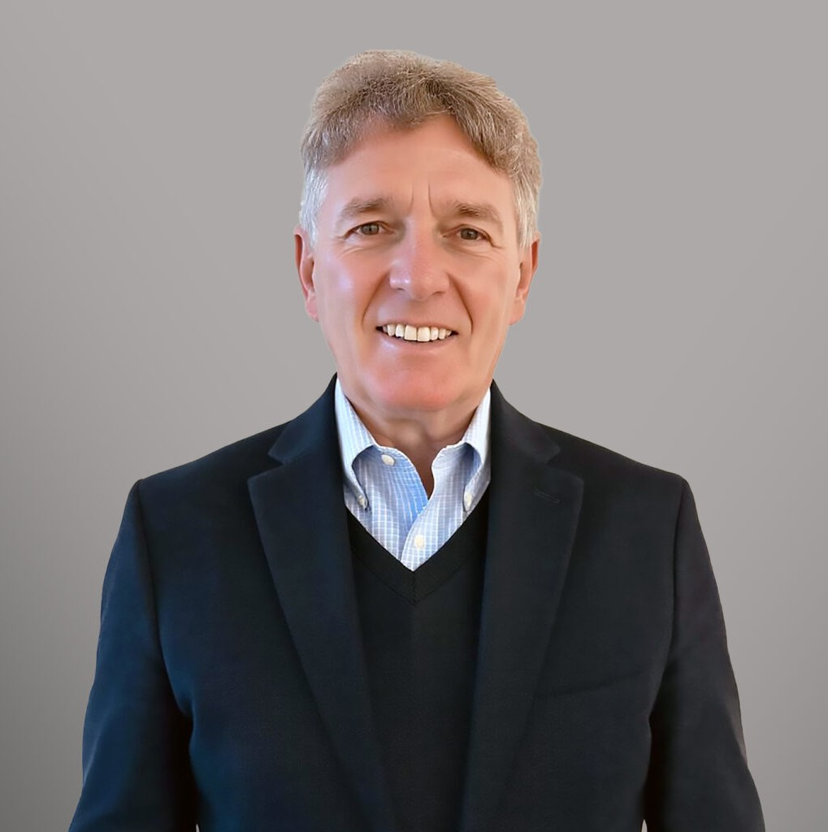

DOUGLAS R. TUELLER

Director of Fennemore Forward

[Real Estate](https://www.fennemorelaw.com/services/real-estate/)

[Fennemore Forward](https://www.fennemorelaw.com/contact-us/fennemore-forward/)

P: 970.708.4045

[dtueller@fennemorelaw.com](mailto:dtueller@fennemorelaw.com)

# DOUGLAS R. TUELLER

Douglas R. Tueller is a Director in Fennemore’s [Real Estate](https://www.fennemorelaw.com/services/real-estate/) practice group. With a distinguished career spanning over four decades, Doug has been a key advisor and participant in business ventures both domestically and internationally.

Doug’s extensive experience includes significant roles in entrepreneurial ventures and senior management positions, including general counsel roles for privately held real estate

development and investment firms. His portfolio includes a diverse range of projects from small residential associations to complex mixed-use commercial, residential, and retail developments across the Western United States. Before joining Fennemore, Doug held prominent positions in leading law firms in California and Colorado and served as special counsel for The Disney Store Group during its initial international expansion period. He commenced practice in Telluride in

1993 and since has operated as both a founding partner of Tueller Law PC and Tueller Gibbs Dye (with offices also in Denver).

In addition to his legal practice, Doug has been actively involved in numerous non-profit

organizations, both internationally and in California, Nevada, and Colorado. His leadership roles include chairing the Rotary International Post-Graduate Fellowship program in Colorado for over a decade and leading the Colorado statewide Rotary District Scholarship Committee since the early 1990s. He was elected chairman of the Telluride Rotary Foundation in 2014 and has served in connection with the Colorado Bar Association Real Estate Section Committee since 2016.

Doug also played a pivotal role in the formation of the Town of Mountain Village near Telluride in the early 1990s.

Currently, Doug serves as general counsel for the Just for Kids Foundation, the Pinhead Institute, Telluride Arts, Mountains to Desert, and the Lone Tree Cemetery in Telluride. His contributions to education include over a decade of service on various committees within the Telluride R-1 School District from the early 1990s to mid-2000s.

Doug’s academic background involved undergraduate studies at the University of Southern California and University of Vienna, law studies at Stanford Law School and University of Hamburg, Germany, as well as research at the Max Planck Institute in Hamburg, Germany as a Rotary Ambassadorial Fellow.

# EDUCATION

J.D., Stanford Law School

A.B., *magna cum laude,* University of Southern California

Guest Scholar, Max Planck Institute for International and Comparative Law, Hamburg, Germany

Rotary Foundation International Graduate Fellow Translation and Related Studies, University of Vienna

# AREAS OF PRACTICE

Real Estate

# BUSINESS MANAGEMENT

Director and Executive Vice-President and General Counsel of McKellar Development Group, Las Vegas, Nevada

Founder, Vice-President and General Counsel, Real Asset Management, Chicago, Illinois and Las Vegas, Nevada

Legal Counsel, The Disney Stores, Inc., Glendale, California

Chief Operating Officer and General Counsel of Carstens Development, Telluride, CO

# AWARDS AND HONORS

Recipient of District Global Alumni Service Awards 2004-2006, Rotary District 5470 Carl Mason Award for Outstanding International Law Work

Finalist for the Business for the Arts Award with the Colorado Business Council for the Arts

# PROFESSIONAL AND COMMUNITY AFFILIATIONS

L.B.J. Congressional Intern, Washington, D.C. International Volunteer, Kibbutz Lahav, Israel

Nevada Foreign Trade Zone, Person-to-Poland Aid Effort, Nevada Zoological Society, Stanford-U.N.L.V. Symposium on Art and The Law, Las Vegas, Nevada

German-American Chamber of Commerce, Japan America Society, AIDS Hospice, Los Angeles, California

Organizing Member, Town of Mountain Village Home Charter Drafting Committee and Election Commission

Town of Mountain Village Councilman

Chairman of Rotary Foundation District 5470 Scholarship Committee – Colorado, Telluride Rotary Club Scholarship Committee and Telluride Rotary Foundation

Founder/Legal Counsel for The Pinhead Institute (a Smithsonian Institute Affiliate), Just For Kids Foundation, Mountains-to-Desert Bike Ride, Telluride, Colorado

Legal Counsel for Telluride Science and Research Center, Ah Haa School for the Arts, Telluride Council for the Arts and Humanities, Telluride Tech Festival and Telluride Gay Ski Week,

Telluride, Colorado

Moderator for various Town of Telluride Election-and Participant in Valley Floor Condemnation Public Debates

# ARTICLES AND PRESENTATIONS

Author, “Buyers and Brokers Beware: The Contract-Deeding Trap for the Unwary,” The Colorado Lawyer, March 2016

Author, “Reporting and Disclosure Requirements for the Foreign Investor in U.S. Real Estate,” Foreign Direct Investment in the U.S., Sweet & Maxwell, 1993, also in French, German, Italian and Spanish

Author, “Reaching and Applying Foreign Law in West Germany: A Systemic Study,” Stanford Journal of International Law, Vol. 19, Spring 1983. Used as materials in a course on the West German Legal System at the University of Chicago Law School

Author, “Problems of Arbitration of International Contract Disputes and Recognition and Enforcement of Foreign Judgments in the Federal Republic of Germany: A Recent Decision of the Bundesgerichtshof.” Stanford Journal of International Law, Vol. 17, Spring 1981

Translated, Wolfgang Hoffman-Riem, “The Freedom of Communications and the Future of Broadcasting in West Germany.” Translated into English from German for publication in Studies in Broadcasting, Nov. 17, 1981, Nippon Hoso Kyokai, Japan

Translated, Manfred Rehbinder, Rechtssoziologie, de Gruyter, 1978. Translated into English for publication in the U.S., 1981-1982

# ADMISSIONS

California Colorado

# LANGUAGES

German