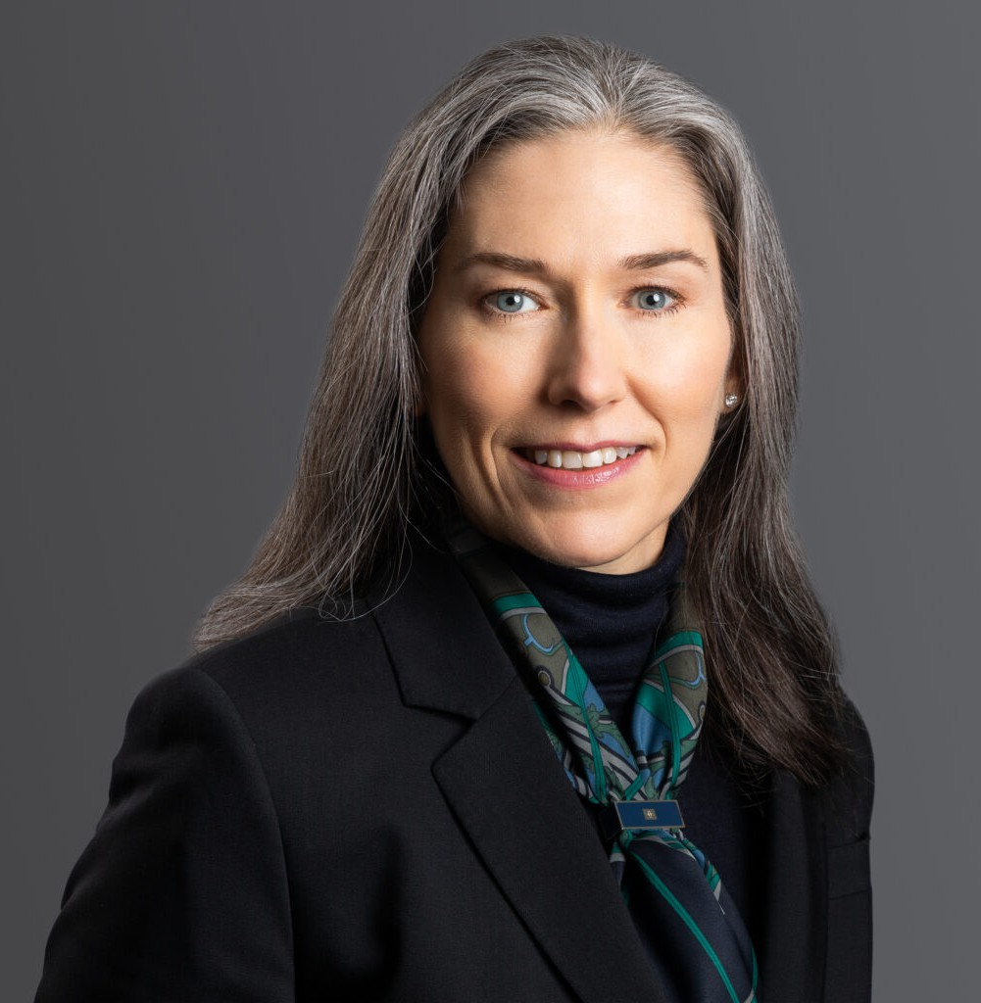

HEIDI J. GASSMAN

Pronouns: she/her

Director

[Trusts & Estates](https://www.fennemorelaw.com/services/trusts-estates/)

[Denver](https://www.fennemorelaw.com/contact-us/denver-2/)

P: 303.813.3821

F: 303.291.3201

[hgassman@fennemorelaw.com](mailto:hgassman@fennemorelaw.com)

# HEIDI J. GASSMAN

Heidi uses her life experience to bring a practical and relatable approach to her estate planning practice. She advises clients on a wide variety of estate planning matters, including estate and

trust administration and pre and post-marital agreements. Additionally, Heidi has experience with real property, business and entity formation and general consultation, and commercial leases and contracts.

Heidi is a member of the Orange Book Forms Committee and the Real Estate Title Standards Committee of the Colorado Bar Association. She has presented multiple seminars on estate planning and probate to businesses and social groups, and teaches continuing education courses for legal and financial professionals on estate planning, probate, trust administration, real property, and business law. Heidi is licensed to practice in Colorado and Washington states, as well as multiple federal jurisdictions.

*“I have worked as a wealth manager and financial advisor for over 20 years and have made it a part of my practice to provide technical expertise, sage advice, and compassionate understanding to my clients. In that time, I have worked with a number of legal professionals*

*who have one or perhaps two of these traits. In working with Moye White, and specifically Heidi Gassman, I have finally found a firm and attorney who embraces this approach. My clients have provided nothing but glowing compliments and an appreciation for the professional and personalized attention they have receive at Moye White.”* – Market Commentator

In her spare time, Heidi enjoys hiking, reading, and spending time with her family.

# EDUCATION

J.D., Seattle University

B.A., University of Washington

# AREAS OF PRACTICE

Trusts & Estates Estate Litigation

Family Office & Private Client Attorneys Real Estate

Tax Law

Estate Planning

# AWARDS AND HONORS

*Best Lawyers*®: Real Estate Law and Trusts and Estates Law, 2022-2025 Colorado Super Lawyer: Estate and Probate, 2024

*Law Week Colorado* People’s Choice “Barrister’s Best” Trust & Estates Lawyer 2021

# ARTICLES AND PRESENTATIONS

Presenter, “Advising Clients on Charitable Gifts of Real Estate,” The Denver Foundation – CLE presentation, 2024

Guest Speaker, “Estate planning issues for seniors”, KOSI 101.1, No Copay Radio, 2024

Co-Author, “Chapter 23, Testamentary Trusts,” *Colorado Estate Planning Handbook: 2023 Updates*, October 2023

Quoted, “Qualified Charitable Distributions – Useful tools for professional advisors,” The Denver Foundation, March 2023

Author, “The New Corporate Transparency Act – What All Business Owners Need to Know,”

*Law Week Colorado*, December 2021

Co-Author, “Proposed Changes to the Federal Tax Law and Their Potential Impact on Existing Estate Plans,” *Firm Blog*, October 2021

Author, “How President Biden’s tax proposal could impact businesses,” *ColoradoBiz*, September 2021

Panelist, “Advising Clients on Charitable Gifts of Real Estate,” The Denver Foundation, February 2024

Co-Presenter, “Oh, No, You Deedn’t – The Real State of Real Estate Fraud in Decedent Estates,” Colorado Bar Association Estate Planning Retreat, June 2023

Presenter, “Real Estate and Wealth Transfer Planning,” Women’s Estate Planning Council, November 2022

Co-Presenter, “Haunted Houses: The Intersection of Estates and Real Property,” El Paso County Bar Association – Probate Section Conference, November 2022

Co-Presenter, “Current Landscape for Trustees,” 42nd Annual Estate Planning Retreat – CBA- CLE, June 2022

Co-Presenter, “2021 Real Estate and Tax Discussion,” The Corundum Group Webinar, November 2021

Presenter, “The Confluence of Trust and Estate and Real Estate Law and Practice,” 39th Annual Estate Planning Retreat – CBA-CLE, 2019

Presenter, “The Spousal Elective Share,” Probate Boot Camp – NBI, 2019

Presenter, “Probating Estates That Include a Business,” Probate Boot Camp – NBI, 2019

Presenter, “Post-Mortem Planning, Trust Administration, and Tax Hurdles,” Probate Boot Camp – NBI, 2019

Presenter, “Basic Tax Planning and Updates; Planning for Unmarried and Remarried Couples, Estate Planning from A to Z,” National Business Institute, 2018

Panelist, “Top Tips and Tricks for Using Orange Book Forms, Orange Book Forms: Colorado Estate Planning Forms,” Colorado Bar Association CLE, 2017

Presenter, “Probating Estates That Include a Business and Spousal Elective Share,” Probate Boot Camp, National Business Institute, 2015

Presenter, “Dispute Resolution,” Construction Law for Public Projects – HalfMoon Education, 2014

Presenter, “Contractual and Statutory Duties of Design Professionals and Contractors in Green Construction,” Construction Law Seminar – HalfMoon Education, 2013

Presenter, “Design Ethics,” AIA Seattle Continuing Education Conference, 2f007

Presenter, “Washington’s Condo Law – One Year Later,” AIA Seattle Continuing Education Conference, 2007

Presenter, “Copyright Law for Design Professionals,” AIA Seattle Continuing Education Conference, 2006

# PROFESSIONAL AND COMMUNITY AFFILIATIONS

American Institute of Architects, Former Individual Allied Member; Former Co-Chair, Practice and Ethics Committee

Colorado Bar Association Real Estate Law Section, Real Estate Title Standards Committee, Member

Colorado Bar Association Trust & Estate Section, Former Chair of the Orange Book Committee Denver Bar Association

Denver Estate Planning Council

King County Bar Association, Former Member, Former Volunteer Attorneys for Persons With AIDS/Volunteer Legal Services (2002-2012)

Rocky Mountain Estate Planning Council

The Denver Foundation’s Professional Advisory Council, Member Washington State Bar Association

Washington State Department of Licensing, Former Certified Real Estate Instructor Yoga Behind Bars, Former Board of Directors

# ADMISSIONS

Colorado Washington

U.S. Court of Appeals for the Ninth Circuit

U.S. District Court – District of Colorado

U.S. District Court – Eastern District of Washington

U.S. District Court – Western District of Washington