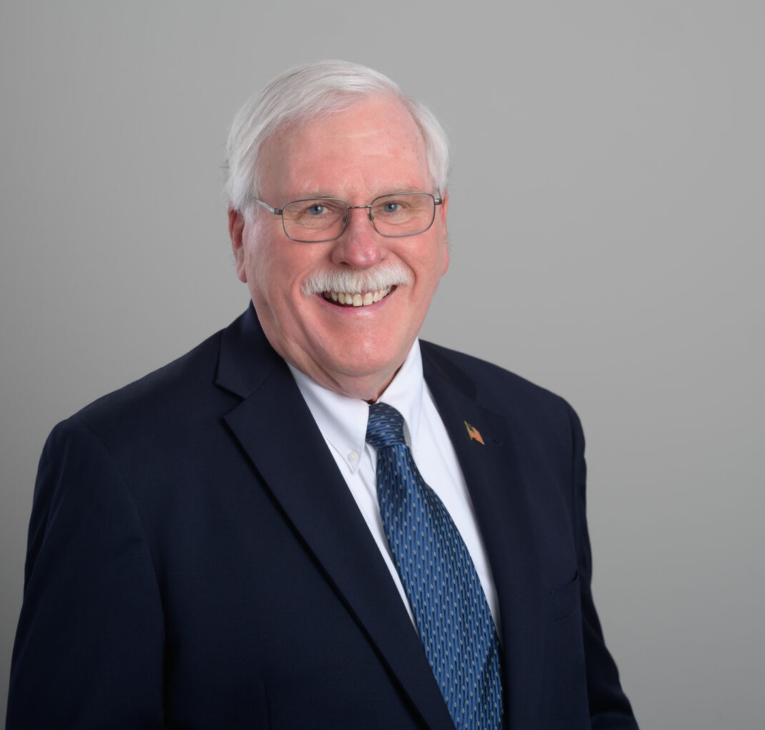

JAMES E. DRUMMOND

Of Counsel

[Business Litigation](https://www.fennemorelaw.com/services/business-litigation/)

[San Diego](https://www.fennemorelaw.com/contact-us/san-diego/)

P: 619.595.3264

F: 619.231.4372

[jdrummond@fennemorelaw.com](mailto:jdrummond@fennemorelaw.com)

# JAMES E. DRUMMOND

James E. Drummond is a construction law attorney adept in contract negotiation, construction financing, and dispute resolution during the construction process. His practice includes litigation of contract and defect claims, representing a diverse clientele such as owners, architects,

contractors, and suppliers in both private and public sectors.

James provides ‘real time’ legal advice to project managers and field staff, ensuring smooth construction operations. He also assists contractors with surety work-outs, demonstrating his proficiency in complex construction-related matters. Beyond construction law, his knowledge extends to business formation, real estate, and financial institution services, showcasing his versatile legal skills.

# EDUCATION

J.D., Stanford University Law School

B.A., University of Illinois at Champaign-Urbana (with Honors)

# AREAS OF PRACTICE

Business Litigation Construction Law Real Estate

# AWARDS AND HONORS

AV® Preeminent™ Peer Review Rating by Martindale-Hubbell Top San Diego Lawyer by San Diego Magazine, 2015-2023 San Diego Super Lawyer, Construction Litigation

# PROFESSIONAL AND COMMUNITY ACTIVITIES

Member, San Diego County Bar Association

# ADMISSIONS

California

U.S. District Court, Northern District of California

U.S. District Court, Central District of California

U.S. District Court, Southern District of California

U.S. District Court, Ninth Circuit