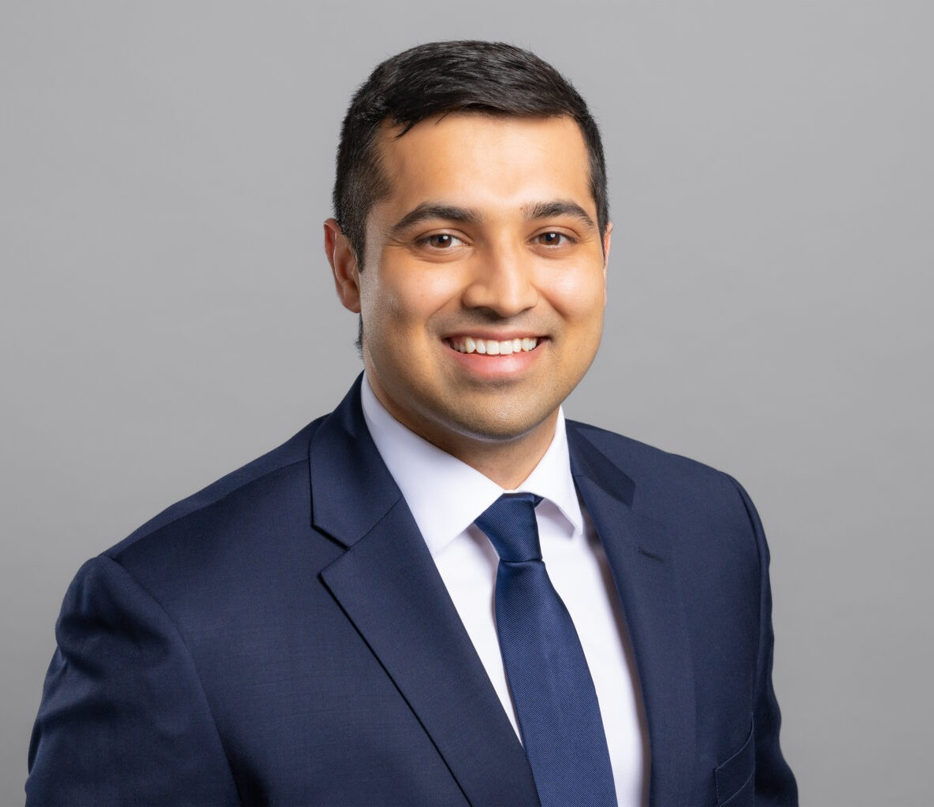

JASKARAN S. GILL

Associate

[Business Litigation](https://www.fennemorelaw.com/services/business-litigation/)

[Fresno](https://www.fennemorelaw.com/contact-us/fresno/)

P: 559.446.3271

F: 559.432.4590

[jgill@fennemorelaw.com](mailto:jgill@fennemorelaw.com)

# JASKARAN S. GILL

Jaskaran Gill is an associate attorney in our Business Litigation practice group who works out of our Fresno office. His practice is focused primarily in the areas of personal injury and civil

litigation. Jas had represented plaintiffs pursuing tort claims in every facet of litigation, including a jury trial. He has also performed insurance defense work, conducted and defended

depositions, attended mediations, and has represented clients in multiple bench trials.

With a neuroscience background, Jas initially worked as an EMT, but his passion for rational, critical and analytic thinking eventually led him to the legal profession. In his practice, he really enjoys solving problems – resolving cases favorably for his clients – and there is no other feeling in the world like getting successfully to the finish line, which make the grind of litigation all worth it.

A Golden State Warriors and Utah Jazz fan, Jas recharges his batteries by playing basketball and enjoying the outdoors. Newly engaged, his fiancé is also on a path to becoming an attorney.

Business Litigation

# EDUCATION

J.D., *Valedictorian*, San Joaquin College of Law Executive Editor, *San Joaquin Agricultural Law Review*

B.S., University of California, Los Angeles

# AREAS OF PRACTICE

Business Litigation

# AWARDS AND HONORS

Rising Star, *Northern California Super Lawyers*®, 2024

Witkin Awards for Academic Excellence, Issued by Witkin Legal Institute, May 2017

# PROFESSIONAL AND COMMUNITY ACTIVITIES

Adjunct Law Professor, San Joaquin College of Law, August 2022 – Present Member, Fresno County Bar Association

Professor for an Advanced Research and Writing Course

# ARTICLES AND PRESENTATIONS

Groundwater Managed: California Takes Its First Step Towards Groundwater Sustainability, *San Joaquin Agricultural Law Review*, Volume 25 · Oct 1, 2016

# ADMISSIONS

California

# LANGUAGES

English Punjabi