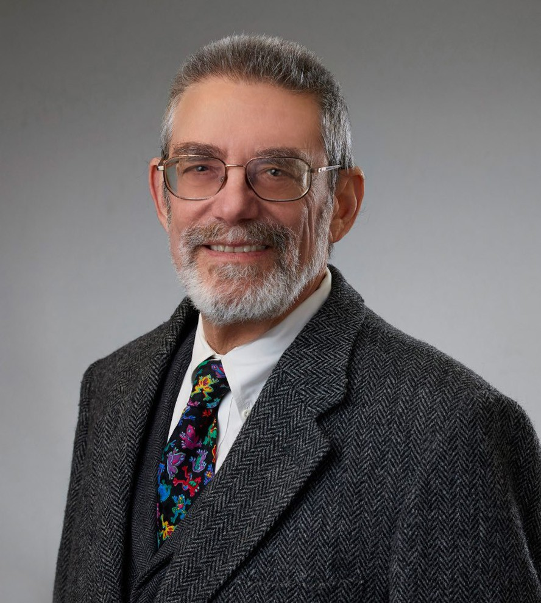

JEROME A. “JERRY” GROSSMAN

Pronouns: he/him

Of Counsel

[Financial Restructuring](https://www.fennemorelaw.com/services/financial-restructuring-bankruptcy-creditors-rights/)

[San Diego](https://www.fennemorelaw.com/contact-us/san-diego/)

P: 619.344.2992

F: 619.231.4372

[jgrossman@fennemorelaw.com](mailto:jgrossman@fennemorelaw.com)

If you could only sense how important you are to the lives of those you meet;

“Therehow iismsomethingportant youofcyourselfan be toha- tMr.t thepeRogersrson.youpeoeavel ple yoatu mverye ay nmeetingever evewithn dreanotheram of.

”

# JEROME A. "JERRY" GROSSMAN

Jerome “Jerry” Grossman is an Of Counsel Attorney in our San Diego office who has a wealth of experience in real estate finance law and secured financing. Jerry has represented clients in a broad range of general commercial and real estate finance matters for more than 40 years. He focuses his practice on Uniform Commercial Code secured transactions, real estate secured

transactions, and other financing transactions (including securitized financings) – from the initiation stage through workouts and restructurings – and third-party legal opinions.

Jerry has devoted his practice to representing borrowers in connection with real estate financings bound for the commercial mortgage-backed securities market, and he continues to represent borrowers in that market. He regularly represents 501(c)(3) organizations in connection with bond financings of educational facilities, real estate acquisitions, and low-income housing. Since joining Fennemore, Jerry’s practice has expanded to include representation of lenders in transactional aspects of loan restructurings and workouts, and reorganizations.

As Of Counsel, Jerry works to represent clients in a broad range of commercial financing transactions, secured and unsecured, including structured finance and tax-exempt bond

financings of infrastructure and other capital projects—at initiation, after closing in connection addressing compliance and administration matters, and in the event of default.

# EDUCATION

J.D., University of California, Berkeley, School of Law

B.A., University of California, San Diego, With Highest Honors Order of the Coif

# AREAS OF PRACTICE

Financial Restructuring Real Estate

Business & Finance

# OTHER EXPERIENCE

Bankruptcy

Tax-exempt financing Secured transactions

# AWARDS AND HONORS

*Best Lawyers,* U.S. News & World Report’s Best Lawyers in America, 2014-present

*Best Lawyers*, Structured Finance, 2012-2025

2014 Top Lawyer, Martindale-Hubbell, San Diego Magazine National Merit Scholar

# PROFESSIONAL AND COMMUNITY ACTIVITIES

Fellow, American College of Commercial Finance Lawyers (2010-present, 2014-17 as member of Board of Regents)

Member, Financial Lawyers Conference (1995-present, Past President and emeritus member of Board of Governors

Member, Uniform Commercial Code Committee, Business Law Section, California Lawyers Association (1995-2000, and 2021-Present, 1999-2000 as Chair)

Member, Executive Committee, Business Law Section, California Lawyers Association (2001- 2004 and 2009-2012, Advisor 2020-Present)

Member, Steering Committee, Opinions Committee, Business Law Section, California Lawyers Association (2001-present, 2007-2011 as Chair)

Editorial Board of the Business Law Section’s publication, “Business Law News” (2013-present, 2014-2015 and 2017-2020 as Editor-in-Chief)

Law Firm Representative to the Working Group on Legal Opinions [(https://www.wglo.net/)](http://www.wglo.net/)) (2007-present)

Board of Governors and Past President, Financial Lawyers Conference

# ARTICLES AND PRESENTATIONS

[Interview, “I’ve Always Envisioned my Career Including a Teaching Component,” Fennemore](https://www.fennemorelaw.com/ive-always-envisioned-my-career-including-a-teaching-component/) [Blog, June 2, 2022](https://www.fennemorelaw.com/ive-always-envisioned-my-career-including-a-teaching-component/)

Co-Presenter, “Analyzing Commercial Reasonableness and Key Strategic Issues in the

Enforcement of Security Interests in LLC Interests,” (Financial Lawyers Conference, December 2021)

Co-Presenter, “Opinions of Counsel in Lending Transactions: Scope and Assumptions, Substantive Opinions, and Qualifications” (Stafford, 2016-2020)

Presenter, “Basics of Understanding and Drafting Legal Opinions in Business Transactions,” (MyLawCLE, May 2019)

Co-Presenter, “You Authorized WHAT?! A Cautionary Tale in Three Acts,” (Financial Lawyers Conference, April 2015)

Adjunct Professor, Western State College of Law at Argosy University, Spring 2015 (teaching a course in secured transactions)

Co-author, CEB Action Guide “Enforcing Security Interests in Personal Property” (2001-2022 editions)

Co-author, “Laws Commonly Excluded from the Coverage of Third-Party Legal Opinions in U.S. Commercial Loan Transactions,” 76 Bus. Law. 889 (2021)

Author, “The Dangerous Allure of Form Loan Documents,” 2019 Business Law News Issue 2

Co-author, Secured Transactions: A Context and Practice Casebook (Carolina Academic Press, 2015)

# ADMISSIONS

California

# LANGUAGE

Spanish