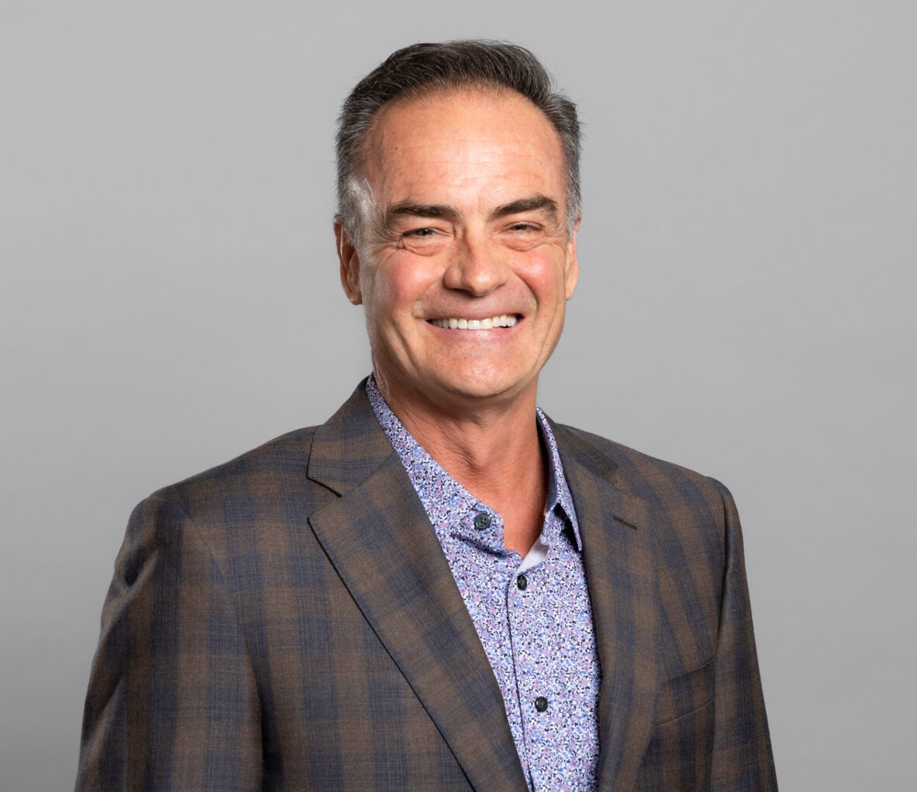

JOHN D. BETHEA

Director

[Real Estate](https://www.fennemorelaw.com/services/real-estate/)

[Phoenix](https://www.fennemorelaw.com/contact-us/phoenix/)

P: 602.916.5344 F: 602.916.5544

[jbethea@fennemorelaw.com](mailto:jbethea@fennemorelaw.com)

**JOHN D. BETHEA**

John maintains a diversified practice in commercial real estate law. His casework includes acquisition and sale of improved and unimproved properties; commercial development; retail, agricultural, industrial and office leasing; ground leases (with an emphasis on retail pad sites); and real estate finance.

A majority of John’s practice focuses on representing national convenience grocery store/automotive refueling facility operators and retail banks in connection with their acquisition and development of commercial pad sites.

Outside of work, John spends time with his wife and children as well as his father and siblings. He enjoys being active outdoors, and participates in snowboarding, mountain biking, motocross and other recreational activities. John’s new hobby is travel, he and his wife have begun traveling to New York to see their daughter perform for the American Ballet Theatre.

# EDUCATION

J.D., Brigham Young University, J. Reuben Clark Law School, *cum laude*

B.S., Brigham Young University

# AREAS OF PRACTICE

OTHER EXPERIENCE

Real Estate Finance and Lending Real Estate

# REPRESENTATIVE CASES

Represents a national operator of convenience grocery store/automotive refueling facilities in connection with the acquisition and development of retail pad sites in Arizona. Is the lead attorney at Fennemore Craig who manages a team of attorneys and paralegals for the client’s real estate needs. Since 1998, he has represented the client in connection with the proposed acquisition and development of over 150 pad sites in Arizona. Representation

includes preparation and negotiation of purchase and sale agreements, covenants, restrictions and easements agreements, development agreements, and ground leases.

Represents a national bank in connection to the acquisition and development of retail pad sites in Arizona. Has represented the client in connection with the acquisition and

development of over 40 properties in Arizona. Is the lead attorney at Fennemore Craig who manages a team of attorneys and paralegals for the client’s real estate needs.

Representation includes among other things, preparation and negotiation of purchase and sale agreements, covenants, restrictions and easements agreements, development

agreements, and ground leases.

Represents national industrial supply and aerospace manufacturer in connection with its real estate matters in Arizona. In 2006, represented the client in connection with a $10,000,000.00 sale/leaseback of an Arizona manufacturing facility. In 2007, represented the client in connection with a $50,000,000.00 sale/leaseback of an Arizona manufacturing facility.

Represents a national hotel operator in connection with its acquisition and development of retail pad sites in Arizona. Representation includes, among other things, preparation and negotiation of purchase and sale agreements, covenants, restrictions and easements

agreements, and ground leases.

Along with Fennemore Craig attorney, Don Miner, represented the seller in connection with the sale of 832 acres of undeveloped real property to a master planned community developer on a “finished lot” basis.

Represented commercial office developers in connection with preparation of office leasing forms, and thereafter negotiation and drafting of initial lease documentation and amendments for office projects known as Anchor Centre (336,939 rsf) and Northern Corporate Center (71,000 rsf).

Along with Fennemore Craig attorney, Jay Kramer, represented office developers in connection with preparation of base form office lease documentation for office projects 91 Glendale (106,191 rsf) and West 101 Corporate Center (82,000 rsf).

# AWARDS AND HONORS

*Best Lawyers in America®,* Real Estate Law, 2019-2025

AV® Preeminent™ Peer Review Rated (the highest rating available), by Martindale-Hubbell

# PROFESSIONAL AND COMMUNITY ACTIVITIES

Member, State Bar of Arizona Member, American Bar Association Member, East Valley Partnership

Member, Fennemore Craig Foundation Associate Counsel, Marc Center

# ADMISSIONS

Arizona

U.S. District Court, District of Arizona