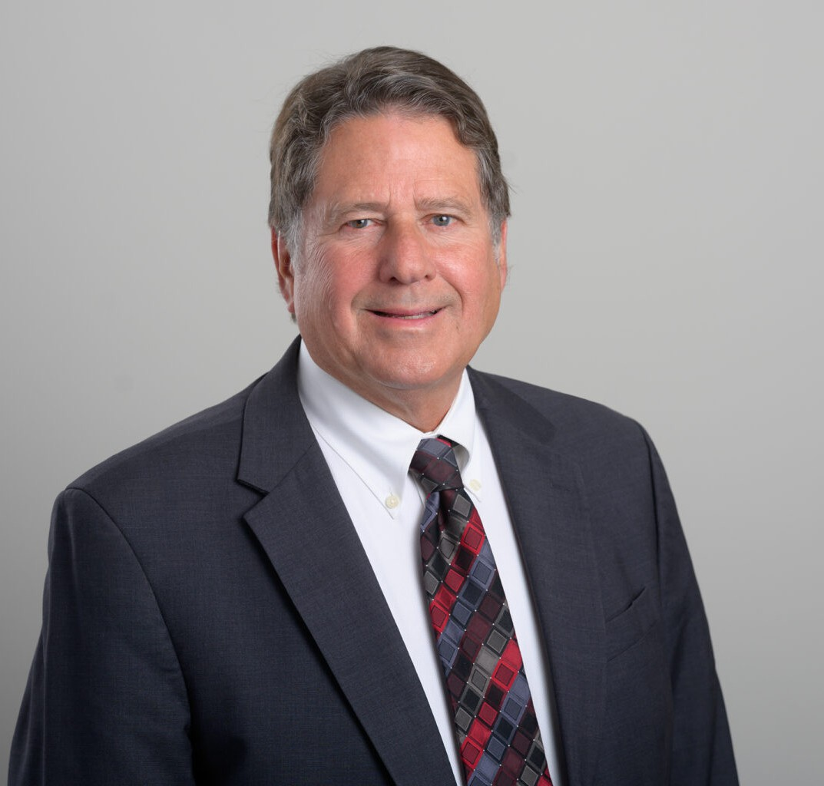

JONATHAN S. DABBIERI

Of Counsel

[Financial Restructuring](https://www.fennemorelaw.com/services/financial-restructuring-bankruptcy-creditors-rights/)

[San Diego](https://www.fennemorelaw.com/contact-us/san-diego/)

P: 619.595.3264

F: 619.231.4372

[jdabbieri@fennemorelaw.com](mailto:jdabbieri@fennemorelaw.com)

# JONATHAN S. DABBIERI

Jonathan S. Dabbieri specializes in debtor/creditor matters, representing bankruptcy trustees, creditors, and chapter 11 debtors. Jonathan also has extensive experience in enforcement of judgments and collection matters.

Jonathan has also handled numerous construction and real property litigation matters. He brings a wealth of knowledge in construction law and effective dispute resolution. His practice includes advising clients in the negotiation of construction contracts, handling mechanics liens, and resolving construction disputes. His ability to interpret and apply construction laws protects his

clients’ matters from potential risks.

Jonathan’s experience extends beyond bankruptcy and construction law. He has advised on various real property matters, including purchase contracts, leases, easements, and title issues. His skill in handling a broad range of commercial lawsuits, such as construction contract disputes and real property litigation, highlights his dispute resolution, creating effective outcomes in

complex legal scenarios.

His legal background is further enriched by his service in the United States Navy Judge Advocate General’s Corps and his role as associate editor of the Indiana University Law Journal.

# EDUCATION

J.D., Indiana University School of Law, Bloomington, *cum laude*

B.A., Columbia University

# AREAS OF PRACTICE

Financial Restructuring Business Litigation

Real Estate

# AWARDS AND HONORS

*Best Lawyers in America®,* Real Estate Law, 2025

AV® Preeminent™ Peer Review Rating by Martindale-Hubbell Top San Diego Lawyer by San Diego Magazine (2015-23) Super Lawyer, Bankruptcy

# PROFESSIONAL AND COMMUNITY ACTIVITIES

Member, Insolvency Law Committee, American Arbitration Association Panel of Arbitrators Member, Business Law Section, California Lawyers Association

# ADMISSIONS

California Indiana