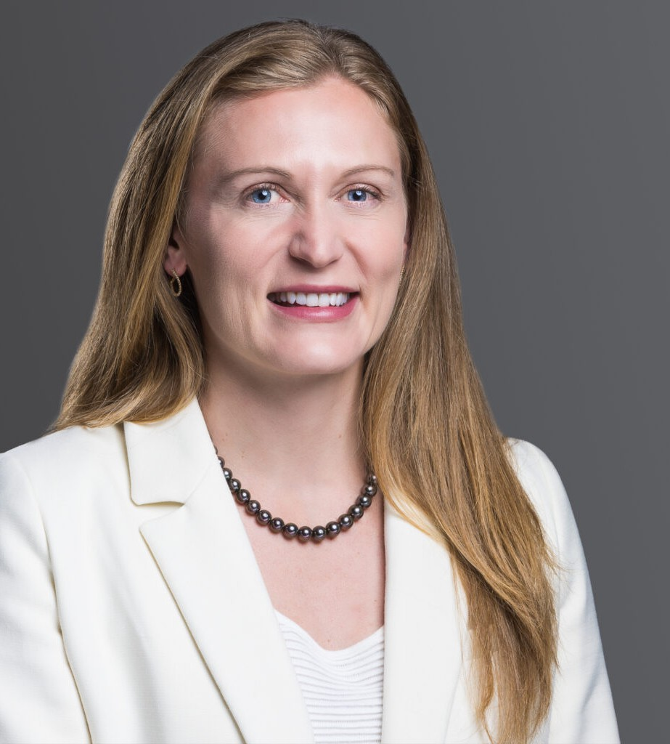

KATHERINE A. BOWLES

Director

[Business Litigation](https://www.fennemorelaw.com/services/business-litigation/)

[Orange County](https://www.fennemorelaw.com/contact-us/orange-county/)

P: 949.430.3437

F: 949.752.0953

[Fresno](https://www.fennemorelaw.com/contact-us/fresno/)

P: 949.430.3437

F: 949.752.0953

[kbowles@fennemorelaw.com](mailto:kbowles@fennemorelaw.com)

# KATHERINE A. BOWLES

Kate Bowles draws upon her in-depth litigation experience and background as a Registered Nurse to bring deep industry knowledge and expertise when representing clients. Focusing on compliance, investigation, enforcement of Medicare/Medi-Cal Fraud and Abuse, Stark

Law\Anti-Kickback Statute, payor disputes and business litigation, Kate uses her first-hand understanding of the challenges faced by clients to achieve exceptional results.

Kate’s experience encompasses all aspects of healthcare, including traditional healthcare systems and emerging groups in the outpatient sector, such as managed care health plans, Medi-Cal enrolled health plans and community support providers, ERISA health plans, surgery centers, telehealth providers, outpatient mental health, home health, infusion pharmacy, physical therapy and rehabilitation, hospital and anesthesia support, care management

support, medical, and nursing provider groups, and more. Representing a diversity of providers allows Kate to effectively evaluate the motivations of various participants within the healthcare industry and take advantage of emerging trends.

Kate handles all aspects of litigation from filing to finish, including trial, mediation, and arbitration of disputes. Kate also brings to her practice a focus on compliance and prevention of disputes and regularly advises clients on how to streamline their businesses, reduce risk, and increase

compliance. In this era of data mining, artificial intelligence, and the rise of hackers, it is ever- more important for clients to take a “big picture” approach to healthcare compliance and data protection.

Kate is licensed throughout California including the U.S. District Courts for the Eastern, Central and Southern Districts of California and the Ninth Circuit Court of Appeal.

# EDUCATION

J.D., Pepperdine University School of Law, *cum laude*

B.S., University of Pennsylvania

# AREAS OF PRACTICE

Business Litigation Health Care ERISA

# ARTICLES AND PRESENTATIONS

Co-Presenter, CalAIM Initiative on Enhanced Care Management and Community Supports, 2024 CSHA Annual Meeting and Spring SeminarLegal Update, May 3, 2024

Author, CIGNA’s New CRNA Payment Policy Adds Fuel To The Fire, Coronis Health, October 27, 2023

# AWARDS AND HONORS

*Best Lawyers in America®,* Health Care Law, 2025

# ADMISSIONS

California