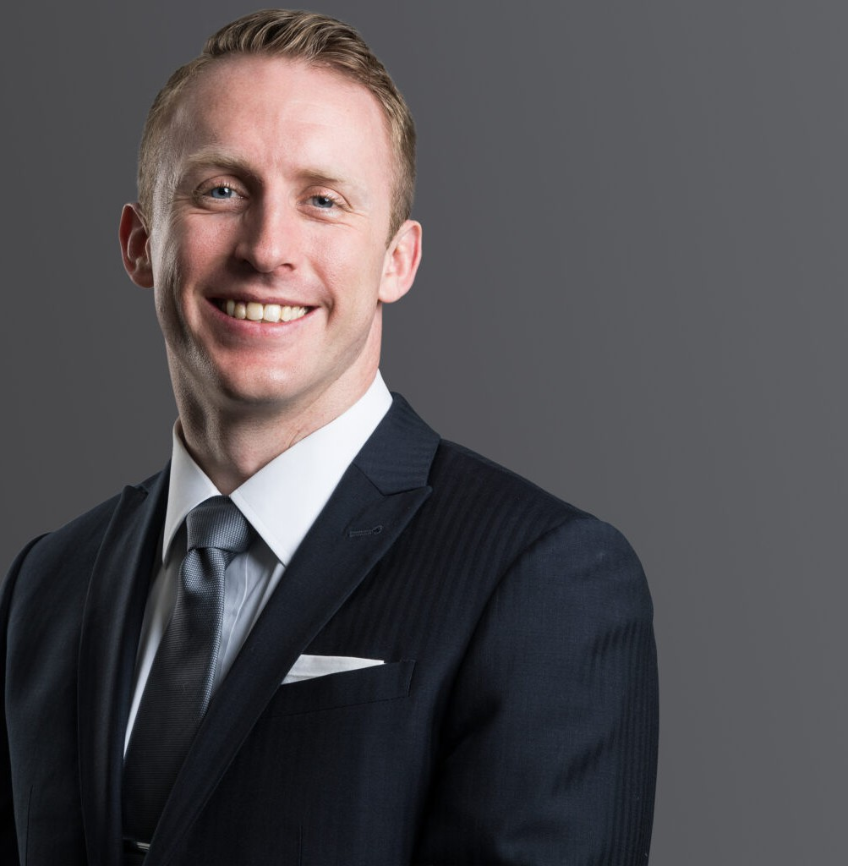

KOLE W. KELLEY

Associate

[Natural Resources](https://www.fennemorelaw.com/services/natural-resources-energy-and-environmental/)

[Denver](https://www.fennemorelaw.com/contact-us/denver-2/)

P: 303.813.3834

F: 303.291.3201

[Basalt](https://www.fennemorelaw.com/contact-us/basalt/)

P: 970.431.9060

F: 303.291.3201

[kkelley@fennemorelaw.com](mailto:kkelley@fennemorelaw.com)

“

Good

Jocko Willink

**KOLE W. KELLEY**

”

Kole advises clients in the agriculture, natural resource, and advanced energy industries related to complex real property and regulatory issues. From his experience sorting cattle and throwing irrigation tubes, to his experience helping clients solve title, survey, mineral, and water issues, Kole brings a practical approach to developing legal project strategies; navigating the federal, state, and local permitting processes; and monitoring the ongoing governmental rulemakings that

impact his clients’ projects.

Kole provides general counsel services to oil and gas clients, mining and oil and gas

transactions, title work, water rights counsel, and public lands law. Kole also has experience representing clients before the Colorado Energy and Carbon Management Commission, drafting oil and gas development plans, and assisting clients as they navigate implementing solar energy projects on federal lands. Kole’s knowledge extends to regulatory matters across the Rocky Mountain West.

With a drive to make a meaningful impact, Kole actively volunteers on several non-profit boards, including the Leadership, Policy, and Governance Foundation, Colorado Junior Swine

Association, the Colorado Farm Bureau, and the Douglas County Farm Bureau, demonstrating his dedication to giving back to the community.

Outside of the legal field and volunteering, Kole can be found overanalyzing a fantasy football lineup, rooting on the Colorado Avalanche, shoveling pig pens on his family’s ranch, or at a

livestock show with a focus on making the next generation better.

# EDUCATION

J.D., University of Denver Sturm College of Law B.S., Adams State University

# AREAS OF PRACTICE

Natural Resources Advanced Energy Agribusiness

# AWARDS AND HONORS

*Denver Business Journal*, Who’s Who in Agriculture, Water Resources Law, 2021

# ARTICLES AND PRESENTATIONS

Presenter, “Administrative Law Outlook in Agriculture,” Elite Leadership Academy, Colorado Farm Bureau

Co-Author, “Energize Denver: Moving toward a more sustainable Denver,” *Colorado Real Estate Journal*, December 2023

Author, “The Renewable Revolution: It’s a Race to the Top,” *Firm Blog*, October 2023 Leadership, Policy and Governance Leadership Academy (2023)

Co-Author, “WOTUS: The Water Definition Battle That Defines the Nation,” 46 MITCHELL HAMLINE L. REV. 76, (2019).

Colorado Farm Bureau Elite Leadership Academy (2020)

Author, “New Rules in the Land of Cool Sunshine,” 21 DENV. WATER L. REV. 271, *Case Note*

(Spring 2018).

Author, “Let There Be Water: Israel’s Solution for a Water-Starved World” 21 DENV. WATER L. REV. 271, *Book Note* (Spring 2018).

Guest Lecturer, “Water Law in the West,” University of Arkansas Honors College Signature Seminar Series and L.L.M. in Agriculture and Food Law program (2018).

Guest Lecturer, “What’s Next in Colorado Water Law,” Adams State University Agribusiness program. (2018).

Author, “A Tough Economic Choice for Water Rights Holders in the San Luis Valley,” DENV. WATER L. REV. *Blog Post* (Mar. 7, 2016).

Author, “House Bill 16-1005 (Colo. Rev. Stat. § 37-96.5-101)” 20 DENV. WATER L. REV. 119, (Fall 2016).

Author, “Najas Realty, LLC v. Seekonk Water Dist.” 20 DENV. WATER L. REV. 138, (Fall 2016).

# PROFESSIONAL AND COMMUNITY AFFILIATIONS

Vice-Chair, Colorado Farm Bureau Young Farmers and Ranchers Committee, 2021-Present Chair, Colorado Bar Association Agricultural and Rural Law Section, 2024-Present

President, Colorado Junior Swine Association, 2023-Present President, Douglas County Farm Bureau, 2023-Present

Board Member, Leadership, Policy, and Governance Foundation, 2023-Present

Co-Board of Governors Representative – Colorado Bar Association Agricultural and Rural Law Section, 2024-Present

Member, Colorado Farm Bureau Membership Task Force, 2024-Present Member, Colorado Livestock Association, 2024- Present

Member, Action Colorado, 2023-Present

Vice-Chair, Agricultural and Rural Law Section, Colorado Bar Association, 2022-2024 Board Member, Colorado Junior Swine Association, 2022-2023

Presidential Selection Committee, Adams State University , 2023 University of Denver Water Law Review, Editor-in-Chief, Volume 22, 2019

# ADMISSIONS

Colorado