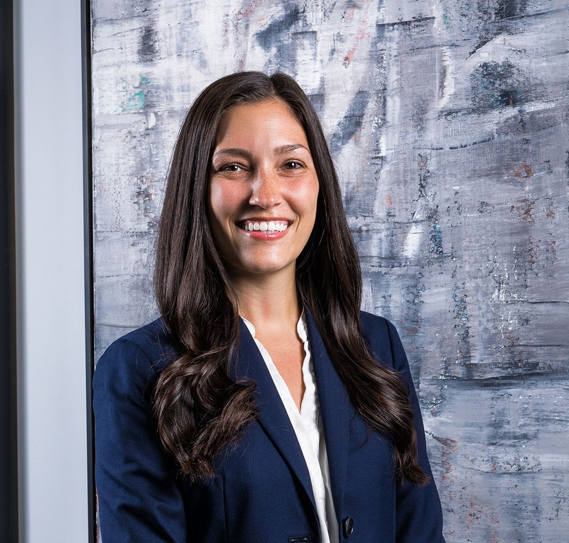

LYNDSEY MAASCH

Associate

[Business Litigation](https://www.fennemorelaw.com/services/business-litigation/)

[Phoenix](https://www.fennemorelaw.com/contact-us/phoenix/)

P: 602.916.5401

F: 602.916.5601

[lmaasch@fennemorelaw.com](mailto:lmaasch@fennemorelaw.com)

“

Keep your heels, head, and standards high.

- Coco Chanel

**LYNDSEY MAASCH**

”

Lyndsey Maasch is an associate attorney who works in our business litigation practice group in our Phoenix office. Her work encompasses a broad range of dispute prevention and resolution matters as well as healthcare law.

Originally from Wisconsin with attorneys in her family and her mom working as a court reporter, Lyndsey grew up talking about legal issues at the dinner table. She knew from an early age that she was destined for law school – not only to become a lawyer, but for the sheer love of

learning. As an attorney, this passion for knowledge means that Lyndsey makes her clients’

complex problems her own. She takes great pride in going the extra mile and always delivering the best service available; above and beyond expectations.

Newly married with a Goldendoodle fur baby, Lyndsey recharges her batteries through hiking and Vinyasa Yoga. She also loves to cook, and her mother’s secret lasagna recipe always delights family and friends.

# EDUCATION

J.D., *magna cum laude,* Arizona State University, Sandra Day O’Connor College of Law B.A., Political Science and Legal Studies, University of Wisconsin-Madison

# AREAS OF PRACTICE

Business Litigation

# ARTICLES AND PRESENTATIONS

[Co-author, “OSHA Issues Emergency Temporary Standard for Health Care Employers,”](https://www.fennemorelaw.com/insights/newsletters/2021/osha-issues-emergency-temporary-standard-for-health-care-employers) [Fennemore Client Alert, July 8, 2021](https://www.fennemorelaw.com/insights/newsletters/2021/osha-issues-emergency-temporary-standard-for-health-care-employers)

# PROFESSIONAL AND COMMUNITY AFFILIATIONS

Member, Auxiliary Board, Fresh Start Women’s Foundation

# ADMISSIONS

Arizona

U.S. District Court, District of Arizona

U.S. Court of Appeals, Federal Circuit