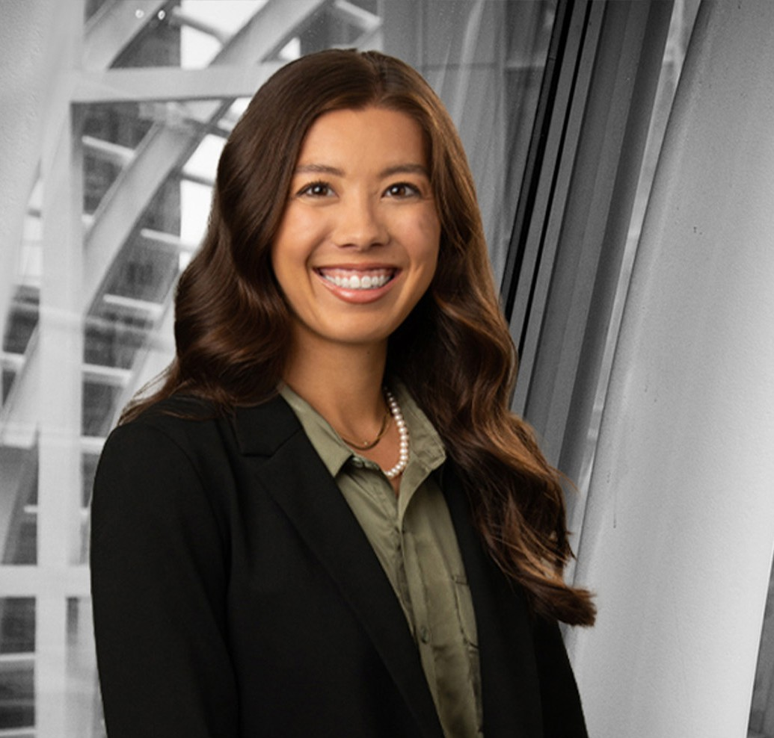

MALLORY P. NORDBERG

Associate

[Business Litigation](https://www.fennemorelaw.com/services/business-litigation/)

[Denver](https://www.fennemorelaw.com/contact-us/denver-2/)

P: 303.764.3703

[mnordberg@fennemorelaw.com](mailto:mnordberg@fennemorelaw.com)

“

Fight for the things you care about, but do it in a way that will lead others to join you.

Ruth Bader Ginsburg

”

# MALLORY P. NORDBERG

Mallory Nordberg is an associate in our Business Litigation practice group who works out of our Denver office. Her practice focuses on education, contract, and employment matters as well as appellate advocacy.

Raised by an Australian father and Korean mother, Mallory and her family have traveled all over the world and she possesses dual citizenship with Australia. In the states, her legal studies and career have taken her to New Mexico, Colorado, and Arizona, where she was a summer associate here at the firm. Mallory now recognizes that her nomadic experience has fashioned her into a compelling advocate for her clients. She’s open to new ideas and change, and has a natural ability to counsel others and resolve issues.

Outside of work, Mallory and her family can be found hiking with their two dogs, or traveling and exploring new places and cultures, including indulging in their passions for new languages, food and books.

Business Litigation

Employment & Labor

# EDUCATION

J.D., University of New Mexico, School of Law, *summa cum laude*

Order of the Coif

Vol. 51 Editor in Chief, Vol. 51 Staff Editor, *New Mexico Law Review*

ABA National Appellate Advocacy Moot Court Competition, 2020

B.A., University of New Mexico, *magna cum laude*

# AREAS OF PRACTICE

Business Litigation

Employment & Labor

# ADMISSIONS

Arizona Colorado