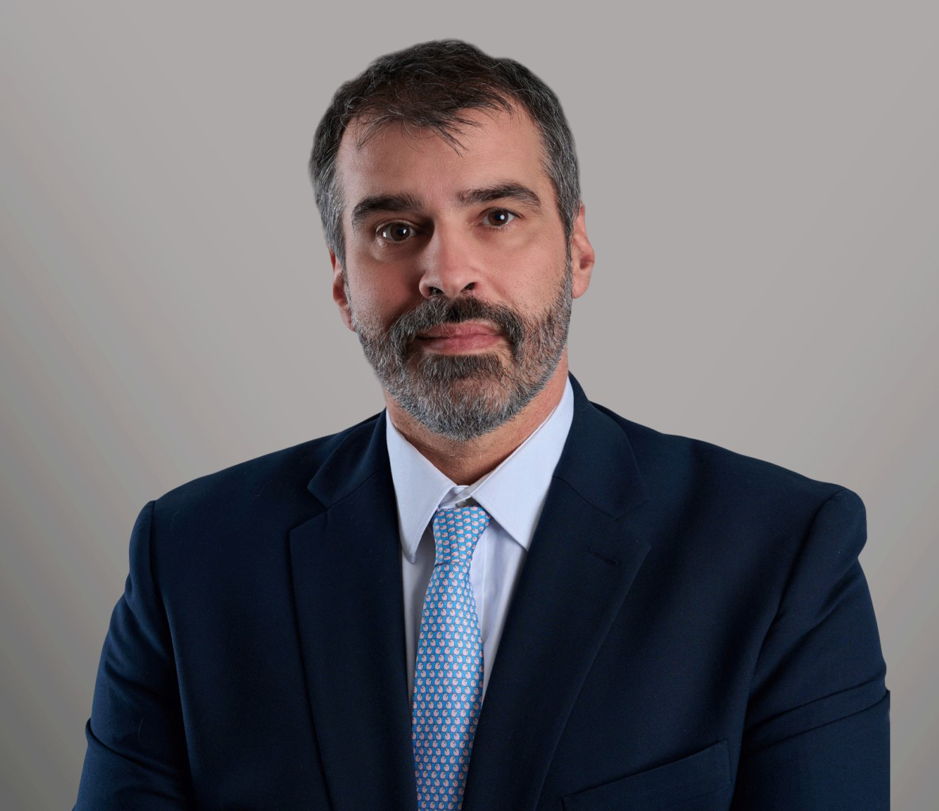

MICHAEL CHAIT

Of Counsel

[Business Litigation](https://www.fennemorelaw.com/services/business-litigation/)

[Seattle](https://www.fennemorelaw.com/contact-us/seattle/)

P: 206.749.0500

F: 206.749.0600

[mchait@fennemorelaw.com](mailto:mchait@fennemorelaw.com)

# MICHAEL CHAIT

Michael Chait brings extensive experience in high-conflict litigation, delivering creative legal solutions characterized by his in-depth industry knowledge and client-centric litigation

approach. His focus on understanding and meeting specific business needs and goals underpins his approach to guiding his clients through all phases of litigation in federal and state courts, as well as alternative dispute resolution proceedings. Additionally, Mike offers valuable advice and counsel on regulatory compliance, transactional, and commercial matters.

Starting his career at Mitchell Silberberg & Knupp in Los Angeles, Mike handled complex commercial and intellectual property disputes before becoming the managing partner at Montgomery Scarp & Chait in Seattle. His broad practice there included defending transportation claims, catastrophic injury suits, employment claims, and a variety of commercial litigation matters. Mike’s ability to dive deep into his client’s industries, ranging from

entertainment to railroads and high tech to retail, underlines his commitment to providing tailored legal strategies that align with his clients’ business needs.

Mike lives on Vashon Island with his wife and three daughters. When not in the office, you can find Mike in the kitchen fermenting something (anything!), building backyard structures with his daughters, or cheering on his old team, the Husky Crew.

# EDUCATION

J.D., University of Southern California Law School B.A., University of Washington, *cum laude*

# AREAS OF PRACTICE

Business Litigation Intellectual Property Employment & Labor

# REPRESENTATIVE MATTERS

***BNSF Railway Company v. Thomas Clark.*** Represented railroad to address a medical examiner’s attempt to use statutory procedure to avoid disclosure of key materials; obtained

writ of mandate on summary judgment, preventing medical examiner’s use of the procedure, which was affirmed by the Washington Supreme Court.

***Chumbley, et al. v. Snohomish County.*** Represented property owner alleging violations relating to permitting of adjacent property’s water treatment system in landslide zone; obtained ruling from Court of Appeals holding that Land Use Petition was timely and County was not preempted from enforcing land disturbing activities and critical areas ordinances.

***Bartz v. Burlington N. Santa Fe, LLC.*** Represented railroad in wrongful death action; obtained dismissal on the pleadings, with the Court of Appeals affirming, as an issue of first impression, that statutory immunity applied to injuries to trespasser occurring upon a railroad bridge or trestle.

***Rossich v. BNSF Railway Company.*** Represented railroad in claims by former employee of retaliation in violation of Federal Railroad Safety Act, alleging termination for reporting an injury; obtained defense verdict after three week jury trial in United States District Court.

***Global Direct Components, LLC v. Lippert Components, Inc.*** Represented RV component manufacturer in lawsuit alleging misappropriation of trade secrets; obtained defense verdict following three week jury trial.

# AWARDS AND HONORS

*Best Lawyers in America®,* Commercial Litigation, 2025 ACLU of Southern California – First Amendment Award Public Counsel – Pro Bono Award

# ARTICLES AND PRESENTATION

A Second Bite at The Apple: State Law Wrongful Discharge Claims, NARTC Special Litigation Conference, presenter, 2018

Social Media & Privacy: Building Your Online Presence and Protecting Your Digital Assets, California Club, panelist and moderator, 2014

Michael Chait, Susan Ross, and Sarah Taylor Wirtz, Tips for Conducting an Internal Investigation, MS&K Corporate Alert, 2014

Michael Chait and Susan Kohn Ross, Cybersecurity Update – How Are You Impacted?, MS&K Corporate Alert, 2014

Michael Chait, Steps to Protect the Identity of Your Secret Source, Lexology, 2013

# PROFESSIONAL AND COMMUNITY ACTIVITIES

Trustee of the Board, Washington Trial Defense Lawyers

Chair, Court Rules Committee, Washington Trial Defense Lawyers

Chair, Court Rules and Procedures Committee, Washington State Bar Association Member, National Association of Railroad Trial Counsel

Member, Federal Bar Association of the Western District of Washington

Jury Diversity Task Force, Washington State Minority and Justice Commission Member, Phi Beta Kappa

# ADMISSIONS

Washington California

United States Court of Appeals, Ninth Circuit

United States District Court, Western District of Washington United States District Court, Eastern District of Washington United States District Court, Central District of California United States District Court, Northern District of California United States District Court, Southern District of California