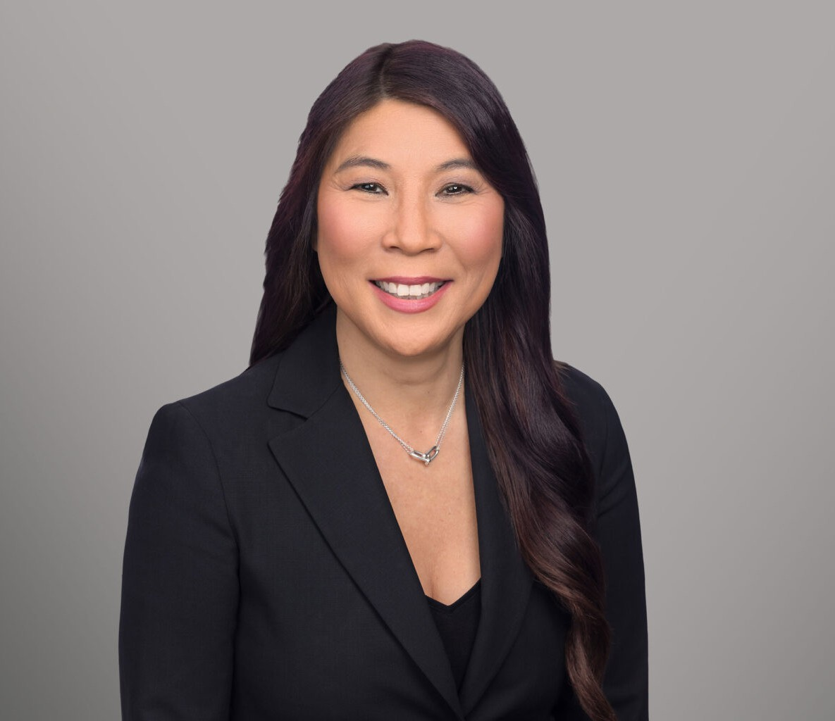

MINNA C. YANG

Director

[Business & Finance](https://www.fennemorelaw.com/services/business-and-finance/)

[Sacramento](https://www.fennemorelaw.com/contact-us/sacramento/)

P: 916.920.5286

F: 916.920.5286

[myang@fennemorelaw.com](mailto:myang@fennemorelaw.com)

# MINNA C. YANG

Minna C. Yang is a Director in the Sacramento Office working in Fennemore’s tax practice group. With over 30 years of experience as a CPA and attorney, Minna is experienced in

federal and state income tax planning for business, real estate and estate planning transactions.

Minna is known for her efficiency and timely execution of complex business transactions and

restructuring. Working often with multi-generation enterprises, she ensures that client projects are completed within critical deadlines thus adding significant value to their business operations.

Areas of specific knowledge include Like-Kind Exchanges, Qualified Opportunity Zone Funds, and Pass-Through Entity Taxation.

Minna enjoys working with families and business owners to accomplish their succession planning objectives in a tax-efficient manner.

When not working Minna enjoys spending time with family over delicious food and attending live performances of music and theater.

# EDUCATION

J.D., Lincoln Law School

M.S., Taxation, Golden Gate University, San Francisco B.S., California State University, Sacramento

# AREAS OF PRACTICE

Business & Finance Mergers & Acquisitions Real Estate

Tax Law

Trusts & Estates Estate Planning

# ARTICLES AND PRESENTATION

Co-Author, “Corporate Transparency Act,” Firm Newsletter, January 19, 2024

Co-Author, “Musings on Implications of the Repeal of the Technical Termination Provisions Under IRC 708 for 1031 Exchanges,” Firm Newsletter, June 17, 2019

Presenter, “Partnership Allocation Rules – Impact of Recent Regulations,” November 15, 2017 Presenter, Honey, I Forgot About the Income Tax!” Firm Presentation, February 25, 2016

# PROFESSIONAL AND COMMUNITY ACTIVITIES

Member, California Society of Certified Public Accountants Member, American Institute of Certified Public Accountants

Member, Tax and Business Sections, Sacramento County Bar Association Member, Tax Section, State Bar of California

Member, Adjunct Instructor, Golden Gate University, 2003-2005

# ADMISSIONS

California

U.S. Tax Court

Certified Public Accountant