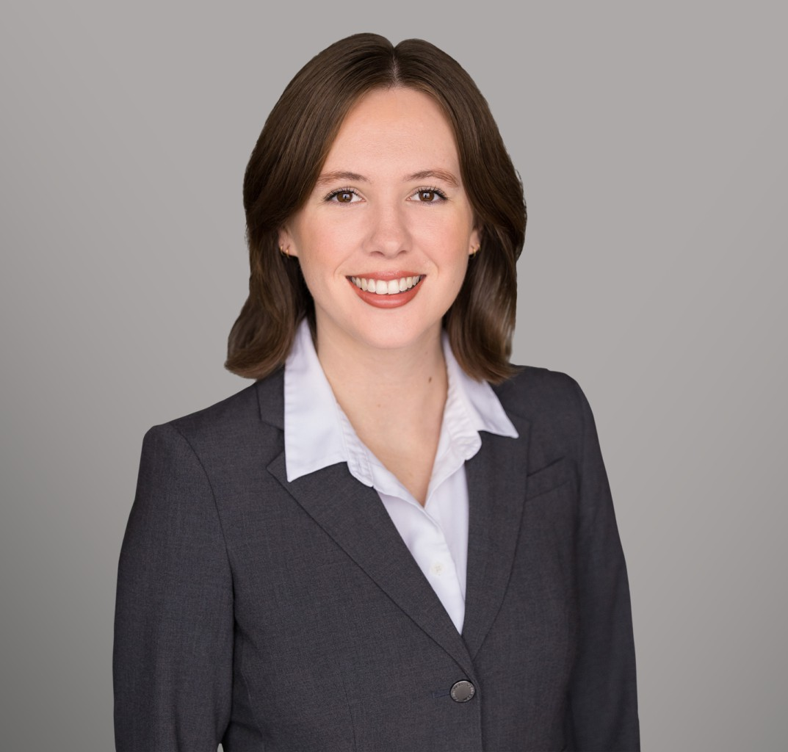

MIRANDA FREEMAN

Associate

[Business & Finance](https://www.fennemorelaw.com/services/business-and-finance/)

[Sacramento](https://www.fennemorelaw.com/contact-us/sacramento/)

P: 916.920.5286 F: 916.920.5286

[mfreeman@fennemorelaw.com](mailto:mfreeman@fennemorelaw.com)

# MIRANDA FREEMAN

Miranda Freeman, an associate attorney, practices taxation, estate planning, and trust administration. She stands out for her adeptness in advanced tax minimization strategies,

integrating these techniques into her estate planning practices to efficiently reduce tax liabilities for her clients. This expertise ensures that clients’ wealth transfer and estate planning goals are met with favorable tax outcomes.

In addition, Ms. Freeman excels in the formation and administration of trusts. Her knowledge in this area allows for effective management and distribution of assets, providing clients with peace of mind and ensuring their estate plans are executed as intended.

# EDUCATION

J.D., University of the Pacific, McGeorge School of Law B.A., University of California, Santa Cruz

# AREAS OF PRACTICE

Business & Finance Tax Law

# AWARDS AND HONORS

Top 16 Oral Advocate

# PROFESSIONAL AND COMMUNITY ACTIVITIES

Sports & Entertainment Law Society, Treasurer, 2020-2021 Vice President, 2021-2022

# ADMISSIONS

California