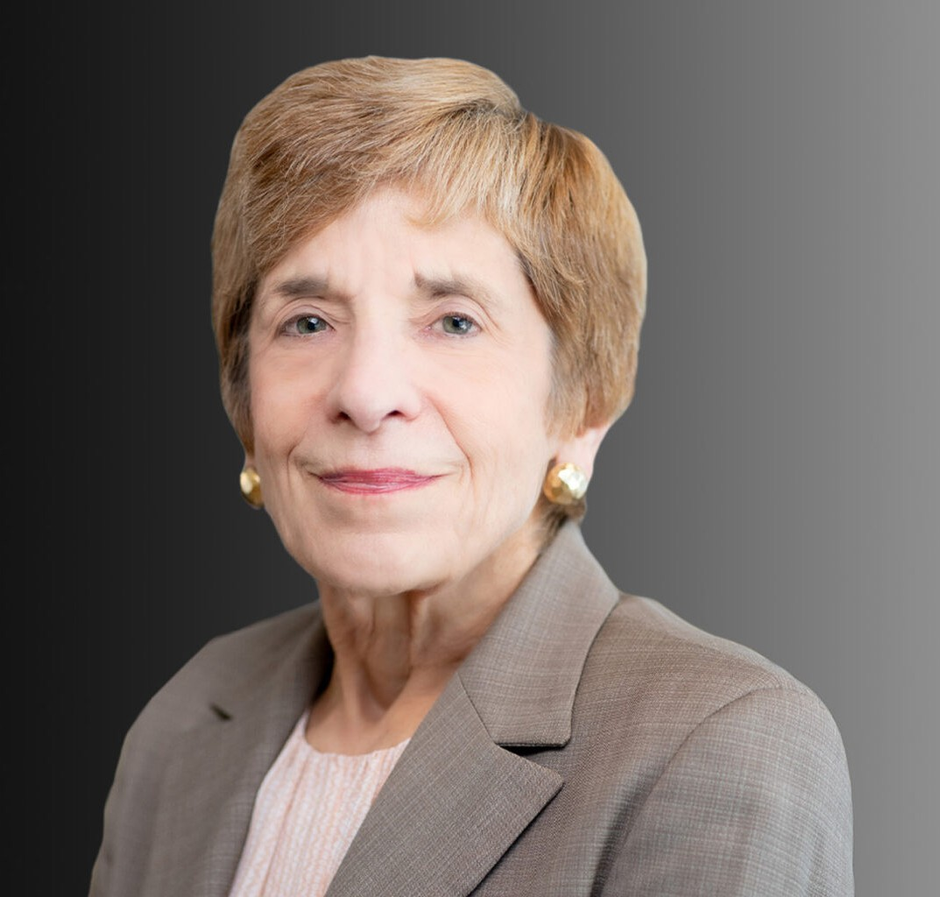

MONICA DELL’OSSO

Director

[Trusts & Estates](https://www.fennemorelaw.com/services/trusts-estates/)

[Oakland](https://www.fennemorelaw.com/contact-us/oakland/)

P: 510.834.6600

F: 510.834.1928

[mdellosso@fennemorelaw.com](mailto:mdellosso@fennemorelaw.com)

# MONICA DELL'OSSO

Monica has more than 35 years of experience in trusts and estates. A respected leader in the

field, she combines extensive insight and experience with a committed, passionate, and caring approach. She is a trusted advisor for a range of clients, with a practice focus on sophisticated estate and gift tax planning, estate and trust administration, and contested matters in estates and trusts.

Working closely with clients, Monica prepares complex estate plans that utilize sophisticated techniques for effective wealth transfer. She provides comprehensive guidance and handles numerous administration matters, including formal probates and post-death trust administrations.

Monica has written and lectured on a wide range of topics related to trusts and estates. A certified specialist in probate, estate planning and trust law by the State Bar of California Board of Legal Specialization and a Fellow of the American College of Trust and Estate Counsel (ACTEC)she is regularly selected for inclusion in multiple peer-rated publications, such as Northern California Super Lawyers.

# EDUCATION

Ph.D. University of Virginia

J.D., University of California, Berkeley School of Law

B.A., St. Mary-of-the-Woods College, *summa cum laude*

# AREAS OF PRACTICE

Trusts & Estates Estate Litigation

Family Office & Private Client Attorneys Estate Planning

# AWARDS AND HONORS

Certified Specialist – Probate, Estate Planning and Trust Law, State Bar of California Board of Legal Specialization

Northern California’s Top 100 *Super Lawyers*, 2007-present

*Best Lawyers in America*®, 2006, 2007, 2010-2025

Top 50 Women *Super Lawyers*, 2007-2022

# ARTICLES AND PRESENTATIONS

Author, “Estate Planning for Vacation Homes,” Estate Planning for Special Assets, Continuing Education of the Bar (CEB), 2005, updated 2008, 2010, and 2014

Author, “Difficult Family Situations,” Complete Plans from Small and Mid-Size Estates, Continuing Education of the Bar (CEB), 2007, updated 2008 – 2010 and 2014

Co-Author, California Civil Practice: Probate and Trust Proceedings, 4 volumes, Thompson, 1993, updated semi-annually

Author, “Surrogate Financial Management,” California Elder Law Resources, Benefits and

Planning: An Advocate’s Guide, Continuing Education of the Bar (CEB), 1993, updated 2003, 2005, 2007, 2010 and 2013

Co-Author, Funding A Revocable Trust, Continuing Education of the Bar (CEB), 1993, updated 2002 and 2003

Co-Author, “Tax Considerations” Drafting California Revocable Trusts, Continuing Education of the Bar (CEB), 2003

Author, “Income Tax Basis,” California Estate Planning, Continuing Education of the Bar (CEB), 2002

Author, “Current Developments in Planning with Private/Family Split Dollar Insurance and Stock Options,” 52 Major Tax Planning, Lexis Publishing, 2000

Co-Author, “Marital Deduction Trusts,” California Transactions Forms – Estate Planning, West Publishing Company, 1999

Co-Author, “Trusts for Minors,” Drafting California Irrevocable Trusts, Continuing Education of the Bar (CEB), 1997

Author, “Representing the Absconding Fiduciary: The Ethical Issues,” California Trusts and Estates Quarterly, 1996

Co-Author, “Estate Planning for Children: An Overview,” Estate Planning 1996, Continuing Education of the Bar (CEB), 1996

Co-Panelist, “Subtrust Funding and Administering Ongoing Trusts,” East Bay Trusts and Estates Lawyers, Trust Administration Boot Camp, 2021

Co-Panelist, “Trust and Estate Litigation Seminar: A Comprehensive Analysis from Intake to Resolution,” Continuing Education of the Bar (CEB), December 2010

Co-Panelist, “How to Cope with the Current Estate and Gift Tax Laws – What are they?” Thirty- Second Annual UCLA-CEB Estate Planning Institute, May 2010

Co-Panelist, “Estate Litigation: Tactical Issues. Case Studies and Resolution Scenarios,” Continuing Education of the Bar (CEB), December 2008

Co-Panelist, “Advanced Estate Planning Practice Update – Fall 2007,” ALI-ABA, September 2007

Speaker, “Post-Mortem Estate Planning,” Professional Education Broadcast Network, November 2006 and August 2007

Speaker, “Post Death Tax Planning and Elections,” 37th Annual Estate Planning Institute, Practicing Law Institute (PLI), October 2006

Speaker, “Post Death Tax Planning and Elections,” Tax Strategies for the High-Income Individual, American Institute of Certified Public Accountants, May 2006

Co-Panelist, “Advanced Estate Planning Practice Update – Winter 2006,” ALI-ABA, February 2006

Speaker, “Estate Litigation: Tactical Issues, Case Studies and Resolution Scenarios,” Continuing Education of the Bar (CEB), November 2005

Speaker, “Use of Disclaimers,” San Francisco Estate Planning Council, November 2005

Speaker, “Post-Death Tax Planning and Elections,” 36th Annual Estate Planning Institute, Practicing Law Institute (PLI), October 2005

Speaker, “Making Waivers Work: Disclosure v. Intelligibility,” Representing Trust and Estate Beneficiaries and Fiduciaries, ALI-ABA, July 2005

Speaker, “Who’s the Client? Ethics for the Trust and Estate Counsel,” State Bar Section Education Institute, January 2005

Co-Panelist, “Estate Planning for Special Assets,” Continuing Education of the Bar (CEB), January 2005

Speaker, “Current Developments in Planning with Private/Family Split Dollar Insurance and Stock Options,” USC Law School 52nd Institute on Federal Taxation, 2000

# PROFESSIONAL AND COMMUNITY ACTIVITIES

Fellow, American College of Trust and Estate Counsel Co-Chair, UCLA-CEB Estate Planning Institute

Past Chair, Estate Planning, Trust and Probate Law Section, Alameda County Bar Association Member, Board of Directors, Legal Assistance For Seniors, 2001-2016

# ADMISSIONS

California