NEAL A. PARISH

Director

[Land Use](https://www.fennemorelaw.com/services/land-use/)

# NEAL A. P“ARISH

[Oakland](https://www.fennemorelaw.com/contact-us/oakland/)

P: 510.834.6600 F: 510.834.1928

[nparish@fennemorelaw.com](mailto:nparish@fennemorelaw.com)

Forget world peace; visualize using your turn signals. ”

With a professional background in planning and economics, including master’s degrees in city planning and transportation engineering, Neal offers private and public agency and private clients a unique mix of real estate and land use knowledge, experience and insight. He counsels on a range of matters including real estate transactions and agreements, easements and title

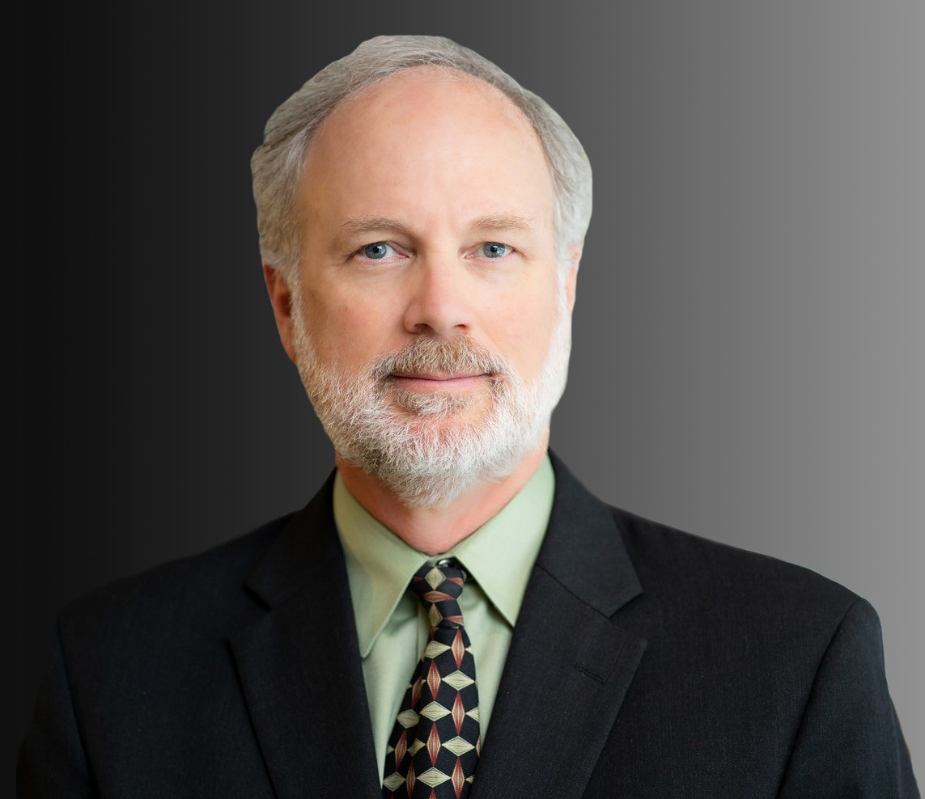

issues, land use permitting, public projects and service contracts, and serving as public agency general counsel.

Skilled in matters of public agency law and experienced in city planning and transportation

issues, Neal guides public agency clients on matters related to construction, design and other professional service contracts and procurement. He also advises clients regarding the implications of, and potential revisions to, new and pending legislation. Neal also serves as general counsel to public agencies, advising on a broad range of issues including compliance with applicable laws such as the Brown Act, Public Records Act, and the Political Reform Act.

For private industry and individual clients, Neal negotiates, drafts and analyzes agreements for real estate transactions, including leases, purchase and sale contracts, easements and related agreements, and subdivision documents including CC&Rs. He also assists clients with land use and related permitting issues, including CEQA, zoning, and other regulatory matters.

# EDUCATION

J.D., University of California, Berkeley, School of Law

M.S. and M.C.P., University of California, Berkeley B.A., University of California, Los Angeles

# AREAS OF PRACTICE

Land Use

Real Estate

Government Relations & Regulatory

# ARTICLES AND PRESENTATIONS

Update Author, “California Easements and Boundaries: Law and Litigation,” California Continuing Education of the Bar, 2010-2021

Update Author, “Office Leasing: Drafting and Negotiating the Lease,” California Continuing Education of the Bar, 2002, 2008-2021

Update Author, “Retail Leasing: Drafting and Negotiating the Lease,” California Continuing Education of the Bar, 2008-2021

Co-Author, “Inclusionary Housing Stays,” The Registry, June 29, 2015

Author, “California Supreme Court Endorses City Authority to Adopt Inclusionary Housing Ordinance,” Wendel Rosen LLP, June 17, 2015

Co-Presenter, “The City Giveth and the City Taketh Away,” Alameda County Bar Association

# PROFESSIONAL AND COMMUNITY ACTIVITIES

Member, Alameda County Bar Association

Member, Real Estate Property Section and Public Law Section, State Bar of California Former Member and Former Chair, Landmarks Preservation Advisory Board, City of Oakland Former Member and Former Chair, Facilities Advisory Committee, Oakland Unified School

District

# ADMISSIONS

California