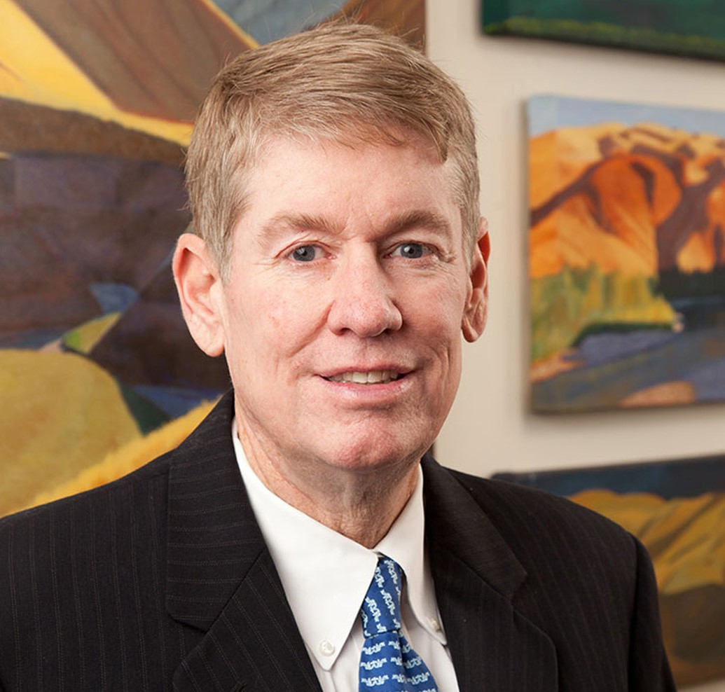

PATRICK J. SHEEHAN

Of Counsel

[Business Litigation](https://www.fennemorelaw.com/services/business-litigation/)

[Las Vegas](https://www.fennemorelaw.com/contact-us/las-vegas/)

P: 702.692.8011

F: 702.692.8071

[psheehan@fennemorelaw.com](mailto:psheehan@fennemorelaw.com)

# PATRICK J. SHEEHAN

Patrick practices in the areas of general real estate and litigation. His work includes drafting and reviewing contracts, business litigation and property tax protests. His clients include developers, homebuilders and other business entities.

# EDUCATION

J.D., Arizona State University, Sandra Day O’Connor College of Law B.S., Finance, Arizona State University

Associate Editor, *Arizona State Law Review,* 1987-1989

# AREAS OF PRACTICE

OTHER EXPERIENCE

Business and Personal Injury Torts Commercial Litigation

Contract Law, Drafting, Reviewing and Litigation Litigation

Property Tax Protests Real Estate Litigation

Tort Litigation and Product Liability Business Litigation

Real Estate Construction Law

# AWARDS AND HONORS

*Best Lawyers in America®,* Commercial Litigation, 2018-2025

# PROFESSIONAL AND COMMUNITY ACTIVITIES

Member, American Bar Association Member, State Bar of Nevada Member, Clark County Bar Association

Member, Nevada Trial Lawyers Association

# ADMISSIONS

Nevada