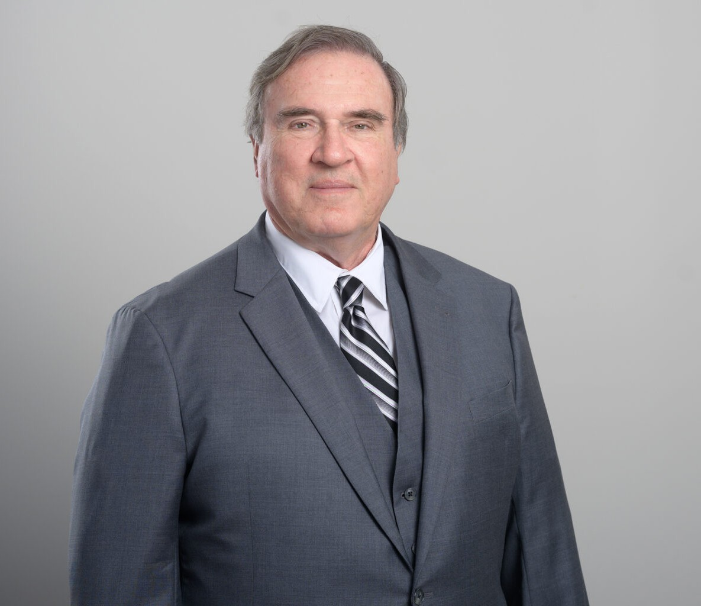

PAUL H. DUVALL

Of Counsel

[Employment & Labor](https://www.fennemorelaw.com/services/employment-and-labor-relations/)

[San Diego](https://www.fennemorelaw.com/contact-us/san-diego/)

P: 619.595.3231

F: 619.231.4372

[pduvall@fennemorelaw.com](mailto:pduvall@fennemorelaw.com)

# PAUL H. DUVALL

Paul Duvall, a member of the Business Litigation and Employment Law groups, is skilled in strategic business dispute resolution, negotiation, and litigation in employment and labor matters, including wage and hour issues.

Before joining Fennemore, Paul represented newspaper and television stations, handling

discrimination, wrongful termination, and wage/hour violations in state and federal courts. His experience as a managing partner at King & Ballow’s San Diego office also included labor issues including collective bargaining, showcasing his knowledge in complex business litigation. His

past roles at Sullivan, Jones & Archer, as a judge advocate in the United States Marine Corps, and as a law clerk for Judge Howard B. Turrentine, have honed his negotiation and litigation skills, making him a formidable legal advocate.

Paul’s diverse legal experience, combined with his strategic and client-centric approach, marks him as a skilled litigator in the realms of commercial and business law.

# EDUCATION

J.D., Northwestern University School of Law B.A., Cornell College

# AREAS OF PRACTICE

Employment & Labor Business Litigation

# ARTICLES AND PRESENTATION

Author, [2023 California Employment Law Update by Paul H. Duvall, Esq.](https://sullivanhill.com/2023-california-employment-law-update-by-paul-h-duvall-esq/), Firm Newsletter, 2023 Presenter, Employment Law Course, AGC San Diego, July 18, 2023

Author, 2023 California Employment Law Update, Firm Newsletter, 2023

# PROFESSIONAL AND COMMUNITY ACTIVITIES

Member, Labor and Employment Section, California Lawyers Association

Member, San Diego Volunteer Lawyer Program President, 1985-1993

Volunteer Faculty, National Institute of Trial Advocacy

# ADMISSIONS

California

U.S. Court of Military Appeals

U.S. Supreme Court

Federal District Courts for California Federal District Courts for Illinois

U.S. Court of Appeals for the Ninth Circuit

U.S. Court of Appeals for the Seventh Circuit

U.S. Court of Appeals for the Fifth Circuit

U.S. Court of Appeals for the Fourth Circuit