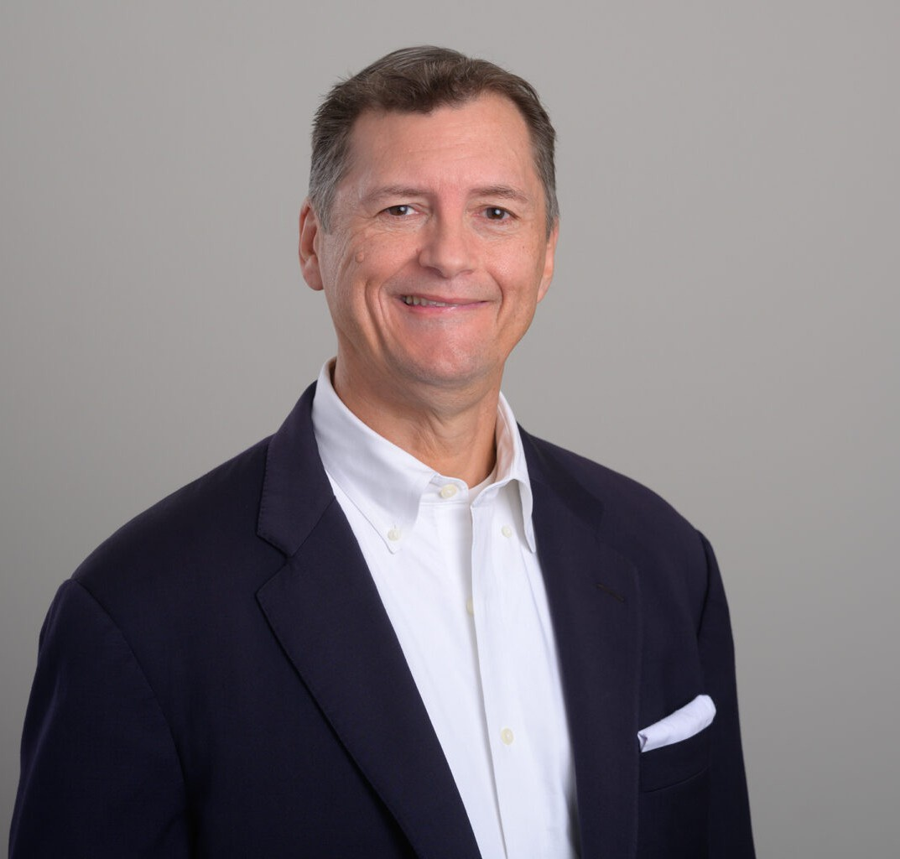

ROBERT P. ALLENBY

Director

[Business Litigation](https://www.fennemorelaw.com/services/business-litigation/)

[San Diego](https://www.fennemorelaw.com/contact-us/san-diego/)

P: 619.595.3209

F: 619.231.4372

[rallenby@fennemorelaw.com](mailto:rallenby@fennemorelaw.com)

# ROBERT P. ALLENBY

Robert P. Allenby is a business litigator with over 30 years’ experience. His primary practice areas are in construction, both public and private projects, and insurance coverage. His construction litigation practice involves mostly disputes that arise during construction, particularly those involving large, public works infrastructure projects. He has extensive experience in disputes involving mechanics lien and stop notice claims; competitive bidding; bid protests; implied warranties of public plans and specifications; contractor/design-professional licensing; extra-

work claims; change order disputes; delay claims; prompt-payment claims; and prevailing-wage disputes. His insurance coverage practice involves representing both policy holders and carriers, including with respect to bad faith claims arising out of first-party and third-party liability policies. Robert also has significant experience with anti-SLAPP motions, appellate litigation, and alternative dispute resolution. He represents a wide range of clients including contractors,

owners, developers, suppliers, design professionals, and municipalities.

Robert began his career as a law clerk to Magistrate-Judge Peter A. Nowinski in the U.S. District Court for the Eastern District of California. His appellate experience has resulted in published

opinions, including *Hazard, Jr. Enterprises, Inc. v. Insurance Company of the West*, 52 Cal. App.

4th 1088 (4th Dist. 1997), a case relating to the California Contractors State License Law, and *Wood v. City of San Diego*, 678 F.3d 1075 (9th Cir. 2012), a case relating to the applicability of anti-discrimination laws to public pensions.

Robert fundamentally believes that his primary job is to work himself out of a job by efficiently identifying and resolving the precise factual and legal issues which so often can serve to end litigation. To those ends, he has built a strong foundation in legal principles and courtroom advocacy and delves into the depths of each case, ensuring a thorough understanding and

strategic planning tailored to his clients’ goals. With Robert, clients receive not just legal services, but a strategic partnership that appreciates and prioritizes their legal and business needs.

# EDUCATION

J.D., University of California, Davis, King Hall School of Law B.A., University of Redlands, *cum laude*

# AREAS OF PRACTICE

Business Litigation Construction Law Real Estate Insurance Coverage

# AWARDS AND HONORS

Peer Recognized in The Best Lawyers in America® for work in the field of Litigation – Insurance Super Lawyer in the area of Construction Litigation in 2021-2024

Super Lawyer in the area of Civil Litigation in 2020 Top Lawyers, *San Diego Magazine*, 2015-2024

AV® Preeminent™ Peer Review Rating by Martindale-Hubbell

# PROFESSIONAL AND COMMUNITY ACTIVITIES

Instructor at San Diego State University’s Extension Studies Program Member, San Diego County Bar Association

Member, American Bar Association

Volunteers as a moot court judge for trial practice law students at University of San Diego

# ADMISSIONS

All State and Federal California Courts