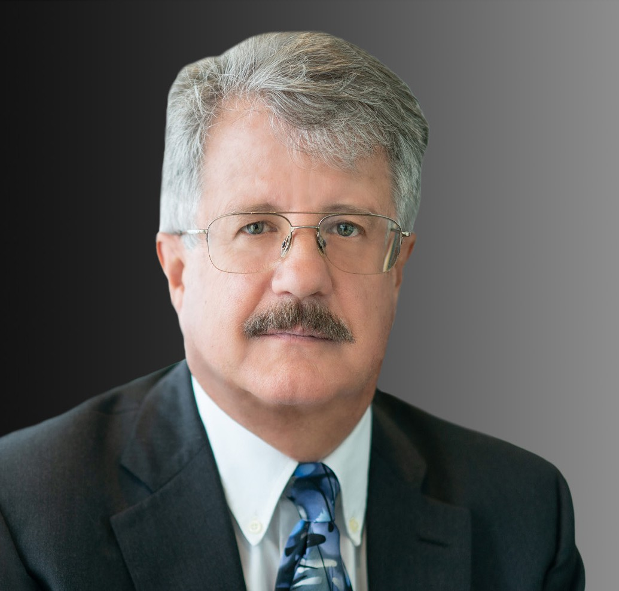

STEVEN M. MORGER

Of Counsel

[Business Litigation](https://www.fennemorelaw.com/services/business-litigation/)

[Oakland](https://www.fennemorelaw.com/contact-us/oakland/)

P: 510.834.6600

F: 510.834.1928

[smorger@fennemorelaw.com](mailto:smorger@fennemorelaw.com)

# STEVEN M. MORGER

Steve, an experienced business litigator, represents clients involved in real estate and complex business disputes. He has particular expertise in the areas of mortgages, deeds of trust, foreclosure and antideficiency issues as well as guarantees. He has also taught for 20 years at the University of California, Berkeley, School of Law. Steve has provided expert testimony involving real estate secured transactions and guarantees as well as title insurance, escrow and related disputes. He works with all aspects of civil litigation and discovery through trial and

appeal.

# EDUCATION

LL.M., Golden Gate University, Taxation

J.D., University of California, Berkeley, School of Law

B.S., University of California, Berkeley, Business Administration with an emphasis in Accounting and Finance

# AREAS OF PRACTICE

OTHER EXPERIENCE

Cannabis

Real Estate Litigation Business Litigation

# AWARDS AND HONORS

*Northern California Super Lawyers*®, 2004 and 2007-2022

# ARTICLES AND PRESENTATIONS

Speaker, “Sale Remedies,” Continuing Education of the Bar Real Property Basics, December 11, 2019

Speaker, “Finance Remedies,” Continuing Education of the Bar Real Property Basics, November 25, 2019

Speaker, “ACBA Bankruptcy Symposium,” Alameda County Bar Association, November 15, 2019

Speaker, “Title Insurance,” Continuing Education of the Bar Real Property Basics, November 7, 2019

Speaker, “Will History Repeat? Comparing and Contrasting Cyclical Real Estate Lending Environments,” Wendel Rosen Client Seminar, May 2017

# PROFESSIONAL AND COMMUNITY ACTIVITIES

Volunteer Legal Advisor, Cartoon Art Museum, San Francisco

Former Member, Board of Directors, Cartoon Art Museum, San Francisco Former Legal Advisor, Neighborhood Housing Services Silicon Valley, San Jose Lecturer, University of California, Berkeley, School of Law

# ADMISSIONS

California

U.S. District and Bankruptcy Courts Northern, Southern, Central and Eastern Districts of California

U.S. District Court, Northern District of Texas

U.S. Court of Appeals, Ninth District