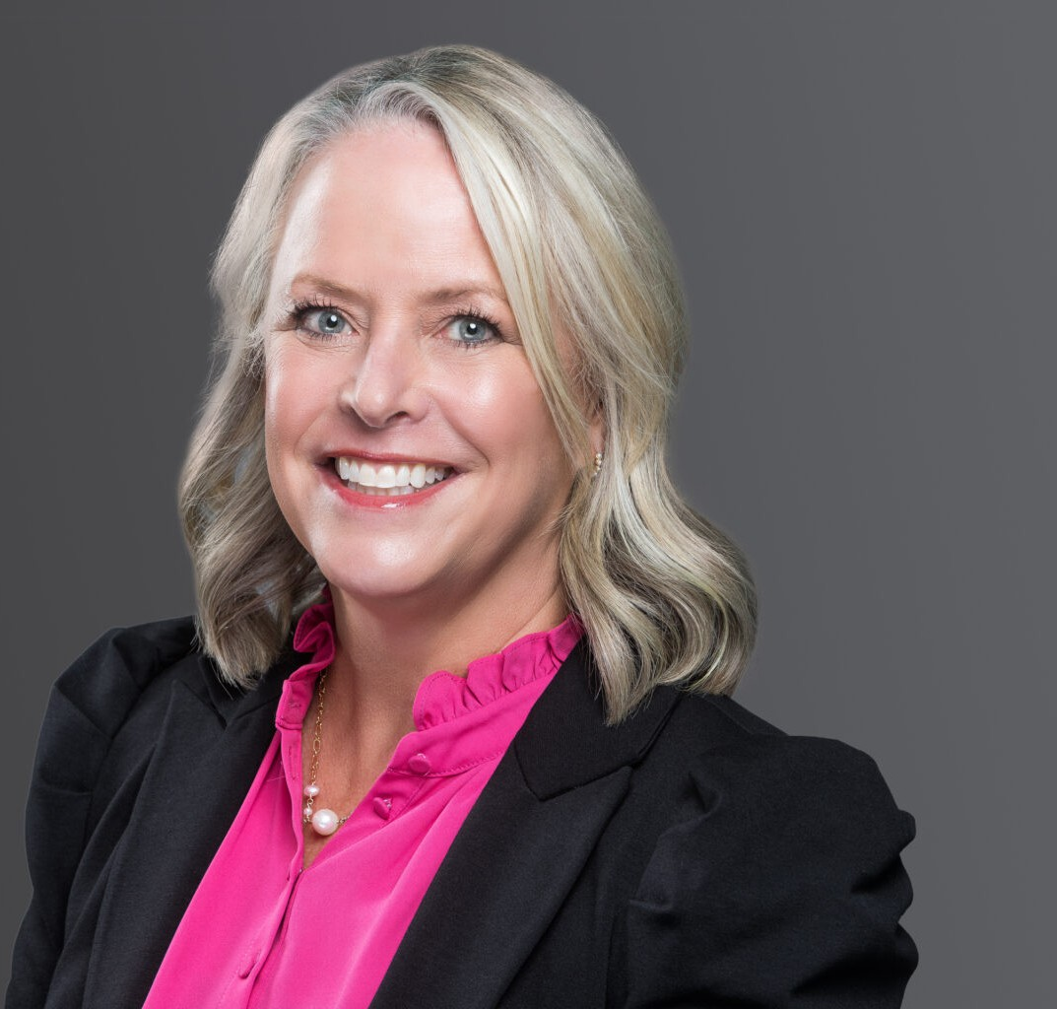

SUSAN M. WISSINK

Director

[Business & Finance](https://www.fennemorelaw.com/services/business-and-finance/)

[Phoenix](https://www.fennemorelaw.com/contact-us/phoenix/)

P: 602.916.5319

F: 602.916.5519

[swissink@fennemorelaw.com](mailto:swissink@fennemorelaw.com)

“

Success is not final, failure is not fatal: it is the courage to continue that counts.

-Winston Churchill

”

**SUSAN M. WISSINK**

Susan Wissink is passionate about helping her clients, learning about their businesses, and helping them reach their goals in the areas of mergers and acquisitions, entity formation, loans, and general corporate matters. In numerous complex transactions, this experienced business attorney has represented both buyers and sellers, including asset and stock-based acquisitions and sales, mergers and other business reorganizations. As a Phoenix-based business attorney, she assists her clients in forming new companies, strategic partnerships, commercial loans, general corporate matters and commercial health care matters.

Helping the victims of 9/11 with their legal needs after the terrorist attacks on the twin towers of the World Trade Center in New York left a profound impression on Susan, and the experience instilled in her a lasting desire to provide pro bono services to those in need. Outside of her work as a sought-after business attorney, her favorite hobbies are spending time with her family, snow skiing, hiking, biking, and volunteering for local charities that help children or animals.

# EDUCATION

J.D., *cum laud*e, Arizona State University, Sandra Day O’Connor College of Law B.A., English, Northwestern University

# AREAS OF PRACTICE

OTHER EXPERIENCE

Health Care

Business & Finance

Emerging Businesses & Technologies Venture Accelerator

Mergers & Acquisitions Agribusiness

# REPRESENTATIVE CASES

Represented Fortune 500 company in numerous asset and stock acquisitions and dispositions, in general corporate and contract matters, and municipal bidding

Represented private lender in numerous loans in the Southwestern United States

Represented building technologies company in both disposition and acquisition of stock or assets

Represented physician-group in sale of practice to large hospital

Represented privately-held pharmaceuticals benefits manager in the sale of company to publicly-held company

Represented automobile dealership companies in connection with purchasing and selling various dealerships in the southwestern United States

Represented a private individual in the sale of a well-known recording studio in West Los Angeles, California

Represented an Arizona-based company in the acquisition of the assets of a California company involved in the formulation and packaging of agricultural, home and garden, and industrial products

Represented a physician-owned group in the surgical device business in combination with a national physician-owned business

Represented physician and dental practices in admission of new partners, reorganizations and mergers and acquisitions

Represented family-owned retail business in sale of all assets

# AWARDS AND HONORS

*Best Lawyers in America®,* Business Organizations (including LLCs and Partnerships), Corporate Law, Mergers and Acquisitions Law, Real Estate Law, 2011-2025

*Chambers USA,* Leading Lawyers for Business, 2011-2024

*Southwest Super Lawyers®,* Business/Corporate, 2018-2023 Women of Achievement Recipient, *InBusiness Magazine*, 2022 Top 100 Lawyers in Arizona, *AZ Big Media,* 2020, 2022

*Southwest Super Lawyers®,* Top 25 Women in Arizona, 2016-2018, 2020-2021 Top 100 Lawyers, *AZ Business Magazine,* 2016 -2020

*Best Lawyers in America®,* Lawyer of the Year, Mergers and Acquisitions Law, 2019

*Southwest Super Lawyers®,* Mergers and Acquisitions, 2007-2008, 2012-2017

Recipient of Top 50 Pro Bono Attorney Award, 2006

Recipient of Volunteer Lawyers Program Award for “Operation Good Neighbor” (assistance to Hurricane Katrina victims), 2006

Recipient of Arizona Business Journal “40 Under 40” Award and State Bar of Arizona Young Lawyer of the Year Award, 2004

Recipient of “Star of the Quarter” award in 2005 and “Star of the Year” award in 2002 from the American Bar Association – Young Lawyers Division

AV® Preeminent™ Peer Review Rated (the highest rating available), by Martindale-Hubbell

# ARTICLES AND PRESENTATIONS

Featured, “SCG Legal Announces 2024 Board of Directors,” SCG Legal, October 1, 2023

Featured, “Top 10 Most Influential Corporate/M&A Arizona Lawyers to Watch in 2023,” Business Today, July 21, 2023

Featured, “Top 100 Lawyers in Arizona for 2023,” AZ Big Media, January 19, 2023

Featured, “Leadership & Achievement: Celebrating 2022 Women of Achievement,” inBusiness, September 2022

Featured, “15 Valley Women Honored, Celebrating Giving Back to Our Community through Event Oct. 7,” inBusiness, August 16, 2022

[Podcast, “The Process of Hiring an Attorney with Susan Wissink,” Fenn.Talks Podcast, May 13,](https://www.youtube.com/watch?v=RLkQPpyAo3Q) [2021](https://www.youtube.com/watch?v=RLkQPpyAo3Q)

[Interview, “The Balance – or Blur – Of Being an Attorney Mom,” Fennemore Blog, May 6, 2021](https://www.fennemorelaw.com/insights/blogs/2021/the-balance-or-blur-of-being-an-attorney-mom)

Interview, “Fennemore Craig Continues 135-year Legacy of Innovation and Growth,” ASU Now, September 16, 2020

[Interview, “What Sets Fennemore Craig Apart From Other Law Firms?” ASU Law, September](https://www.youtube.com/watch?v=x_4Y_x8cMGE&feature=youtu.be) [15, 2020](https://www.youtube.com/watch?v=x_4Y_x8cMGE&feature=youtu.be)

[Interview, “Car Safety,” Fox 10, May 1, 2018](https://vimeo.com/fennemorecraig/review/267639243/eee169740b)

Speaker, “Key Current Topics and Questions From Four M&A Healthcare Experts,” Alliance Arizona Chapter, November 16, 2017

Quoted, “Growing Economy Keeps Merger Legal Firms Busy,” *Phoenix Business Journal,* August 26, 2016

Speaker, “ULI Arizona & DY Deep Dive Series: What’s the Endgame?” Urban Land Institute, April 2016

Speaker, “Private Equity – Acquiring the Privately-Held Company,” ACC Private Equity Presentation, December 2015

Speaker, “Workplace Violence Happens. How will you respond?” State Bar of Arizona

Author, “Sarbanes-Oxley and Recent Pronouncements of the Securities and Exchange Commission,” Financial Executives Institute

Speaker, “Sarbanes-Oxley Considerations for Privately-Held Companies”, Maricopa County Corporate Council Division

# PROFESSIONAL AND COMMUNITY ACTIVITIES

Treasurer, Board of Directors, SGC Legal, 2025

Chair, She Rise

Former Member, Management Committee, Fennemore President, Fennemore Foundation

Former Practice Group Leader of Business & Finance Member, SGC Legal Women in Law Taskforce

Member, Northwestern University’s Alumni Admissions Council Fellow, American Bar Foundation

Board of Trustees and Past President, Childsplay

Past Chair, Director, Children’s Museum of Phoenix, 2006-2015

Member, P.A.N.D.A. (which raises money for Steele Children’s Research Center), Board President, 2010-2011

Former Director, Arizona Humane Society, 2003-2012; Board Chair, 2008; Compassion with Fashion Chair, 2010

# ADMISSIONS

Arizona California Colorado