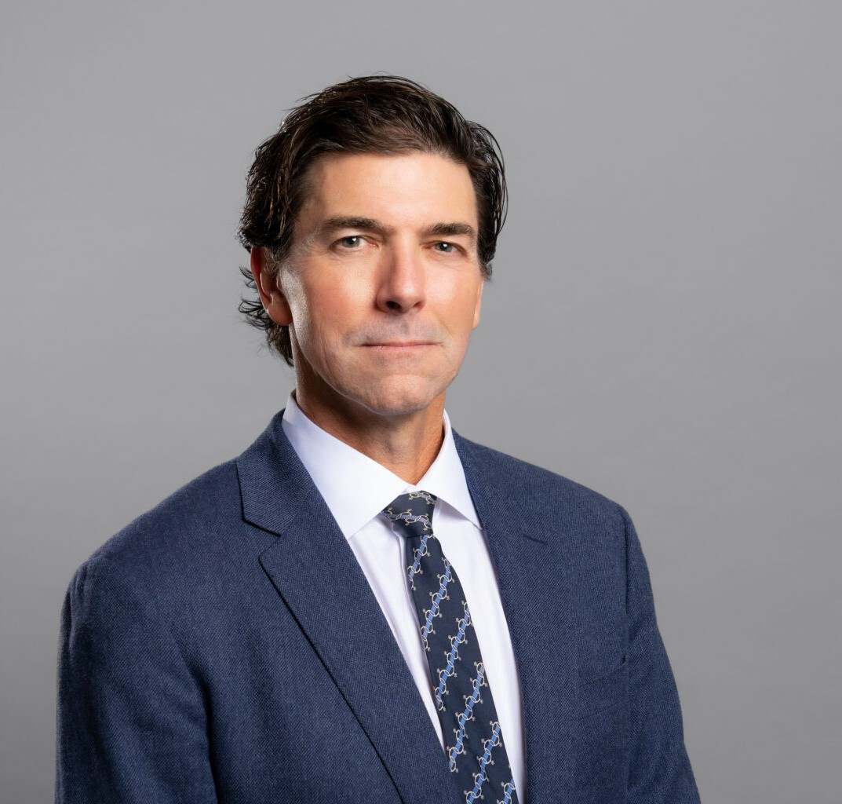

TODD A. WILLIAMS

Director

[Land Use](https://www.fennemorelaw.com/services/land-use/)

[Oakland](https://www.fennemorelaw.com/contact-us/oakland/)

P: 510.834.6600

F: 510.834.1928

[toddwilliams@fennemorelaw.com](mailto:toddwilliams@fennemorelaw.com)

# TODD A. WILLIAMS

Todd represents clients in the broad spectrum of land use, real estate and environmental issues in both litigation and administrative proceedings.

He works with private clients and public entities, including landowners and developers of residential, infill, commercial and industrial property, as well as local agencies, providing

property entitlement processing and local government land use approvals; CEQA compliance and litigation; planning and zoning law advice; and real property litigation. He also has experience with infill project streamlining, density bonus and housing laws, affordable housing and historic preservation regulations, as well as advising clients on public-private partnerships, the Subdivision Map Act, the Williamson Act, and cannabis land use regulations, along with

easement and boundary dispute matters.

A contributing editor on the 2010 – 2011 edition of State and Local Government Land Use

Liability, and a reviewer of the 2012 and 2013 editions of the Municipal Law Handbook, Todd also has spoken throughout the state on land use law, with particular emphasis on CEQA.

# EDUCATION

J.D., University of California College of the Law, San Francisco B.A., University of California, Los Angeles

# AREAS OF PRACTICE

Land Use Real Estate

Natural Resources Cannabis Business

# AWARDS AND HONORS

*Best Lawyers in America®,* Lawyer of the Year, Land Use and Zoning Law, 2025

*Best Lawyers in America®,* Land Use and Zoning Law, 2018-2025

*Northern California Super Lawyers*®, 2010-2023

# ARTICLES AND PRESENTATIONS

Featured,” Trumark Homes snags 30-acre Livermore site entitled for more than 400 homes,” San Francisco Business Times, February 3, 2023

Featured, “Five ‘builder’s remedy’ projects submitted in Mountain View, Los Altos Hills,” San Francisco Business Times, February 14, 2023

Author, “California Supreme Court Denies Review in Berkeley Shellmound Case Paving the Way for Housing Under SB 35”, Wendel Rosen Client Update, August 2, 2021

Speaker, “Bisnow East Bay Multifamily Update,” Bisnow, August 19, 2021

Speaker, “Density Bonus: a Strong Development Tool Gets Stronger,” Wendel Rosen LLP, June 8, 2021

Speaker, “Streamlined Housing Approval with SB 35, SB 330 and New Pro-Housing Legislation,” Wendel Rosen LLP, October 20, 2021

Speaker, “How the Housing Crisis Act (SB330) Can Ease Approvals for Housing Development Projects” Wendel Rosen Webinar, October 29, 2020

Speaker, “Demystifying the new 2018 Housing Laws and Update on Major Oakland Projects” Wendel Rosen Client Seminar, January 9, 2018

Co-Author, “Slate of New Housing Bills Take Effect,” Wendel Rosen Client Update, January 3, 2018

Speaker, “Oakland Construction & Development: The Boom Continues!” Wendel Rosen Client Seminar, November 10, 2016

Speaker, “What Every Real Estate Attorney Should Know About CEQA,” Wendel Rosen Client Seminar, October 21, 2016

Speaker, “Oakland’s Impending Development Impact Fees & the California Supreme Court’s Steps to Rein in CEQA,” Wendel Rosen Seminar, April 2016

Speaker, “What Every Lawyer Needs to Know About CEQA + New Supreme Court Developments,” Alameda County Bar Association, February 2016

Speaker, “Expert Briefing: CEQA Update,” Bay Planning Coalition, October 2015 Co-Author, “Inclusionary Housing Stays,” The Registry, June 29, 2015

Speaker, “Current Issues in CEQA and Planning and Zoning,” Building Industry Association’s 2015 BIG Show, April 2015

Author, “California Supreme Court Provides Key CEQA Guidance Regarding Categorical Exemptions,” Wendel Rosen Client Update, March 3, 2015

Speaker, Land Use and CEQA Update, Contra Costa Planning Directors, July 2014 Speaker, Land Use and CEQA Update, Marin County Planning Directors, June 2014

Speaker, CEQA Reform and Challenges to Plan Bay Area, Air and Waste Management Association, February 2014

Co-Author, “Court of Appeal Reinstates Regional Air Quality Thresholds for Greenhouse Gas Emissions,” Wendel Rosen Client Update, August 14, 2013

Participant, Land Use Law Update Roundtable, California Lawyer, June 2013

Speaker, Recently Adopted CEQA Streamlining for Infill, Air and Waste Management Association, May 2013

Speaker, Land Use and CEQA Update, Marin County Planning Directors, May 2013 Reviewer, The California Municipal Law Handbook, 2012-2013

Co-Author, “Air Quality District’s CEQA Thresholds Invalidated,” Wendel Rosen Client Update, April 6, 2012

Author, “Court Weakens Use of CEQA’s Categorical Exemptions,” Wendel Rosen Client Update, March 28, 2012

# PROFESSIONAL AND COMMUNITY ACTIVITIES

Member, SPUR – Oakland

Member, Land Use Task Force, East Bay Leadership Council Member, Alameda County Bar Association

Vice Chair, Real Property Section, Land Use Subsection, State Bar of California

# ADMISSIONS

California

United States District Court, All California Districts United States Court of Appeals, Ninth Circuit