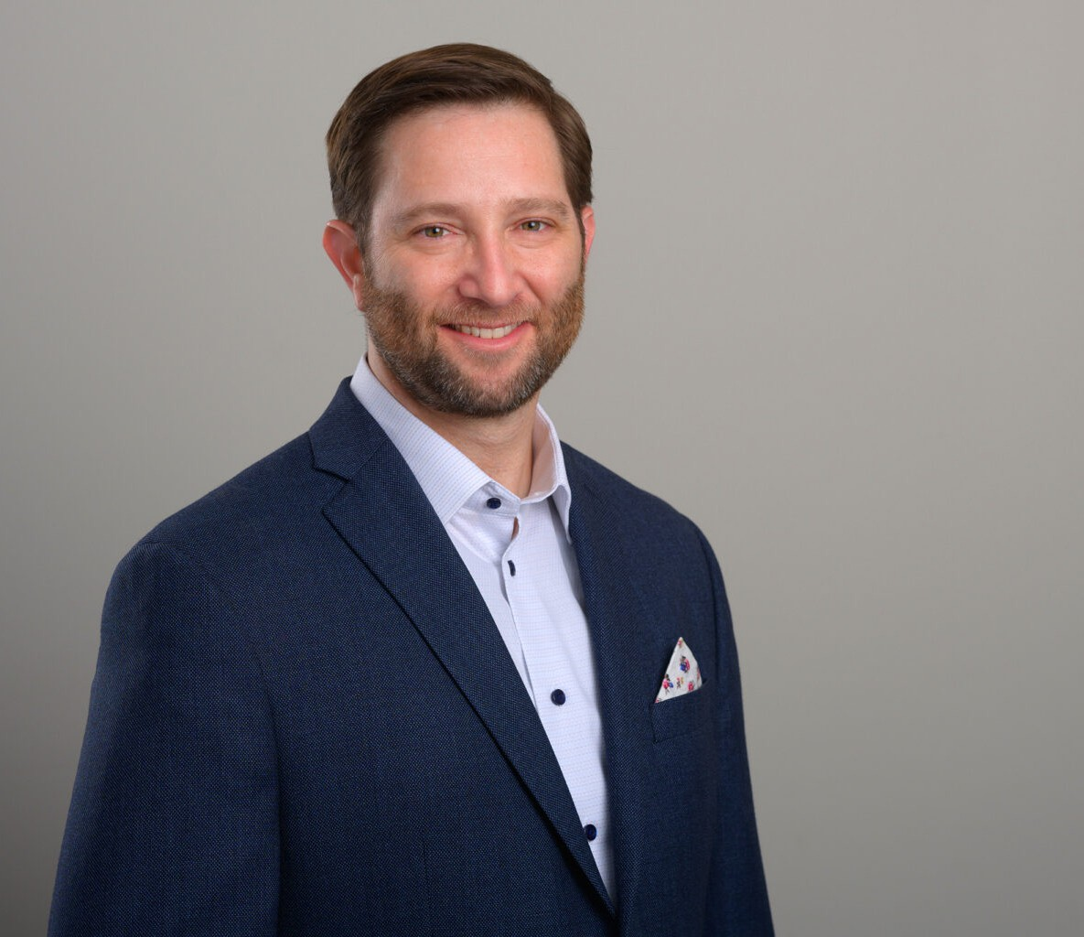

YANIV NEWMAN

Director

[Business Litigation](https://www.fennemorelaw.com/services/business-litigation/)

[San Diego](https://www.fennemorelaw.com/contact-us/san-diego/)

P: 619.595.3246

F: 619.231.4372

[ynewman@fennemorelaw.com](mailto:ynewman@fennemorelaw.com)

# YANIV NEWMAN

Yaniv Newman is a litigator in the Insurance, Construction, and Commercial and Business Litigation practice groups.

His practice focuses on representing commercial lines policyholders in disputes with their insurers and to secure the policy benefits to which they are entitled. His clients include a wide array of corporate policyholders throughout California and Washington in disputes involving commercial property and liability policies – including general liability, directors and officers liability,

employment practices liability, and errors & omissions (professional) liability coverage, among others – and has represented policyholders in every stage of both reimbursement claims by insurers against their insureds, and in bad faith claims against insurers.

Using his deep understanding of insurance coverage principles, Yaniv also serves as a trusted advisor to his clients on the use of insurance products to shift and mitigate operational risk. His experience in coverage litigation, including reimbursement actions by insurers and bad faith actions by insureds, showcases his ability to navigate intricate insurance-related legal

challenges.

Yaniv discovered his passion for insurance coverage law while representing builders, developers, contractors and other construction industry stakeholders for much of his career. Yaniv continues to serve as trusted counsel to builders, developers, and contractors on matters involving both

public and private works throughout California and Washington, and enjoys the genuine, hard- working individuals that make up the construction industry. From the initial stages of contract negotiation to project completion, Yaniv handles a range of issues arising during construction, such as performance and payment disputes, progress claims, and mechanic’s liens. His experience extends to post-completion disputes, including warranty and construction defect

claims, where his skill in negotiating complex legal matters has resulted in numerous favorable dispute resolutions.

Yaniv’s litigation experience is rounded out by the myriad business and commercial disputes he has had the pleasure to both defend and prosecute during his career. His approach to legal representation – whether as counselor or advocate – reflects a commitment to providing

thoughtful, strategically efficient solutions.

Yaniv is a proud veteran of the United States Marine Corps, and served in Operation Iraqi

Freedom. Following his service in the Marine Corps, Yaniv earned a Bachelor of Science degree

in Business Administration from the University of California – Berkeley, Haas School of Business. Yaniv went on to earn his Juris Doctor from the University of San Francisco School of Law.

When he’s not providing his clients with outstanding legal services, Yaniv enjoys spending his free time with his spouse and young daughter. Yaniv also enjoys the occasional round of not-so-great golf.

# EDUCATION

J.D., University of San Francisco School of Law B.S., University of California, Berkeley

# AREAS OF PRACTICE

Business Litigation Construction Law Insurance Coverage

# AWARDS AND HONORS

Best Lawyers: Ones to Watch, by Best Lawyers in America® – Construction Law, 2025

Best Lawyers: Ones to Watch, by Best Lawyers in America® – Commercial Litigation, 2025 Rising Star by Super Lawyers – Construction Litigation, 2020-2021

Rising Star by Super Lawyers – Insurance Coverage

# ARTICLES AND PRESENTATION

Presenter, “Cyber Threats: Preparation and Protection for you and your Clients,” California Lawyers Association, May 23, 2024

Co-Presenter, “Are You and Your Clients Paying Enough Attention to Cyber-Risk?” San Diego County Bar Association, October 20, 2023

Author, “Developers and Contractors Are Potentially Liable For Subcontractors’ Employees’ Unpaid Wages,” Firm Newsletter

Author, “California Court of Appeal Expands Insurance Coverage for Wage and Hour Litigation Under EPLI Policies,” Firm Newsletter

# PROFESSIONAL AND COMMUNITY ACTIVITIES

Member, Construction Law Section, San Diego County Bar Association Member, Building Industry Association of San Diego

Member, Claims Litigation Management Alliance

Former Chair of the Board of Directors, Swords to Plowshares

# ADMISSIONS

California Washington