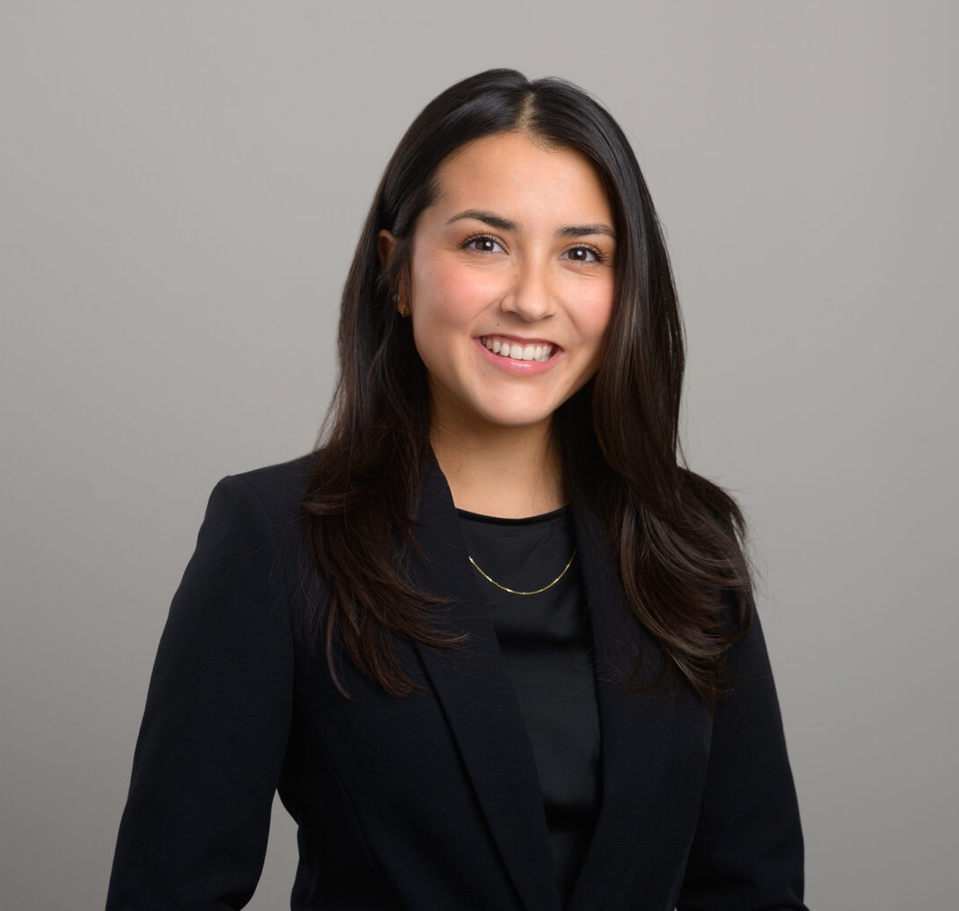

ALEXA K. SMITH

Associate

[Business Litigation](https://www.fennemorelaw.com/services/business-litigation/)

[San Diego](https://www.fennemorelaw.com/contact-us/san-diego/)

P: 619.595.3211 F: 619.231.4372

[alexa.smith@fennemorelaw.com](mailto:alexa.smith@fennemorelaw.com)

# ALEXA K. SMITH

Alexa K. Smith is an associate in Fennemore’s Business Litigation group. In her practice, she works with a broad range of clients such as general contractors, small business owners, and nonprofits on a variety of commercial litigation matters including insurance coverage and construction

defects.

While in law school, Alexa served in multiple roles advocating on behalf of children, with a focus on children in foster care. Alexa served as a research assistant to then Assistant Dean Dalton, University of San Diego School of Law, researching developing case law on education and disciplinary law. She also served as a legal intern at Riverside County Counsel in their Child Welfare Division. Alexa’s experience as an extern with the Children’s Advocacy Institute’s policy clinic researching and advocating for developing law to benefit children and participation in the Advocated for Children and Education Club at University of San Diego taught Alexa invaluable lessons in research and advocacy. Alexa’s passion for advocating on behalf of disadvantaged children provided great insight into how to advocate on behalf of clients.

Outside the office, Alexa enjoys watching crime documentaries, walking her dog, reading books, and participating in a challenging Pilates class.

Business Litigation

# EDUCATION

J.D., University of San Diego School of Law, *cum laude*

B.A., San Diego University, *summa cum laude*

# AREAS OF PRACTICE

Business Litigation

# AWARDS AND HONORS

James D’Angelo Outstanding Child Advocate Award, Children’s Advocacy Institute, 2024 Excess of 100 hours of pro bono legal service, 2024

Recipient, Law Honor Scholarship, 2022-2024 Dean’s List, San Diego State University, 2017-2020

McCuen Endowed Economics Scholarship, San Diego State University Noon Rotary Scholarship

# PROFESSIONAL AND COMMUNITY ACTIVITIES

Member, Advocates for Children and Education, 2021-2024 Member, Women’s Law Caucus, 2021-2024

Member, Business Law Society, 2021-2024

Research Assistant, Assistant Dean Dalton, University of San Diego School of Law, 2022-2024 Legal Intern, Riverside Country Counsel, 2022

Intern, Children’s Advocacy Institute, University of San Diego, 2019 Resident Advisor, San Diego State University, 2018-2020

Intern, Chemehuevi Indian Tribe Accounting Department, 2018 Member, Phi Kappa Phi, 2019-2020

Member, Order of the Omega, 2019-2020 Service Director, Kappa Alpha Theta, 2017-2020

# ADMISSIONS

California