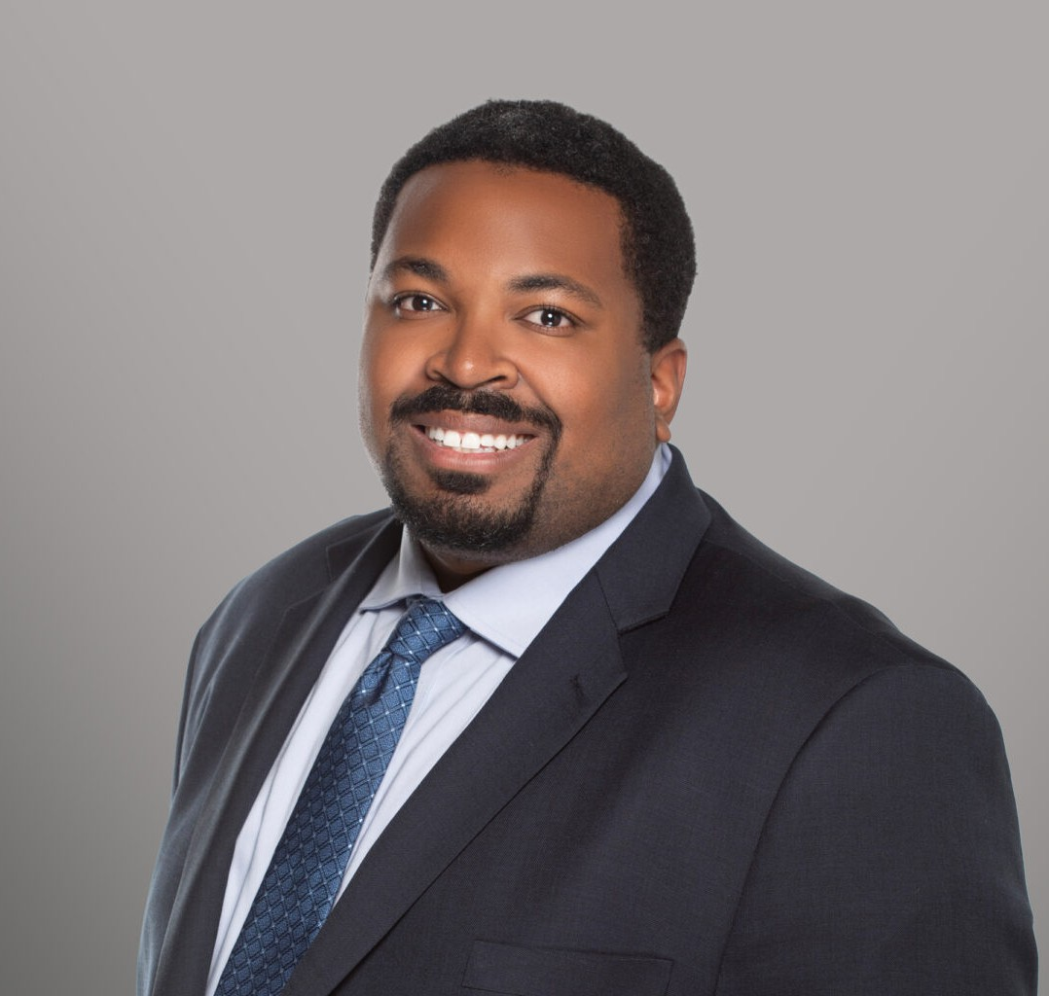

AMIR FREEMAN

Associate

[Business & Finance](https://www.fennemorelaw.com/services/business-and-finance/)

[Fresno](https://www.fennemorelaw.com/contact-us/fresno/)

P: 559.446.3209 F: 559.432.4590

[afreeman@fennemorelaw.com](mailto:afreeman@fennemorelaw.com)

# AMIR FREEMAN

Amir Freeman is an Associate at the firm practicing in [Business & Finance](https://www.fennemorelaw.com/services/business-and-finance/) and [Estate Planning](https://www.fennemorelaw.com/services/estate-planning/).

He works with clients on matters involving entity structure and formation, mergers and acquisitions, trust administration, and trust planning.

Amir earned his law degree from the Gould School of Law at the University of Southern California (USC). During his time at USC, Amir was a mentor at Legal Education Access Pipeline, where he supported low-income, marginalized students to create law school applications. He was also

president of USC Gould Street Law and the community outreach chair of the Black Law Student Association. As a USC Research Assistant, he gained valuable insight into how the intersection of law, race, and journalism influences prosecutorial conduct in criminal law.

In his spare time, Amir enjoys mixology, photography, and a challenging game of billiards.

# EDUCATION

J.D., University of Southern California Gould School of Law B.A., University of California, Los Angeles

# AREAS OF PRACTICE

Business & Finance Estate Planning

# PROFESSIONAL AND COMMUNITY AFFILIATIONS

Research Assistant, USC Gould School of Law, 2022-2023 Mentor, Legal Education Access Pipeline, 2022-2023 Member, President, USC Gould Street Law, 2021-2023

Member, Community Outreach Chair, Black Law Student Association, 2021-2024

# ADMISSIONS

California