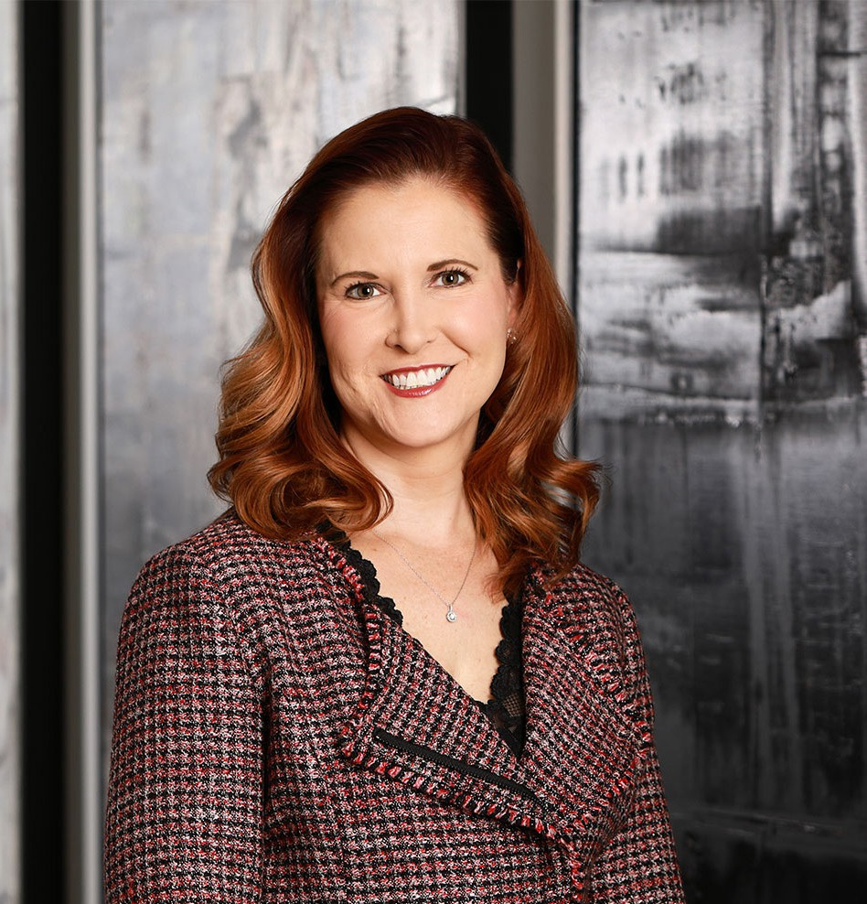

ANDREA L. MARCONI

Director

[Business Litigation](https://www.fennemorelaw.com/services/business-litigation/)

[Phoenix](https://www.fennemorelaw.com/contact-us/phoenix/)

P: 602.916.5335 F: 602.916.5535

[amarconi@fennemorelaw.com](mailto:amarconi@fennemorelaw.com)

“

The question isn't who is going to let me; it's who is going to stop me.

-Ayn Rand

**ANDREA L. MARCONI**

”

Andrea Marconi is an experienced litigator and serves as Chair of the firm’s business litigation practice group. Her broad spectrum of work encompasses many areas, including complex commercial litigation, franchise litigation and banking issues such as payment processing, credit card processing and ACH transactions. In addition, Andrea has experience with entities

throughout the healthcare industry, including representing health insurers and medical billing companies in numerous matters such as coverage issues, regulatory and compliance matters, and defense of bad faith claims. Routinely arbitrating and contesting cases in state and federal courts around the country, she also has extensive experience litigating a wide array of real estate contract disputes, insurance coverage and indemnity matters, restrictive covenants, and trade secret litigation.

Although she did not come from a family of attorneys, Andrea knew early on her calling was to be an attorney. She has always loved analyzing problems, persuading others as to her opinion on the facts and arguing with her father — and often winning — at the kitchen table. As a business litigation attorney, she now advises a diverse group of clients, including individuals, small and mid-sized businesses, and Fortune 500 companies.

She litigates disputes from start to finish — and often resolves these cases before they need to be addressed in the courthouse. She continues to study the art and science of disagreements, and how to best solve them, which is often conducive to long-term relationships with her clients. She frequently takes the role of outside general counsel, looking at ways of avoiding ambiguity that could lead to costly disputes in the future. While not afraid to fight when necessary, Andrea’s approach throughout her career as a business litigation attorney has been to learn her clients’

business inside and out, understanding critical issues and proactively handling any problems in an efficient and cost-effective manner.

When not litigating, Andrea is probably volunteering in the community. Her passion for animal welfare is showcased in her efforts as the chair of the Arizona Humane Society’s board of

directors, and her enthusiasm for hoops is evidenced by her seat on the Phoenix Suns Charities

88 Big Gorilla board of directors. Her two sons are her pride and joy, and her weekends are spent at their numerous basketball and soccer events.

# EDUCATION

J.D. Arizona State University, Sandra Day O’Connor College of Law B.A., Political Science, Sociology, University of Arizona

# AREAS OF PRACTICE

**OTHER EXPERIENCE**

Litigation

Business Litigation Health Care

Real Estate Intellectual Property

# REPRESENTATIVE CASES

Represented the State of Arizona, Arizona Department of Transportation, in a 135 plaintiff mass action seeking 8 figures in damages resulting from flooding that occurred in Mesa, Arizona, along the U.S. 60 freeway. Following a hard fought and complex 3 week jury trial, we obtained a unanimous jury verdict on all of plaintiffs’ claims. The jury also unanimously found

that we established the “State of the Art” affirmative defense, which would have barred any liability that otherwise might have been established.

Achieved early dismissal of large California pension plan in federal court litigation involving claim for benefits.

Prosecuted claims against contractor and negotiated favorable settlement in favor of the country’s second largest waste management company in slope failures case.

Achieved early dismissal of public employee in a high-profile case alleging negligence and breach of duty claims.

Represented a national franchisor of massage and spa clinics with franchises in 49 states, including serving as co-lead member of the franchisor’s national defense counsel team for various kinds of tort claims.

Defended and negotiated a favorable settlement of non-compete, trade secret misappropriation and unfair competition claims brought against a high-level sales employee after his departure from a prior employer.

Defended credit card processing company in numerous putative class action cases that were consolidated and transferred to a multi-district litigation involving claims arising out of one of the largest alleged pyramid and Ponzi schemes in U.S. history.

Achieved dismissal of payment gateway provider in same multi-district litigation involving claims arising out of one of the largest alleged pyramid and Ponzi schemes in U.S. history.

Representation of third-party payment processor in numerous aspects of its business, including contract drafting and review, regulatory and compliance issues, employment matters, and

litigation.

Represents clients in defending against vicarious liability and respondeat superior claims arising out of negligent and intentional conduct by employees, contractors, franchisees, and other like individuals or entities.

Defended large supplier of automated voice response systems in indemnification action arising out of patent infringement claims alleged against a call processing center to whom the client provided its product.

Represented a local fine dining restaurant group and was part of the team who negotiated a favorable settlement for client in actions involving claims of breach of a multi-million dollar promissory note against the financiers who purchased the restaurant group and defending

against trademark and trade dress infringement claims asserted by the purchaser against the restaurant group.

Represented a large solid waste company in arbitration regarding a success fee and royalty contract where the claimant contended it had earned a large success fee and multi-million dollar royalty in connection with a landfill expansion. After a full evidentiary hearing, the arbitrator ruled that the claimant had not established entitlement to either the success fee or royalty and issued an award in favor of the waste company. The claimant moved the Arizona Superior Court to vacate the award. The court denied the motion to amend and confirmed the arbitration award.

Defended claims by a putative class of consumers alleging unlawful pharmaceutical pricing in multi- district litigation matter.

Represented a Japanese EPC subcontractor in arbitration of consolidated claims arising out of the construction of a 790-Megawatt Power Plant in the Midwestern United States.

Defended more than 30 individual personal injury claims alleging purported benzene exposure in a Midwestern community against one of the world’s largest oil companies related to one of the company’s refineries and achieved a successful settlement of all remaining

claims.

Participated in negotiating a favorable settlement and business licensing agreement to resolve trade secret and misappropriation claims against a large industrial manufacturer client.

# AWARDS AND HONORS

*Best Lawyers in America®*, Banking and Finance Law, 2022-2025 *Best Lawyers in America®*, Litigation – Real Estate, 2024 and 2025 Most Influential Women in Arizona, AZ Big Media, 2023

*Southwest Super Lawyers®,* Business Litigation, 2019-2024

*Women Achievers of Arizona*, Arizona Capitol Times, *2021*

*Southwest Super Lawyers®,* Top 25 Women, State of Arizona

*AZ Business Magazine*, Top 100 Lawyers in Arizona

*Southwest Super Lawyers®,* Rising Star, 2014-2016

AV® Preeminent™ Peer Review Rated (the highest rating available), by Martindale-Hubbell

# ARTICLES AND PRESENTATIONS

Featured, “Most Influential Women in Arizona,” AZ Big Media, July 2023

Featured, “Meet the 2022 Women of Chandler,” Chandler City Lifestyle, May 2022

Interview, “Community Highlights: Meet Andrea Marconi of Fennemore Craig,” VoyagePhoenix, March 24, 2022

Author, “Beyond Boilerplate: Preparing the Right Dispute Resolution Clause for Business Contracts” AZ Attorney Magazine, November 2021

Co-Presenter, “Protecting Your Business and Brand,” KNOW Women National Summit, October 23, 2021

[Co-author, “OSHA Issues Emergency Temporary Standard for Health Care Employers,”](https://www.fennemorelaw.com/insights/newsletters/2021/osha-issues-emergency-temporary-standard-for-health-care-employers) [Fennemore Client Alert, July 8, 2021](https://www.fennemorelaw.com/insights/newsletters/2021/osha-issues-emergency-temporary-standard-for-health-care-employers)

[Author, “What to Know: Updated OSHA COVID-19 Guidance for Workplaces,” Fennemore](https://www.fennemorelaw.com/insights/newsletters/2021/what-to-know-updated-osha-covid-19-guidance-for-workplaces) [Client Alert, June 24, 2021](https://www.fennemorelaw.com/insights/newsletters/2021/what-to-know-updated-osha-covid-19-guidance-for-workplaces)

[Author, “Contract Dispute Resolution Provisions Are Not One-Size-Fits-All,”](https://inbusinessphx.com/legal-regulations/contract-dispute-resolution-provisions-are-not-one-size-fits-all#.YJVOOrVKgUH) [*InBusiness*, May 1,](https://inbusinessphx.com/legal-regulations/contract-dispute-resolution-provisions-are-not-one-size-fits-all#.YJVOOrVKgUH) [2021](https://inbusinessphx.com/legal-regulations/contract-dispute-resolution-provisions-are-not-one-size-fits-all#.YJVOOrVKgUH)

[Author, “COVID liability law protects a wide range of entities,”](https://issuu.com/timespub/docs/afn_0428_book/32) [*Ahwatukee Foothills News*, April](https://issuu.com/timespub/docs/afn_0428_book/32) [26, 2021](https://issuu.com/timespub/docs/afn_0428_book/32)

[Co-author, “Arizona Enacts COVID-19 Liability Protections for Health Professionals,” Fennemore](https://www.fennemorelaw.com/insights/newsletters/2021/arizona-enacts-covid-19-liability-protections-for-health-professionals) [Client Alert, April 22, 2021](https://www.fennemorelaw.com/insights/newsletters/2021/arizona-enacts-covid-19-liability-protections-for-health-professionals)

Quoted, “What is covered by Gov. Ducey’s executive order on vaccine passports?” News 4 Tucson, April 22, 2021

[Author, “Governor Ducey Bans “Vaccine Passports” for State and Local Governments,”](https://www.fennemorelaw.com/insights/newsletters/2021/governor-ducey-bans-vaccine-passports-for-state-and-local-governments) [Fennemore Client Alert, April 19, 2021](https://www.fennemorelaw.com/insights/newsletters/2021/governor-ducey-bans-vaccine-passports-for-state-and-local-governments)

[Author, “Arizona Enacts COVID-19 Liability Shield Law,” Fennemore Client Alert, April 14, 2021](https://www.fennemorelaw.com/insights/newsletters/2021/arizona-enacts-covid-19-liability-shield-law)

Author, “Could Congress overturn Arizona’s right-to-work law?” *AZ Big Media,* March 8, 2021 Interview, “Andrea Marconi of Fennemore: ‘Focus on Yourself’,” Thrive Global, February 3,

2021

Interview, “Attorney Andrea Marconi of Fennemore: 5 Things I Wish Someone Had Told Me When I First Became an Attorney,” *Authority Magazine,* January 13, 2021

Presenter, “Top 5 Legal Tips to Protect Your Business and Brand,” KNOW Women Master Class, August 25, 2020

[Author, “What Regulatory Actions Can Tell Payment Processors and ISOS About the](https://www.fennemorelaw.com/insights/newsletters/2020/what-recent-regulatory-actions-can-tell-payment-processors-and-isos-about-the-anticipated-wave-of-covid-19-related-enforcement-and-how-to-protect-your-business) [Anticipated Wave of COVID-19 Related Enforcement and How to Protect Your Business,”](https://www.fennemorelaw.com/insights/newsletters/2020/what-recent-regulatory-actions-can-tell-payment-processors-and-isos-about-the-anticipated-wave-of-covid-19-related-enforcement-and-how-to-protect-your-business) [Fennemore Client Alert, June 23, 2020](https://www.fennemorelaw.com/insights/newsletters/2020/what-recent-regulatory-actions-can-tell-payment-processors-and-isos-about-the-anticipated-wave-of-covid-19-related-enforcement-and-how-to-protect-your-business)

[Author, “All Good Things Must Come to an End,” Fennemore Client Alert, April 28, 2020](https://www.fennemorelaw.com/insights/newsletters/2020/all-good-things-must-come-to-an-end)

[Co-author, “COVID-19 and its Impact on the Deadline to Bring Legal Claims,” Fennemore](https://www.fennemorelaw.com/insights/newsletters/2020/covid-19-and-its-impact-on-statutes-of-limitation-for-legal-claims) [Client Alert, April 28, 2020](https://www.fennemorelaw.com/insights/newsletters/2020/covid-19-and-its-impact-on-statutes-of-limitation-for-legal-claims)

Interview, “Women You Must Know and Do Business With,” *The KNOW Book + Tribe*, January 27, 2020

Author, “Spec’s Family Partners, Limited v. First Data Merchant Services,” Fennemore Client Alert, June 21, 2019

[Co-author, “Vazquez v. Jan-Pro Franchising International, Inc.,” Fennemore Client Alert, May](https://www.fennemorelaw.com/insights/newsletters/2019/vazquez-v-jan-pro-franchising-international-inc-) [28, 2019](https://www.fennemorelaw.com/insights/newsletters/2019/vazquez-v-jan-pro-franchising-international-inc-)

Author, “Changes to the Administration of Commercial Litigation in Arizona: A Brief Overview of the Commercial Court Pilot Program”

Author, “Financial Institutions & Social Media: Final Guidance Issued By the FFIEC”

Author, “Facilitating Financial Transactions in the Age of Internet Gambling: Compliance with the Unlawful Internet Gambling Enforcement Act”

Author, “CFPB Announces Early Warning Notice of Enforcement Actions”

Author, “Betting and Buying: The Legality of Facilitating Financial Payments for Internet Gambling”

Author, “The Dodd-Frank Act and Consumer Financial Protection Bureau, What You Need to Know”

Presenter, “Emerging Issues: Social Media Guidelines for Banks and Financial Institutions Explored”

Presenter, “Deconstructing a Litigation Budget”

# PROFESSIONAL AND COMMUNITY ACTIVITIES

Board Member, Chandler Chamber Ninth Circuit Lawyers Representative

Federal Bar Association, Federal Litigation Section, Secretary/Treasurer Federal Bar Association, National Sections and Divisions Council

Board of Directors, Phoenix Chapter of Federal Bar Association, Past President and Member Arizona Women Lawyer’s Association, Board of Directors

Arizona Humane Society Board of Directors, Chair

Board of Directors, Vice-Chair

Board of Directors, Governance Committee Chair

Co-Chair of Arizona Humane Society Signature Event, Compassion with Fashion Board of Directors, Member

Phoenix Suns Charities 88

Board of Directors (known as “The Big Gorillas”) Member

Member, Site Council for Curriculum Development, Knox Gifted Academy (Chandler) Board of Directors, Herberger Theater Center

Board Member, Women’s Metropolitan Arts Council

# ADMISSIONS

Arizona

U.S. District Court District of Arizona

U.S. District Court District of Colorado

U.S. Court of Appeals Ninth Circuit