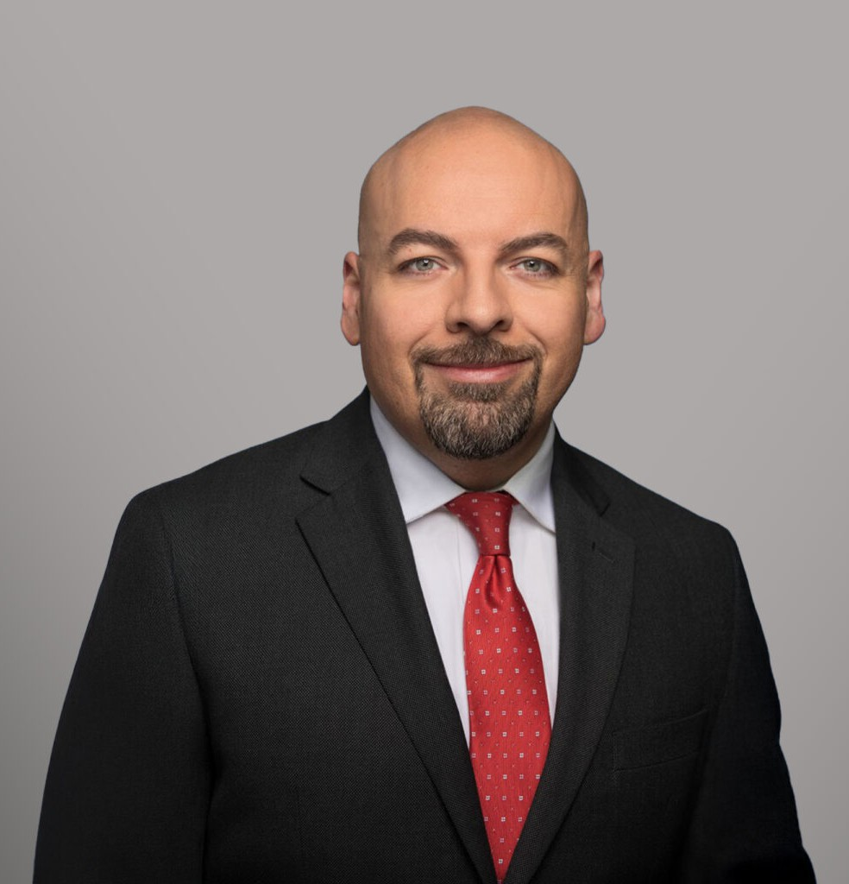

ANDREW SANCHEZ

Paralegal

[Trusts & Estates](https://www.fennemorelaw.com/services/trusts-estates/)

[Sacramento](https://www.fennemorelaw.com/contact-us/sacramento/)

P: 916.273.1857

[asanchez@fennemorelaw.com](mailto:asanchez@fennemorelaw.com)

“

Each day provides its own gifts.

Marcus Aurelius

**ANDREW SANCHEZ**

”

With over 25 years of professional experience as a paralegal, Andrew Sanchez has established a distinguished career in the legal field. He began his journey in 1999, earning an Associate of Applied Science Degree in Legal Assisting from MTI Business College (now Campus Sacramento). After his first year at MTI, he gained valuable hands-on experience by securing a position at a civil litigation law firm, where he worked as a paralegal for five years.

Andrew takes great pride in providing clients with peace of mind and clarity as they navigate the often complex aspects of estate planning. His extensive experience includes drafting comprehensive estate planning documents—such as revocable and irrevocable trusts, wills, powers of attorney, and other supplementary estate documents—as well as assisting with post- death trust administrations and probates.

Additionally, Andrew has knowledge in corporate and LLC formations, dissolutions, and maintaining corporate records, further showcasing his versatility and commitment to client success. His dedication to detail and personalized client service has made him a trusted professional in the estate planning legal community.

In his free time, Andrew loves reading, weightlifting, mixed martial arts, motorcycles, and tabletop roleplaying games.

# AREAS OF PRACTICE

Trusts & Estates Estate Planning

# EDUCATION

A.A.S, Legal Assisting, MTI Business College (now Campus Sacramento)

# PROFESSIONAL AND COMMUNITY ACTIVITIES

Member, Sacramento Valley Paralegal Association

# ADMISSIONS

*\*Not licensed to the practice of law*